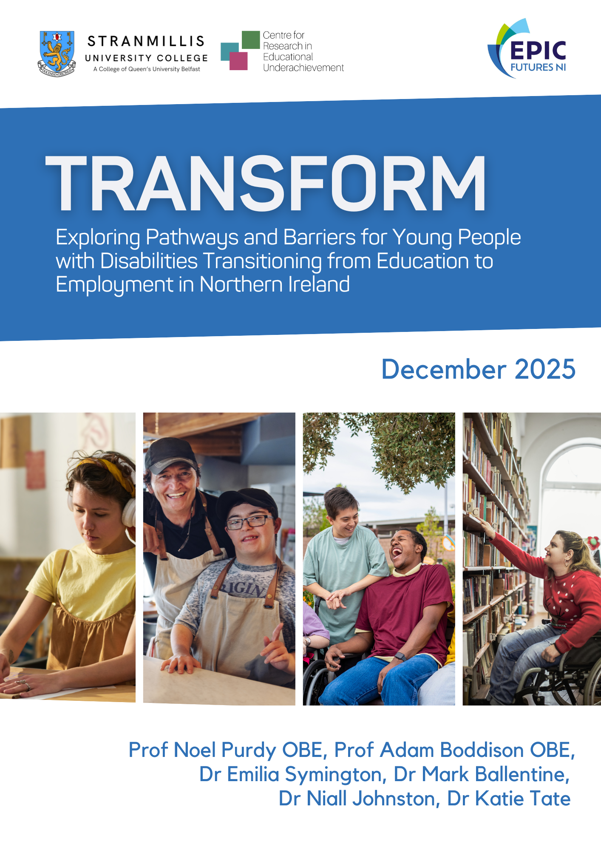
Cover Page

Epic Futures

Prof Noel Purdy OBE, Prof Adam Boddison OBE, Dr Emilia Symington, Dr Mark Ballentine, Dr Niall Johnston

TBC 2025

Executive Summary

Aims of the Study
This mixed-methods study, funded by EPIC Futures NI, set out to explore the challenges and issues facing young people with special educational needs (SEN) as they transition from full-time school education into further education, training, employment or day-care provision. The study set out to explore the following key research objectives:
- To identify what provisions are available to young people with special educational needs (SEN) as they transition from full-time school education
- To critically examine the main challenges, gaps and barriers in the current transition process and the impacts this has on young people and their parents/carers
- To draw lessons and offer insights to policymakers and service providers to support the development of more coherent, equitable and effective pathways for young people with SEN as they move into adult life.
Methodology
This study examined the pathways and barriers experienced by young people with special educational needs and disabilities (SEN) as they transition from education into post-19 training, employment, and adult services in Northern Ireland. The study drew on the perspectives of young people with SEN, parents and carers, school leaders, employers, training providers, and other key stakeholders. A mixed-methods design was adopted, consisting of four interconnected phases that combined desk-based research, scoping activities, surveys, and semi-structured interviews:
Phase 1A: Desk-Based Scoping of Opportunities
A structured review of existing literature, policies, and reports was undertaken to map the current landscape of post-19 education, training, employment, and day-opportunity pathways for young people with SEN. This phase identified the range of current provision and highlighted gaps in the existing evidence base.

Phase 1B – Regulation and Quality Assurance Review

The second phase involved an analysis of the regulatory and oversight frameworks that govern post-19 SEN pathways. This included an analysis of accreditation processes, quality assurance systems, and inspection arrangements across departments and agencies.

Phase 2A – Fieldwork (Survey)
Two online surveys were conducted to capture parental perspectives on the transition process.
- The first survey was conducted with parents/carers of young people aged 16-19 preparing to transition from special school.
- The second survey was conducted with parents/carers of young people who had recently transitioned from special school within the last three years.
These surveys explored the options available to their children, their experiences of the transition process, and barriers within the transition system, including a lack of suitable opportunities, lack of access to information and a lack of transport provision.
Phase 2B – Fieldwork (Qualitative Interviews)
The final phase of research consisted of in-depth, semi-structured interviews. These interviews were conducted either in-person or online between August and October 2025 and typically lasted between 30-90 minutes. Questions focused on various aspects of the transition process; lived experiences of this, what has worked well, main gaps and challenges, and stakeholder perspectives of this process. These interviews were conducted with a range of participants to ensure insights were drawn from those with lived experience, as well as those with a responsibility in the transition process. Participants included: 6 parents/carers, 15 young people, 3 school leaders, 9 official stakeholders (including DfE officials and employment support providers), and 12 members of the Association for Real Change in Northern Ireland (ARC NI).
Findings
The desk-based mapping revealed a lack of centralised oversight for post-19 SEN provision in Northern Ireland. Due to the lack of any centralised database, it is not possible to determine the full nature, extent or distribution of available opportunities across the region, however the analysis suggested that current provision falls substantially short of demand. On average, there is only one provision for every 91 young people with SEN, with particularly high ratios in areas such as Warrenpoint, Newtownabbey, Belfast, Antrim, Carrickfergus, Bangor, Ballyclare, Cookstown and Craigavon. Regional inconsistencies were a major theme emerging from this research, with significant gaps across the north, east, and southeast of Northern Ireland where opportunities are widely spaced and unevenly distributed. Overall, the lack of a centralised database suggests that neither policymakers nor service users have a clear picture of what exists, where gaps lie, or where investment would be most impactful.
The regulation review indicated that the post-19 SEN regulatory landscape is fragmented, with oversight varying considerably across sectors. This is apparent, for example, as within education and training, the Education and Training Inspectorate (ETI) remains the principal regulatory authority, providing robust inspection and quality assurance across a wide range of pathways. However, the picture is less consistent outside of education and training. Day Care Centres, for example, benefit from clear, centralised regulation through the Regulation and Quality Improvement Authority (RQIA), providing transparency, accountability and consistent standards across Northern Ireland. In contrast, Day Opportunities remain entirely unregulated (sitting outside the statutory responsibility of both the RQIA and the ETI), leaving a significant gap in quality assurance, safeguarding and strategic planning. Taken together, these findings highlight the need for a more coherent and consistent regulatory framework across post-19 SEN provision in Northern Ireland.
Findings from the two parent/carer surveys also shed light on the main challenges and barriers faced by young people in the transition process. The survey conducted with parents/carers whose children are preparing to transition from special school, revealed widespread uncertainty and concern. Many were unsure about available post-school options, reflecting insufficient transition planning, inconsistent communication and a lack of suitable local pathways. Parents/carers also reported highly variable school support, with some schools offering strong guidance and others leaving families feeling unsupported. This inconsistency contributed to reduced confidence in the transition process. Parents also described a lack of meaningful opportunities available to their child, especially regarding employment. The dominance of day centres and day programmes was seen as evidence of a narrow and limited post-school landscape for young people with significant learning needs. Overall, many parents lacked confidence that their children would transition into appropriate, fulfilling and needs-led pathways and felt the current transition system was inadequate and poorly equipped.
The survey conducted with parents/carers whose children have recently transitioned from special school, revealed that for many, the post-school transition was unsuccessful, distressing and/or inadequate. Many parents/carers also indicated that post-19 opportunities frequently lack the quality, consistency or expertise needed to meet complex needs, resulting in significant frustration among families. They believed that the transition system fails at several interconnected points: planning, service coordination, range of opportunities, transport infrastructure and Health and Social Care support, while regional inconsistencies were also considered a central issue.
The semi-structured interviews also revealed a number of challenges and barriers within the transition process. The young people, families and stakeholders who were interviewed consistently described a post-19 system that is ill-equipped to support young people with SEN as they move into adulthood. Key themes emerging from the interviews included: a siloed and fragmented transition system; insufficient and inconsistent provision across regions; barriers to access, including transport; information gaps; unsuitable or inaccessible environments; limited availability of meaningful, person-centred pathways; and a strong need for government-led, system-wide improvement, coupled with greater cross-departmental coordination and more effective strategic regional planning.
Recommendations
- The need for a single, live, centralised mapping system
There is an urgent need to develop and maintain a single, centralised, live mapping system (a genuine “one-stop-shop”) supported by dedicated staffing to assist young people as they navigate this critical transition. This central resource should be funded on a cross-departmental basis (DE, DfE, DfC and DoH), updated regularly, and made accessible to all young people and their parents/carers as they prepare to transition beyond school.
- The need for legislative reform and a statutory duty beyond 19
Introduce robust, rights-based statutory protections for young people with SEN beyond age 19, accompanied by sustained multi-departmental funding. Legislative reform should ensure that seamless statutory support across education, training, employment and care, extends to the age of 25 and beyond in order to prevent the initial “cliff edge” at 19 and any secondary “cliff edge” at 25. Such statutory protections would place clear duties on departments to deliver coordinated, enforceable provision.
- The need for investment in the capacity of existing services
Invest substantially in strengthening the capacity, quality and consistency of existing post-19 provision across Northern Ireland, including sufficient staffing, sustainable funding, enhanced transport support and rigorous quality assurance. Provision should be age-appropriate, needs-led and equitably distributed across regions, supported by centralised planning to ensure that services meet current and future demand.
- The need for joined-up planning between government departments and agencies
Establish a formal cross-departmental mechanism (such as a dedicated disability transition unit or jointly mandated leadership structure) to coordinate policy, planning and service delivery for young people with SEN beyond age 19. This mechanism should include shared accountability, integrated data systems and co-funded programmes to ensure that departments work cohesively rather than in silos.
- The need to listen to the voices of young people
Embed the meaningful participation of young people with SEN at every level of transition planning and policy development. Structured mechanisms should be created to ensure that their views inform the design, implementation and evaluation of post-19 provision, in line with UNCRC and UNCRPD commitments. Young people’s aspirations and lived experiences must be central to shaping supports that enable them to thrive.

Conclusion
This study highlights the urgent need for change within the current post-19 transition process for young people with special educational needs (SEN) in Northern Ireland, as they transition from full-time school education into further education, training, employment or day-care provision. Across all strands of research within this study, young people with SEN, their families, and the professionals who work with them described a transition system that is fragmented, inconsistent and frequently unable to meet even the most basic expectations of clarity, continuity and access to meaningful opportunities. The evidence from the current study underscores the need to work towards transformational progress in how post-19 pathways are planned, delivered and evaluated. The recommendations emerging from the study emphasise several core priorities: the need for a centralised mapping system; strengthened legislative protections; investment in sustainable and high-quality services; coordinated cross-departmental planning; and the meaningful involvement of young people themselves. Overall, the findings from this study offer a clear insight into the diverse realities, challenges and barriers faced by young people with SEN and their families, and points towards the need to create a coherent and equitable transition system that genuinely enables all young people to thrive and achieve meaningful outcomes as they move into adult life.

Acknowledgements

The research team at the Centre for Research in Educational Underachievement (CREU), Stranmillis University College, Belfast, would like to thank all those who participated in this research project, and in particular the young people, their parents, school leaders, officials and other key stakeholders who so readily agreed to participate in the data collection.
The research team are also indebted to the project’s expert reference group of Claire Breen, Julie Jordan, Zak Nicholls, Tara Mills and Daniel Magill for their constructive guidance and insights.
Finally, this project was funded by EPIC Futures NI, led by Ulster University, as part of the Local Policy Innovation Partnerships programme funded by UK Research and Innovation (UKRI), the Economic and Social Research Council, the Arts and Humanities Research Council and Innovate UK. We are grateful to EPIC Futures NI for funding this important and timely research and for the consistent support of Professor Kristel Miller (Director: EPIC Futures NI) and Claire Lynch (Project Manager: EPIC Futures NI).

How to cite this research report:
Purdy, N., Boddison, A., Symington, E., Ballentine, M., Johnston, N. & Tate, K. (2025). TRANSFORM: Exploring Pathways and Barriers for Young People with Disabilities Transitioning from Education to Employment in Northern Ireland​. Belfast: Centre for Research in Educational Underachievement, Stranmillis University College. (For further information contact: n.purdy@stran.ac.uk).
Contents

Executive Summary 2
Acknowledgements 6
Contents 7
List of Tables & Figures 9
Chapter 1: Introduction and Context 10
1.1 United Nations Conventions 10
1.1.1 UN Convention on the Rights of the Child 10
1.1.2 UN Convention on the Rights of Persons with Disabilities 11
1.2 The Northern Ireland Context 12
1.2.1 SEN Legislative Context 13
1.2.2 Department for the Economy Funded Pathways 14
1.2.3 Department of Health Funded Opportunities 19
1.2.4 Regulation and Quality Assurance 20
1.2.5 The SEN Reform Agenda (2025) 22
1.2.6 DfE Review of Post-School Education, Skills and Training (2025) 23
1.2.7 DfE: Ministerial Statement to the NI Assembly (June 2025) 23
1.2.8 DfC Consultation on a Disability and Work Strategy for NI (2025) 25
1.3 Conclusion 26
Chapter 2: Methodology 28
2.1 Research Design and Methodology 28
2.2 Ethical Considerations 29
2.3 Data Analysis 29
2.4 Research Limitations 29
Chapter 3: Mapping of SEN provisions for post-compulsory education in NI 30
3.1 Methodology 30
3.2 Analysis 30
3.3 Limitations 30
3.4 Mapping 31
3.5 Results 31
3.6 Geographical Analysis 31
3.7 Day Centres 32
3.8 Discussion 34
Chapter 4: Parents of Pupils Preparing to Transition from Special School 35
4.1 About You and Your Child 35
4.2 Preparing for Transition 37
4.3 Survey Open-Ended Responses: The Biggest Positive Difference to Transition? 42
4.3.1 Inadequate Transition Planning, Information and Communication 42
4.3.2 Transport and Working Hours Barriers 43
4.3.3 Support from Social Workers 43
4.3.4 Physical and Emotional Support and Guidance 44
4.3.5 Employment and Training that is Meaningful 44
4.3.6. Inequality and Gaps in Provision 45
4.3.7. Importance of Starting Early 45
Chapter 5: Parents of Pupils Who Have Recently Transitioned from Special School 46
5.1 About You and Your Child 46
5.2 Experience After Leaving Special School 48
5.3 Survey Open-Ended Responses: The Biggest Positive Difference to Transition? 54
5.3.1 Inadequate Transition Planning, Information and Communication 54
5.3.2 Support from Social Workers 55
5.3.3 Access to Suitable, Tailored Opportunities Post-School 55
5.3.4 Transport and Family Logistics 56
5.3.5 Emotional Support and Guidance 56
5.3.6 Early Engagement on Needs and Supported Employment 57
5.3.7 Parental Burden and the Need to “Fight” 57
Chapter 6: Qualitative Results 58
6. Qualitative Findings 58
6.1 Introduction 58
6.2 Siloed Transition System 59
6.3 Insufficient Provision 65
6.4 Barriers to Access 72
6.5 The Need for an Improved Post-19 System 75
Chapter 7: Conclusion and Recommendations 82
7.1 The need for a single, live, centralised mapping system 82
7.2 The need for legislative reform and a statutory duty beyond 19 83
7.3 The need for investment in the capacity of existing services 84
7.4 The need for joined-up planning between government departments and agencies 85
7.5 The need to listen to the voices of young people 86
7.6 Conclusion 87
8. References 88
9. Author Bios 92
Appendix 1- Capacity Calculation 93

List of Tables & Figures

Table 1.1. SfLW Providers named on the DfE contract – 1st Aug 2025 – (Gov.uk, 2025). |  | 16
Table 2.1. Qualitative data collection participant overview. |  | 29
Table 3.1. Provision Maps and Links. |  | 31
Table 4.1. What is your child’s gender, and what age is your child? |  | 35
Table 4.2. What is the nature of your child’s special educational needs or disability? (Select all that apply) |  | 36
Table 4.3. Which region do you live in, and which Health and Social Care Trust supports your family (if any)? |  | 37
Table 4.4. How clear are your child’s post-school options (e.g., training, employment, further study), and how supported do you feel by your child’s school in preparing for the transition? |  | 38
Table 4.5. What type of opportunities do you believe are realistically available to your child after school? (Tick all that apply) |  | 39
Table 4.6. How confident are you that your child’s next steps will be meaningful and suitable for their needs? |  | 40
Table 4.7. How easy has it been to get information about transition options and support? |  | 40
Table 4.8. What areas of support do you feel are most lacking? (Tick all that apply) |  | 41
Table 5.1. What is your child’s gender, and what age is your child? |  | 46
Table 5.2. What is the nature of your child’s special educational needs or disability? (Select all that apply) |  | 47
Table 5.3. Which region do you live in, and which Health and Social Care Trust supports your family (if any)? |  | 47
Table 5.4. What is your child currently doing? |  | 48
Table 5.5. How would you describe your child’s experience since leaving school? |  | 49
Table 5.6. How well did your child’s special school help to prepare your child for their next steps, and how would you rate the quality of support your child has received to date in their current setting? |  | 50
Table 5.7. What challenges has your child faced since leaving school, and what supports have made the biggest difference? (Tick all that apply) |  | 51
Table 5.8. What supports have made the biggest difference? (Tick all that apply) |  | 51
Table 5.9. Has your child experienced any delay in starting their post-19 placement? |  | 52
Table 5.10. Did your child start a post-19 placement that did not meet their needs? |  | 52
Table 5.11. Since your child started a post-19 placement that did not meet their needs, what were the main reasons the placement was unsuitable? (Tick all that apply) |  | 53
Figure 1.1: Pathways for young people with SEN in Northern Ireland after leaving Special School |  | 13
Figure 3.1. Geographical locations of Provisions across Northern Ireland. |  | 32
Figure 3.2. Map of Day Centres specialising in MP, LD, PH and SI. |  | 33
Figure 3.3 Map of Day Care Centres specialising in MP, LD, PH and SI, as well as Day Care Centres who have not declared a specialisation. |  | 33

Chapter 1: Introduction and Context
This study set out to explore the challenges and issues facing young people with special educational needs (SEN) as they transition from full-time school education into further education, training, employment or day-care provision. The study set out to explore the following key research objectives:
- To identify what provisions are available to young people with special educational needs (SEN) as they transition from full-time school education
- To critically examine the main challenges, gaps and barriers in the current transition process and the impacts this has on young people and their parents/carers
- To draw lessons and offer insights to policymakers and service providers to support the development of more coherent, equitable and effective pathways for young people with SEN as they move into adult life.
This opening chapter sets the context for the study by outlining the international, national and local frameworks that shape the post-school experiences of young people with special educational needs and disabilities in Northern Ireland. It begins by examining the United Nations Convention on the Rights of the Child (UNCRC) and the United Nations Convention on the Rights of Persons with Disabilities (UNCRPD), highlighting their relevance to education, transition and employment. The chapter then turns to the Northern Ireland context, mapping the complex landscape of post-school pathways across education, employment and health-funded provision, and summarising the evolving legislative and policy architecture surrounding SEN and disability. Particular attention is given to recent reforms, reviews and strategic initiatives led by the Departments of Education, Economy and Communities in Northern Ireland. Together, these sections provide a critical backdrop for the chapters that follow, which explore how these frameworks are experienced in practice by young people, families and professionals.

1.1 United Nations Conventions

1.1.1 UN Convention on the Rights of the Child

The UN Convention on the Rights of the Child (UNCRC), which the UK ratified on 16 December 1991 and brought into force on 15 January 1992, is a human rights framework that protects children’s rights to education, participation, and development, including specific protections for children with disabilities. In relation to the move from school into employment or further training, the UNCRC provides an essential safeguard to ensure that young people with disabilities are supported throughout this transition. Key provisions, such as Article 2 which prohibits discrimination, explicitly including disability-based discrimination, and Article 23 (outlined below) which focuses on the rights of children with disabilities, require governments to deliver appropriate assistance so that these children can participate fully in society, including access to inclusive education environments that are responsive to their individual needs. Notably, Article 23 highlights the obligation to ensure effective access to “education, training… [and] preparation for employment”, aimed at promoting each child’s fullest possible social inclusion and personal development.

Article 23

1. States Parties recognize that a mentally or physically disabled child should enjoy a full and decent life, in conditions which ensure dignity, promote self-reliance and facilitate the child’s active participation in the community.
2. States Parties recognize the right of the disabled child to special care and shall encourage and ensure the extension, subject to available resources, to the eligible child and those responsible for his or her care, of assistance for which application is made and which is appropriate to the child’s condition and to the circumstances of the parents or others caring for the child.
3. Recognizing the special needs of a disabled child, assistance extended in accordance with paragraph 2 of the present article shall be provided free of charge, whenever possible, taking into account the financial resources of the parents or others caring for the child, and shall be designed to ensure that the disabled child has effective access to and receives education, training, health care services, rehabilitation services, preparation for employment and recreation opportunities in a manner conducive to the child’s achieving the fullest possible social integration and individual development, including his or her cultural and spiritual development.
4. States Parties shall promote, in the spirit of international cooperation, the exchange of appropriate information in the field of preventive health care and of medical, psychological and functional treatment of disabled children, including dissemination of and access to information concerning methods of rehabilitation, education and vocational services, with the aim of enabling States Parties to improve their capabilities and skills and to widen their experience in these areas. In this regard, particular account shall be taken of the needs of developing countries.

The UNCRC thus emphasises that every child should be supported to reach their full potential. Article 29 reinforces this by stating that education must aim to develop a child’s personality, talents, and mental and physical abilities to the fullest extent.
The Convention also calls on governments, educational settings, families and wider communities to work together to create coherent pathways that bridge academic experiences with vocational training and employment opportunities. The UNCRC also ensures that young people with disabilities are given the opportunity to express their views (Article 12) and be actively involved in shaping their own transition plans, helping to strengthen their autonomy and confidence. In this way, the UNCRC offers a strong rights-based framework that not only protects children with disabilities, but also informs inclusive approaches that enable them to move successfully from education into meaningful employment or further training, and to engage fully in society.
It is important to note, however, that the UNCRC applies only to individuals under the age of 18, which limits its direct scope in relation to older young people with special educational needs and disabilities.

1.1.2 UN Convention on the Rights of Persons with Disabilities

The UN Convention on the Rights of Persons with Disabilities (UNCRPD), ratified by the UK in July 2009, is a significant treaty that protects the rights and dignity of people of all ages with disabilities, with particular focus on inclusion, accessibility and eliminating discrimination.
A core principle of the UNCRPD is full participation, meaning that young people with disabilities should be directly involved in shaping the policies and processes that influence their transition to adulthood. This includes ensuring availability of tailored support, such as careers guidance, mentoring, and assistive technologies, all of which are key resources for enabling effective progression into further education or work. The Convention also highlights the need for inclusive settings that recognise individual strengths and support personalised educational and professional development routes.
By fostering empowerment and self-determination, the UNCRPD supports the creation of transition strategies that help young people with disabilities overcome traditional obstacles and succeed in their chosen paths. Ultimately, it stands as both a legal and ethical obligation for societies to develop inclusive systems that respect diversity and ensure that every young person can realise their potential and make a meaningful contribution to their community.
In particular, Article 24 of the UNCRPD considers the education of persons with disabilities and notes their entitlement to education “at all levels and lifelong learning”:

States Parties recognize the right of persons with disabilities to education. With a view to realizing this right without discrimination and on the basis of equal opportunity, States Parties shall ensure an inclusive education system at all levels and lifelong learning directed to:

a. The full development of human potential and sense of dignity and self-worth, and the strengthening of respect for human rights, fundamental freedoms and human diversity;
b. The development by persons with disabilities of their personality, talents and creativity, as well as their mental and physical abilities, to their fullest potential;
c. Enabling persons with disabilities to participate effectively in a free society.

Paragraph 5 of Article 24 also emphasises that persons with disabilities are entitled to equal access to post-compulsory education with reasonable adjustments and without discrimination, to help facilitate their full participation:

States Parties shall ensure that persons with disabilities are able to access general tertiary education, vocational training, adult education and lifelong learning without discrimination and on an equal basis with others. To this end, States Parties shall ensure that reasonable accommodation is provided to persons with disabilities.

1.2 The Northern Ireland Context
In Northern Ireland, young people with a statement of SEN begin their transition process at the age of 14. This involves a statutory annual review which includes information provided by the Education Authority (EA), Health and Social Care (HSC) Trust, DfE Careers advisers, representatives of the school and parents/carers. There are two key aspects to the transition process for young people: a ‘Health’ transition process where the young person must undergo an adult learning disability assessment; and an ‘Educational’ transition process, where the EA transitions team oversee a young person’s transition until they leave the school system.

Young people with statements of SEN leaving special school have many of the same options as young people without statements of SEN and/or in mainstream schools. There is a largely bi-partite system of departmental responsibility as follows: options under Department for the Economy (DfE) responsibility, including progression to Further Education, Higher Education, employment and training and skills; and options under Department of Health responsibility, including Day Opportunities and Day Care provision, both funded by the Health and Social Care Trusts (rather than through DfE), whether through direct-payments, through the local council or Trust, or a ‘mixed package’. This system is diagrammatically represented in Figure 1.1 and also includes the Department for Communities (see reference below to the current consultation on a new Disability Work Strategy for Northern Ireland 2025-2035).
Day Opportunities are defined by the HSC (2014) as “a package of community-based day time activities which will engage adults with a learning disability in areas such as accredited further education; volunteering; paid supported employment; social enterprise activity and opportunities to meet and make friends and use local leisure and recreational facilities” (HSC, 2014, p.3). They usually focus on engaging young people within a social context, while Day Care is more focused on looking after the individual’s (more complex) care needs.
Of young people with SEN leaving mainstream schools in 2022/2023, the most common destination (involving roughly 1,500 out of 3,500 young people) involved study at one of Northern Ireland’s six FE colleges, followed by training provisions and HE as the third most likely option (DfE, 2025c). While data for Special School leavers was not included in the report (due to low numbers and the potential for identification), discussions with principals and other stakeholders has found that FE, training and health funded options are the most common pathways for this group (DfE, 2025c).

Figure 1.1: Pathways for young people with SEN in Northern Ireland after leaving Special School

1.2.1 SEN Legislative Context
The rights of people with Special Educational Needs and Disabilities (SEN) within Northern Ireland are governed by a number of different pieces of legislation. The Employment and Training (Northern Ireland) Act (1950) first set out the Department’s responsibilities in relation to securing, providing and promoting training and employment, with specific mention given to encouraging an increase in opportunities for people with disabilities to obtain, undertake and retain employment and training. Almost half a century later the Disability and Discrimination Act (1995) made it illegal to discriminate against someone for their disability and the need for ‘reasonable adjustments’ was first introduced. This was further developed by Section 75 of the Northern Ireland Act (1998) which included a duty on public authorities to promote equality of opportunity and good relations, including for disabled people. Unlike in Great Britain, where the Equality Act 2010 consolidated equality legislation, these duties in Northern Ireland remain governed by the Disability Discrimination Act 1995, Section 75, and subsequent legislation including the Special Educational Needs and Disability (Northern Ireland) Order 2005 (SENDO). Together, these frameworks provide key protections for people with SEN in both education and employment.
The Chronically Sick and Disabled Persons (NI) Act (1978) first set out the Department of Health’s (DoH) responsibility to identify and provide support services to those with learning disabilities with the goal of enhancing wellbeing and social inclusion. The Education Order (1996) later set out the duties of the then five separate Education and Library Boards (which merged into the Education Authority in April 2015), to provide special provisions for people with special educational needs. The Education Order (1996) was followed by the Code of Practice on the Identification and Assessment of Special Educational Needs (DE, 1998), which provided important guidance regarding the five-stage approach to the identification and assessment of special educational needs, the statutory assessment process, the procedures for annual reviews and also included the first mention of preparation for post-education transition. The duty to provide reasonable adjustments for people with SEN in further and higher education, however, was not introduced until The Special Educational Needs and Disability Order (SENDO, 2005). This was further clarified with details and case studies to guide implementation in the subsequent Supplement to the Code of Practice on the Identification and Assessment of Special Educational Needs (DE, 2005).
Two more pieces of legislation that have relevance in this area are the Children’s Services Cooperation Act (2015) and The Rural Needs Act (2016). The Children's Services Cooperation Act (2015) aims to improve co-operation and sharing of information between the relevant services related to children and young people. Crucially, this Act extends the right of people with disabilities to access the provisions within the Act from 18 to 21 years old. The Rural Needs Act (2016) aims to improve outcomes for people in rural areas with particular focus on their social and economic needs. As part of a move to alleviate the social isolation of people in rural areas, the legislation includes mention of providing training and support for people with SEN.
The Special Educational Needs and Disability (SEND) Act (2016), while containing significant proposals, has never been fully implemented, largely as a result of the repeated collapse of the Northern Ireland Assembly. Now, almost ten years later, and with the recent publication of the new SEN Reform Agenda (DE, 2025), it is unclear whether this legislation will ever be fully enacted. Parts of the Act that have been implemented relate to the reduction in time limits for assessment of needs, a revised definition of the term ‘child’ for the purposes of special education (extending the individual’s right to provisions to the end of the school year during which they turn 19) and the duty on the Education Authority to take into account the views of the child or young person. Section 4 of the SEND Act (2016), contains significant proposals regarding post-19 transition, setting out a statutory duty for co-operation between the Education Authority (EA) and Health and Social Services to jointly prepare a transition plan, as well as establishing a joint inspection team to review how well this co-operation is functioning every 3 years. At the time of writing (November 2025), this has not yet been implemented.

1.2.2 Department for the Economy Funded Pathways

Further Education (FE)
The most common immediate destination for mainstream school leavers with SEN is further education (DfE, 2025c). FE is also thought to be one of the most popular pathways amongst special school leavers as well (DfE, 2025c). Young people with SEN in Northern Ireland do not have a guaranteed right to access FE. In theory, this stands in contrast to the extended statutory provision to the age of 25 in England under Education, Health and Care (EHC) Plans, although there is evidence that the realisation of this falls far short of the original intentions as a result of inadequate and inconsistent funding (HCEC, 2019; NAO, 2024). Where young people with SEN do secure a place in FE, the DfE supports FE colleges to make reasonable adjustments and provide support for students with SEN through the Additional Support Fund (ASF) which is a ring-fenced funding pot of £4.5m per annum (DfE, 2025c).
The ASF funding is divided into two categories, ‘Basic’ (£2m) and ‘Discrete’ (£2.5m). Basic covers most of the support young people with SEN might need if studying on mainstream courses such as technical/personal support, while discrete funding helps FE colleges meet the costs involved in delivering tailored courses for students who may not be ready to study in mainstream courses. The recent DfE review found however that ASF funding had not been increased for many years, specifically 20 years for discrete funding and 8 years for basic funding (DfE, 2025c), thus representing a substantial cut to funding in real terms over this time period. This funding stagnation has occurred over a 20-year period when there has been a 29% increase in young people with SEN and a 134% increase in pupils with a statement of SEN (DfE, 2025c). This highlights a disconnect between the rising SEN population and the static levels of funding available, suggesting a significant shortfall that risks undermining the capacity of FE colleges to provide equitable, high-quality provision for learners with the most complex needs.
There is also a lack of continuity in support as young people transition from school to FE. One issue noted is that when young people move to FE colleges, the statutory support guaranteed through their SEN statement does not transfer with them. This leaves many learners without the support they need as they may not have known to disclose their needs or seek the additional supports themselves before beginning the course. As well as this, Belfast Metropolitan College is the only one of the six FE Colleges in Northern Ireland that employs support assistants who assist with both educational support and personal care. This means that if a learner has personal care needs and is not in the greater Belfast area, FE College provisions are essentially closed to them unless they can privately organise their own personal care support. It is believed that Belfast Metropolitan College’s exemption to being regulated by RQIA is part of a historic arrangement between Belfast Metropolitan College and the former Belfast HSCT (DfE, 2025c). While it is unusual for an institution to be allowed to provide care without being regulated by RQIA, this example shows that, with some flexibility, exemptions could be made that would allow other FE colleges in Northern Ireland to offer care to individuals with higher support needs, essentially giving them the access to further education they are currently denied.
Furthermore, there are a series of different programmes across Northern Ireland that FE colleges can avail from such as Step Up (DARE), Skills for Life and Work (SfLW) and Skill SET, which are discussed below:

Step Up - Dare
FE colleges have benefitted, since 2023, from additional DfE funding through the ‘Step Up’ programme which aims to target people with disabilities, females in sectors with a gender imbalance, care-experienced young people and individuals not in education or employment or who are otherwise economically inactive (DfE, 2025d). While funding was originally released to cover the financial years 2023/24 - 2024/2025 (DfE, 2025d) the project seems to be operating on a rolling basis with places being advertised until March 2026 (NI Direct, 2025). Disability Access Route to Education and Employment (DARE) is one of the three branches of Step Up and is aimed at supporting disabled people to enhance skills, gain qualifications, work experience and create pathways into FE and employment. From the financial years 2023-2025 the DARE scheme received £4.2m and was intended to support 1,000 individuals with a disability (DfE, 2025c).
A recent ETI (2025) review of the Step Up programme found that it was successful in “improving the quality of life and life chances of individual learners most at risk of marginalisation and sustained economic inactivity” (ETI, 2025, p.9). It highlighted the role of mentoring as a key strength of the scheme and noted how classes were “characterised by mutually respectful relationships with dedicated lecturers who understand learners’ needs and provide high levels of support and positive reinforcement” (ETI, 2025, p.2). While the ETI (2025) report praises the Step Up scheme, it is important, in this context, to note that it often talks about Step Up in general, rather than DARE specifically.

Skills for Life and Work
Skills for Life and Work (SfLW) is an educational initiative that includes adjustments and support for people with a disability (up to the age of 22) and those with in-care experience (up to the age of 25). It also funds access to transport, including taxis for those unable to avail of public transport. The programme provides training and qualifications in personal development, employability and essential skills. While programmes may incorporate work experience, they may also provide ‘world of work’ activities for those who are not yet ready for work experience. These may include project-based learning, work inspiration activities and workplace visits. FE colleges make up roughly 10-15% of SfLW providers, with the rest delivered through private training organisations (DfE, 2025c). There were twenty named private SfLW providers on DfE’s contract award notice (See Table 1) (Gov.uk, 2025). There were 1,754 new starts for the 2024/25 academic year and roughly 50% of people on the course have a disability (DfE, 2025c). Training providers note that this is a popular pathway for young people who have previously attended a special school. On 1st Aug 2025 the DfE was awarded £234,000,000 including VAT (£195,000,000 excluding VAT) to run the programme until July 2027, with the possibility of four one-year extensions (Gov.uk, 2025).

SfLW Providers named on DfE 2025 Contract (1 Aug 2025)
21Training Limited | Coalisland Training Services | Disability Action (NI) | Limestone Youth Training Project | Springvale Training Limited
Ashton Community Trust | Craft Training LTD | Gaelchursai Limited | Rutledge Training Limited | The Now Project Limited
Bryson Energy | D.F.P.F. Limited | Get Skills Employment & Training LTD  (London) | Skilled NI | Ulster Supported Employment Limited
Clanrye Group Limited | Derry Youth and Community Workshop Limited | Impact Training (N.I.) Limited | Springboard Opportunities Ltd | Workforce Training Services Limited

Table 1.1. SfLW Providers named on the DfE contract – 1 Aug 2025 – (Gov.uk, 2025).

SPF - Skill SET – Empower
The Shared Prosperity Fund (SPF) was the British Government’s successor to the European Social Fund (ESF) which finished in 2023 and provided £15.6m per annum (DfE, 2025c). The SPF is aimed at supporting people who are economically inactive, however the SPF, unlike the ESF, does not include a programme for social inclusion.
One programme funded by the SPF is Skill SET. Skill SET is a collaboration between 7 regional and national disability organisations (Action Mental Health, Adapt NI, Cedar, Mencap (N.I.), Now Group, Orchardville and the RNIB - Royal National Institute of Blind People) with the primary focus of supporting people with a disability or health conditions to find employment.
Another relevant programme funded by the SPF is the Empower programme, which is an employment programme aimed at helping people with SEN gain employment, qualifications, skills and day to day issues of finding, applying for and maintaining employment (Gov.uk, 2025a).
The final relevant scheme funded by SPF is the PROSPER (People, Resilience, Opportunities, Success, Participation, Employment and Results) project. The project aims to provide wrap-around support for economically inactive people including people with SEND (Gov.uk 2025a). The UKSPF allocation for Northern Ireland as a whole was £45,488,433 for the financial year 2025/2026 (Gov.uk, 2025b), however it is not possible to say how much of this goes into disability-related programmes such as Skill SET, Empower or PROSPER. It is interesting to note that while the population of Wales is 62% greater than the population of Northern Ireland (NI = 1,920,400, Wales = 3,107,500) (ONS, 2022; NISRA, 2023), it received almost five times the amount of SPF funding (£209,732,954).

Higher Education (HE)
HE providers also have access to some funding schemes that allow them to further support and recruit students with disabilities. Most notable is the Disabled Students’ Allowance grant (DSA). The DSA can provide students (including undergraduate, part-time and postgraduate students) with up to £25,000 per academic year to help support them in their studies (DfE, 2025c). The support generally takes the form of one-to-one non-medical help, specialist equipment and travel support. Approximately 2,500 students receive DSA each year in Northern Ireland, with spending amounting to roughly £4m annually.
HE providers must also include a Widening Access and Participation Plan (WAPP) for any courses where they charge more than the basic HE fee. While WAPP may initially seem restrictive for HE providers, only 10% of the additional income must go to widening participation. It is estimated that this 10% equates to roughly £10m across the sector (DfE, 2025c). Support from WAPP is aimed at disabled students but also those from areas of high deprivation, adult returners and care-experienced young people.
Recently, researchers at Stranmillis University College (Gibson et al., 2025) completed a DfE-funded feasibility study which examined the Trinity Centre for People with Intellectual Disabilities, and in particular the potential establishment of an inclusive HE programme for people with intellectual disabilities in Northern Ireland. The report also considered the Republic of Ireland’s Programme for Access to Higher Education (PATH), which funds 11 institutions, at a cost of €11m, to support at least 150 students with disabilities annually. The authors concluded that this route to HE for people with intellectual disabilities was both effective and financially sustainable. Gibson et al. (2025) describe it as “incontestably feasible, with no insurmountable challenges identified” (Gibson et al., 2025, p.3) and suggest “…moving forward with implementation, recommending a pilot programme as the next step towards establishing a permanent scalable pathway to higher education and employment for people with intellectual disabilities in Northern Ireland” (Gibson et al., 2025).

Employment
People with disabilities who are economically inactive can benefit from the same services available to any economically inactive person. This is often provided by the Department for Communities (DfC) through different networks within Jobs & Benefits, such as Jobseekers, and people with a disability or health condition can avail of a work coach who will help advise them. As well as the schemes open to all economically inactive people, there are three schemes aimed at helping disabled people find and maintain work: Access to Work, Workable (NI) and the Condition Management Programme.
Access to Work is focused on practical problems and can be used in a variety of ways and is available to anyone with a physical or mental health condition or disability. You can apply for grants to pay for practical support with your work including: specialist equipment and assistive software, support workers such as BSL interpreters, a job coach, travel costs, vehicle adaptations and adjustments to the physical workplace (Gov.uk, 2025c). As well as this you can also access mental health support, such as one-to-one sessions with a mental health professional and communication support for job interviews. It is important to note, however, that the money cannot be used to make ‘reasonable’ adjustments to the workplace as this falls under the responsibility of the employer (Gov.uk, 2025c).
The Workable (NI) scheme helps disabled people find and maintain employment. This includes things like educating and training employers and work colleagues in whatever the individual needs, whether behavioural or environmental adaptations, or simply an awareness of the condition itself. As well as this, participants can benefit from a one-to-one job coach to help find employment and create a career pathway. One notable aspect of Workable (NI) is that it is a long-term support, available to those that need it without a limited window (NI Direct, 2025a). According to the DfE (2025c) and NI Direct (2025a) the DfC has contracted three organisations (Disability Action, Supported Employment Solutions (SES), Ulster Supported Employment Ltd (USEL) (DfE, 2025c; NI Direct, 2025a), to run the Workable (NI) scheme.

Finally, the Condition Management Programme (CMP) helps people to manage their health condition to help them gain or maintain employment. While the CMP may be applicable for disabled people, it is more applicable to those who have chronic health conditions such as arthritic complaints, back and neck problems, chronic fatigue, depression, pain, stress and heart, circulatory and respiratory disorders (NIDirect, 2025b).

Vocational and Training Programmes
The main funding block for vocational training in Northern Ireland is the ApprenticeshipsNI programme. It includes a disability supplement of up to £2,886 to help training suppliers to provide additional support for those who need it. HM Revenue and Customs (HMRC) (2020) carried out a review of the Apprenticeship NI population 2017/2018, which gives a clear percentage overview of the types of career paths supported by the scheme: 22% wholesale and retail, 16% manufacturing, 13% construction, 12% admin and support services, 10% human health and social work, 9% accommodation and food services, 4% finance and insurance, 4% other services and 10% other trades (HMRC, 2020). According to DfE (2025c) there were 11,774 participants on the ApprenticeshipsNI scheme in 2024, but only 3.8% had a declared disability. This suggests that while the scheme may be intended to help the disabled community, more needs to be done to increase the number of people with disabilities availing of the ApprenticeshipsNI scheme. Another potential issue is that males account for 72% of current participants and 95% of participants at level 2/3 (DfE, 2025e), suggesting that further work also needs to be done to attract females (with and without disabilities) to participate in the programme.

Social Enterprises
Social Enterprises are independent businesses with a focus on social and environmental issues. The DfE (2025f) defines a social enterprise as “...businesses with primarily social objectives whose surpluses are principally reinvested for that purpose in the business or community, rather than being driven by the need to maximise profit for shareholders and owners” (DfE, 2025f, p.7). They often create employment opportunities and provide training for marginalised groups in society, such as people with disabilities. In 2019, there were 843 social enterprises in Northern Ireland generating approximately £980m annually and employing almost 25,000 people (DfE, 2025f). A recent study has shown that the number of social enterprises in Northern Ireland has risen to roughly 1,225 in 2025 (SENI, 2025), showing an upward trend of interest. While social enterprises related to disabled people will often employ disabled people, they can also simply be raising money to support disabled people without employing them. Due to the range of causes Social Enterprises support, and the variety of ways they implement that support, it is not possible to say at what level the Social Enterprise economy impact the opportunities of young disabled people leaving second level education.

1.2.3 Department of Health Funded Opportunities
One of the responsibilities of the Health and Social Care (HSC) Trusts is to coordinate transition planning for the young people in their care. This includes “planning, delivering [and] commissioning Day Care and Day Opportunities for adults with learning disabilities” (DfE, 2025c, p. 17). Young people with SEN who are under HSC care will have undergone an HSC assessment, including an assessment of Learning Disability, which then informs their overall assessment of need (DfE, 2025c).
However, this process is separate from the Statement of SEN issued by the Education Authority (EA). This distinction can create an apparent overlap in responsibilities, and families may find that their child is not eligible for certain HSC services because their assessment was conducted by the EA rather than by HSC. In theory, this should not occur: the EA transitions process, which begins at age 14, is intended to facilitate communication between the EA and HSC to ensure information sharing and effective planning for a smooth transition as the young person approaches 16–19 years.
In practice, though, the high demand for services means that HSC involvement does not always happen in a timely manner, particularly where the young person is not already known to the Children’s Disability Service (DfE, 2025c).

Day Care Centres
Once an individual is assessed by the HSC as having a Learning Disability, they then have access to the support that they need, which though diverse, is often provided through either Day Care or Day Opportunities. Day Care caters for disabled people who have high care needs (often medical or personal care needs), that can rarely be provided for in other settings. HSC (2025) defines a Day Care Centre as “Day centres offer services to older people and those who have mental health issues, physical disabilities and/or learning disabilities. They focus on short-term reablement programmes, alongside carer support. The emphasis is on helping people maintain a level of independence” (HSC, 2025). The DfE notes that “demand far outstrips capacity in some areas and this can mean young people are placed on waiting lists or offered limited provision … rather than full-time provision” (DfE, 2025c, p.18).
Another difficulty with Day Care is that it serves adults up until the age of 65, which can represent a very difficult transition from school for a young person with SEN who has spent their whole educational pathway amongst people who are 19 or below. The DfE (2025) described this as a “unsuitable and inappropriate option for many school leavers” (DfE, 2025c, p.18). All Day Care centres are assessed by the Regulation and Quality Improvement Authority (RQIA), an independent regulator of health and social care services in Northern Ireland, that monitors and inspects the availability, quality and safety of those services, and encourages improvement. It was established under the Health and Personal Social Services (Quality, Improvement and Regulation) (Northern Ireland) Order 2003.

Day Opportunities
Day Opportunities, by contrast, are currently unregulated and appear to sit outside the responsibility of both the Education and Training Inspectorate (ETI) and the Regulation and the Quality Improvement Authority (RQIA). Staff are not allowed to provide medical or personal care on site, which means that attendees would often have lower care needs than their counterparts in Day Care. Day Opportunities are often focused on community-based activities, social inclusion and informal skills development. Some Day Opportunities may wish to prepare young people for formal qualifications, but this would not be standard.
Day Opportunities are largely provided by private organisations, but they are often funded through direct payments, cash transfers made by Health and Social Care (HSC) Trusts, to individuals assessed as needing social care services. To receive direct payments, adults (and parents of young disabled people) must first undergo a needs assessment and financial assessment, through which the HSC Trust determines eligibility and calculates a personal budget adequate to meet their assessed needs. Once agreed upon, these payments are made directly to the individual, giving them the flexibility to choose and arrange Day Opportunities providers in their locality. Additionally, young people with SEN can combine part-time attendance at DfE-funded training with part-time attendance at a Day Opportunities centre to create a flexible blend of social inclusion and educational provision. One negative feature of the current system that is commonly mentioned by special school principals, parents and providers is again related to the overlap in assessment by the HSC and the EA. Students who have significant Special Educational Needs (SEN) but are not assessed by HSC as having a Learning Disability, are not allowed to access either the Day Care or Day Opportunities pathways. The DfE (2025c) describes this as a “significant problem for young people who have SEN and are extremely vulnerable due to their other conditions but do not come within the Adult Services Learning Disability remit” (DfE, 2025c, p.19), highlighting a frequent disconnect and disparity between the assessment methods and outcomes associated with children and young people’s SEN services and adult disability services.

1.2.4 Regulation and Quality Assurance

Educational and Training Provisions
The main inspectorate group related to educational and training provisions is the Education and Training Inspectorate (ETI). ETI’s function is to provide “inspection services and information about the quality of education being offered to the Department of Education (DE) and Department for the Economy (ETI, 2017, p.1). Their remit covers everything from nursery/primary/post-primary schools to special education, FE, HE and work-based learning, as well as a range of other areas including policy, planning and improvement work (ETI, 2017). This essentially means that the ETI are the main inspectorate for post second level education and work-based courses young people with SEN would attend including SfLW, ApprenticeNI and Step Up/DARE (ETI, 2025; 2025a; 2025b). It is also likely ETI would be in charge of reviewing any projects related to the UKSPF Skill SET funding. Whether this has been decided yet, however, is unclear as the UK government (2025) only names the Ministry of Housing, Communities and Local Government as responsible for the management of these schemes in Northern Ireland (Gov.uk, 2025d).
While less notable than the ETI, the bodies that award qualifications may also be considered involved in quality assurance, as they need to ensure the qualifications they award are up to standard and level appropriate. The Open College Network Northern Ireland (OCN), which itself is regulated by both CCEA and Ofqual, offers technical and vocational qualifications from entry level to level 5 (OCN, 2025). The OCN works closely with institutions that would be popular with students with SEN such as FE, private training institutes, voluntary and community organisations and public sector bodies. Other examples of awarding bodies relevant in this area include Pearson Education Ltd., The English Speaking Board (ESB), The Northern Council for Education, Cambridge OCR and the Skills and Education Group Awards.

Social Enterprises
Social Enterprises, like Day Opportunities, have few oversights outside of those a business or charity would normally be under. However, Social Enterprises Northern Ireland (SENI) have become the de facto representative body for social enterprises across Northern Ireland (SENI, 2025). SENI claims to have around two-thirds of the Social Enterprises in Northern Ireland as members (n = 800+/1225+) (SENI, 2025). SENI states that their mission is to connect, support and empower social enterprises in Northern Ireland (SENI, 2025). While it is unclear whether the group has any regulatory authority or power to implement change within social enterprises, it stands to reason that the support they give social enterprises will help ensure they are operating at a high quality and sustainable level.

Day Opportunities
The main quality assurance regulators for SEN provisions in Northern Ireland are the Education and Training Inspectorate (ETI) and the Regulation and the Quality Improvement Authority (RQIA). However, significant gaps remain within this provision, with some services not currently regulated. As noted above, Day Opportunities fall entirely outside the statutory remit of both the RQIA and the ETI. While this is partly because such provision does not typically involve personal care or clinical treatment, the absence of any regulatory oversight is a major cause for concern. It leaves both providers and participants vulnerable and creates unacceptable inconsistency in quality, safeguarding practices, and accountability across the sector.
There is therefore a compelling case for the introduction of proportionate regulation of Day Opportunities. Appropriate regulatory oversight would promote greater consistency, enhance the quality and safety of provision, and strengthen protections for vulnerable learners as well as for service providers. Even a light-touch framework, supported by clear standards, could help to standardise the nature of provision and improve communication and coordination across the sector.
As previously highlighted, a centralised mechanism for monitoring or oversight, whether a dedicated body or a coordinated tracking system, would greatly enhance transparency by mapping available Day Opportunities and capturing changes as services open, close, or adapt. This would provide an accurate and dynamic picture of provision across Northern Ireland, supporting more strategic planning and better-informed decision making.
It is essential, however, that any move towards regulation is co-designed with Day Opportunity providers. Without careful engagement, there is a risk of unintended negative consequences, particularly for smaller or community-based organisations. Ensuring that providers are meaningfully involved in shaping any regulatory framework will help safeguard the diversity and accessibility of provision and minimise potential adverse impacts on service users who rely heavily on these supports.

Day Care Centres
Unlike Day Opportunities, all Day Care Centres are overseen by a centralised organisation: The Regulation and Quality Improvement Authority (RQIA) (NI Direct, 2025c). Day Centres are inspected on an annual basis and reports published online fostering a sense of trust between RQIA and the service users. This centralised oversight also allows us to access exact, and complete data, regarding all Day Care Centres across Northern Ireland, something which would seem essential to making informed decisions and should be considered as standard across all areas of SEN provision.
Overall, the regulatory landscape for post-19 SEN provision in Northern Ireland is fragmented, with levels of oversight varying significantly across sectors. Within education and training, the Education and Training Inspectorate (ETI) remains the principal authority, providing robust inspection and quality assurance across a wide range of post-compulsory pathways. Awarding bodies such as OCN and others also play an important (though non-regulatory) role by ensuring that qualifications are credible, high-quality and capable of supporting meaningful progression for learners with SEN.
In contrast, the landscape for Day Care and Day Opportunities is markedly uneven. Day Care Centres benefit from clear, centralised regulation through the RQIA, providing transparency, accountability and consistent standards across Northern Ireland. This model demonstrates the value of central oversight, particularly in enabling access to accurate data and providing assurance for service users and providers alike.
Day Opportunities, however, remain entirely unregulated (sitting outside the statutory responsibility of both the RQIA and the ETI), leaving a significant gap in quality assurance, safeguarding and strategic planning. Given the growing scale and importance of this sector for adults with SEN, the absence of statutory oversight represents a substantial risk. Introducing proportionate regulation, co-designed with providers, would enhance quality, support consistency, and better protect vulnerable learners, while avoiding unintended consequences for small or community-based organisations. Similarly, Social Enterprises, which provide important vocational and community-based opportunities for many young people and adults with SEN, operate with minimal formal oversight. Representative groups such as ARC NI and Social Enterprise NI are already acting as sector convenors, and are well placed to contribute to any future discussions about centralised monitoring or proportionate regulation.
Taken together, these findings highlight the need for a more coherent and consistent regulatory framework across post-19 SEN provision in Northern Ireland. Strengthening oversight, particularly for currently unregulated sectors, would support improved quality, clearer pathways, and better protection for learners (and providers), while ensuring that providers remain supported and engaged in shaping future developments.

1.2.5 The SEN Reform Agenda (2025)
In 2025, Education Minister Paul Givan MLA, published the SEN Delivery Plan for 2025-2030 (DE, 2025). In his Ministerial Forward, Minister Givan stated that:

“Our aim is that all our children and young people with Special Educational Needs will benefit from greater inclusion and receive the right support from the right people at the right time and in the right place.” (DE, 2025, p.1)

While the focus is predominantly on compulsory education, there is however some mention of the importance of collaboration in relation to providing clear pathways of opportunity towards post-compulsory education, training and employment:

“Collaboration across the Education Sector including all sectoral representatives, Executive Departments, Local Government, the Voluntary & Community Sector and the Private Sector will underpin delivery of this SEN Reform Agenda. Cross Departmental collaboration is key, particularly with the Departments of Health, Economy, Communities and Justice, to ensure access to the appropriate data to inform planning of the schools’ estate, address workforce requirements and enhance support and interventions, as well as ensuring clear pathways of opportunity to move into adulthood, further training, education or employment for school leavers with SEN at post 16 and post 18/19. (p.2)

This is in line with the Northern Ireland Executive’s Programme for Government 2024-2027 (Doing What Matters Most), which, for the first time, included as one of its 9 priorities, “Better Support for Children and Young People with Special Educational Needs”. It notes the importance of cross-departmental collaboration and this, along with access to appropriate data, “will also ensure that we are developing the learning opportunities and skillsets of our young people in line with Northern Ireland’s economic objectives and ambitions, ensuring clear pathways of opportunity for further training, education or employment at post 16 and post 19” (NI Executive, 2025, p.39).

1.2.6 DfE Review of Post-School Education, Skills and Training (2025)
In 2025, the DfE published an extensive review into post-school education, skills and training for people with SEN consisting of desk-based research and over 90 stakeholder engagements. They estimated that roughly 19% (c.68,000) of the school population in Northern Ireland have SEN with roughly 8% (c.27,000) having a statement of SEN. Of these pupils with SEN, 83% are educated in mainstream classes, 6.4% in specialist provision in mainstream schools (SPiMS) and 10.6% in Special Schools (DfE, 2025c).
The likelihood of people with SEN being in employment after school are significantly lower than for their non-SEN counterparts. As DfE (2025c) note “…even if a disabled person is educated to degree level or above, their chances of being in employment are significantly lower than their non-disabled peers” (DfE, 2025c, p.11). This is further supported by statistics relating to the employment gap between people with disabilities and people without disabilities. The employment rate in Northern Ireland for people without disabilities was 85.9% in 2021, while for people with disabilities it was just 38.3%, representing an employment gap of 47.6 percentage points (DfE, 2025c). This disparity of employment levels raises serious questions as to the equality of opportunity afforded to disabled people in Northern Ireland.
Young people with SEN begin their transition process at age 14. This involves a statutory annual review which includes representatives of the EA, Health and Social Care (HSC) Trust, DfE Careers advisers, representatives of the school, as well as parents/carers. There are essentially two aspects to the transition process for young people: A ‘Health’ transition – where the young person must be reassessed as an adult to see if they can qualify for support, creating much uncertainty; and an ‘Educational’ transition, where the EA transitions team oversee a young person’s transition until they leave the school system. It is noted in DfE’s (2025c) review that “it was clear these reviews do not always take place in a timely manner, they can be perceived as a ‘tick box’ exercise and if a young person does not have a Social Worker, the HSC aspects can be missed with potential to delay subsequent stages” (DfE, 2025c, p.11).

1.2.7 DfE: Ministerial Statement to the NI Assembly (June 2025)
On 16th June 2025, the Minister for Economy, Dr Caoimhe Archibald MLA, made a statement to the Northern Ireland Assembly following a departmental review of post-school education, skills and training provisions and legislative protections for young people with SEN. In her speech she highlighted three areas of action: Improved Provisions, Enhanced Learner Support and Strengthened Foundations.

Improved Provisions
With regard to ‘Improved Provisions’ Dr Archibald highlighted the fact that funding for the Further Education (FE) provision for students with learning disabilities had not increased for many years. To address this, she asked the Education and Training Inspectorate to undertake an evaluation of existing FE provision in order to enhance funding bids for SEN courses and accessibility in FE colleges.
Another notable aim was “to partner with employers to create sustainable, long-term employment opportunities” (DfE, 2025) and, as already identified as an action in her 3-year Apprenticeship Action Plan, to co-design a new model for apprentices with SEN. The Minister was very supportive of apprenticeships for people with SEN in general, describing them as a “fantastic pathway” (DfE, 2025). The minister’s praise also extended to social enterprises describing them as “…a core part of the Health and Social Care Trusts’ Day Opportunities programme” (DfE, 2025).
In August 2025 DfE released their ‘Apprenticeship Action Plan’ which has a section focused on apprenticeships for people with disabilities. Deliverable actions mentioned are: 1) to create an Apprenticeship Inclusion Challenge Fund (AICF) that will fund innovative projects to increase the number of people with disabilities in apprenticeships, 2) to create a Supported Apprenticeship Pilot to help young people who had SEN at school to move from school to employment (by March 2026), 3) to establish the Apprenticeship Connections Programme that will create a ‘menu of employer options’ to help employers engage with the work-based learning vocation training system, and 4) to introduce pre-apprenticeship programmes to run short pilot courses to provide new routes to apprenticeships (DfE, 2025a).
Finally, in her statement to the Assembly, Dr Archibald also made mention of wanting to continue providing a strong part-time offer, which, she noted, is often accessed as part of the health-based day opportunities programmes, as well as the need for a consistent offer across the FE sector in order to ensure equality of opportunity in both urban and rural areas (DfE, 2025).

Enhanced Learner Support
In relation to ‘Enhanced Learner Support’ the Minister noted that the Statement of Special Educational Needs finishes at the end of school and that this leads to a lack of security for learners with SEN regarding their FE or Higher Education (HE) choices, as well as time and resources wasted in reassessment. To address this, she explained that she had asked her “officials to develop a statutory Assessment and Support Model for students with learning support needs in Further Education” (DfE, 2025). It is suspected that this will be similar to the current Statement of Special Educational Needs, but tailored for FE, and, importantly, underpinned in legislation.
The Minister also requested officials to bring forward proposals for creating a new Transitions Support Function to create a more seamless transition from school. She noted that the Education Authority (EA) Transitions team, who work with young people from age 14 to help them prepare for their transition to adulthood, can no longer support students as soon as they leave school. This leaves many students feeling “lost” if there are any decisions that need made, or extra support required, after this point.

Strengthened Foundations and the Careers Action Plan
The ‘Strengthened Foundations’ aspect of Minister Archibald’s speech discussed a wide range of issues facing young people with SEN. It mentioned again the difficulty in communication and data sharing between government departments and noted multiple research projects aimed at addressing this. These included an evaluation to be carried out by the Education and Training Inspectorate (ETI), provision mapping to be carried out by Stranmillis University College (in the current EPIC Futures ‘Transform’ study) and a Research and Innovation policy fellowship to undertake SEN-focused research using the Longitudinal Educational Outcomes dataset.
The Minister also made reference to the joint DfE-DE Careers Action Plan, which would be published soon after the speech was delivered. One of the 7 key aims of the action plan was to “strengthen provision for those with special educational needs (SEN) and those who experience barriers at all ages. We will ensure our practitioners have continual up to date training and that we have appropriate plans in place to fully meet the needs of this group” (DfE, 2025b, p.21).
More specifically the Careers Action Plan aims to:
“• Review and improve the careers support provided to children with a statement of SEN, including those at age 19+
• When designing our delivery model, we will prioritise SEN pupils in schools and vulnerable adults.
• We will pilot different methods of delivery with SEN pupils, including examining the impact of repeated careers interventions.
• Ensure Careers Advisers’ Continuous Professional Development includes relevant SEN information and specialist training to work effectively with SEN young people and vulnerable adults.
• Hold regular upskilling sessions for Careers Advisers and other practitioners to ensure they are aware of latest demographics in relation to those with SEN to ensure future provision is appropriately tailored. First session to be held before 31 March 2025.
• Provide focused careers advice for people of all ages and stages of their career including 14–19-year-olds who have SEN and/ or a disability, health condition or special educational need.
• Develop innovative digital technology solutions for SEN young people and adults
• Procure and implement a software tool for autistic young people and adults.
• Then consider opportunities to widen to ensure needs of other SEN young people and adults are met.
• Explore the development of a SEN specific careers bulletin to provide timely and updated information on the relevant pathways, sources for additional information and support, related advice” (DfE, 2025b, p.21).

The Minister also discussed improving the choices for students who do not feel that FE is appropriate, specifically mentioning continuing the access and support young people are entitled to within the ‘day opportunity’ and ‘supported employment’ models. The Minister also suggested the development of “collaborative and co-funded cross-departmental pilots to provide pathways for these young people for whom our existing systems don’t work” (DfE, 2025). Finally, the Minister mentioned both the issues of transport and pupils being forced to leave school at 16 (in mainstream schools that do not provide specialist provision in sixth form) as areas that need to be addressed, as well as the possibility of a flexible school end date whereby students could defer finishing school for one year in exceptional circumstances.
The Minister finished her speech by noting:

“One of those cross-cutting issues is an appropriate legal right for young people with Special Educational Needs. First and foremost, parents want their children to be in the right setting for them. So, the priority is to build up and resource pathways for people with Special Educational Needs… I want to see the Executive work together to give people with Special Educational Needs a legal right to an appropriate pathway, whether that is an educational-based setting, or a health-based setting” (DfE, 2025).

1.2.8 DfC Consultation on a Disability and Work Strategy for NI (2025)
Most recently, in October 2025, Minister for Communities, Gordon Lyons, launched a consultation on a new Disability and Work Strategy for Northern Ireland (DfC, 2025). The new strategy aims to increase the number of disabled people (and people with health conditions) in the workforce by 50,000 over the next decade; as well as to achieve a disability employment rate of at least 50% in Northern Ireland (DfC, 2025a).
The strategy is constructed around four themes: Personalised Support; Inclusive Skills, Careers and Educational Transitions; Supporting and Enabling Employers; and, Strategic and Structural Enablers (DfC, 2025). Minister Lyons described the Personalised Support theme as being related to improving current supports and interventions, engaging with frontline teams, identifying improvements, ensuring stability in pre-employment and in-work supports and creating clear employment pathways for disabled people and people with health conditions, by further integrating health and employability provisions (DfC, 2025).
The second theme of Inclusive Skills, Careers and Educational Transitions looks mostly at bolstering current services with a commitment to improve the transition process, introducing specialised careers advisors for disabled people and people with health conditions and improving access to provisions for people with them, specifically making mention of skills, training, apprenticeships, further education and higher education (DfC, 2025a).
The third theme Supporting and Enabling Employers also consists of three main commitments. Firstly, it aims to improve awareness among employers of the value of employing disabled people and addressing misconceptions employers may have. It also commits to providing support to identify and implement best practice when employing disabled people. Finally, the DfC (2025a) seems to concede that current employer-facing provision is inadequate or at least difficult to navigate. The DfC (2025a) commits to fixing this and creating a better informed and collaborative employer-facing service (DfC, 2025a).
The final commitment relating to Strategic and Structural Enablers aims to partner across the disability and work ‘ecosystem’ to improve representation and collaboration citing the ‘nothing about us without us’ principle (DfC, 2025a). The commitment also states that the Northern Ireland public sector will “lead by example” (DfC, 2025a, p.27), by ensuring inclusive practices and maximising employment opportunities for disabled people and people with health conditions. The final commitment put forward in the consultation on the new Disability and Work Strategy was shifting the focus to ‘outcomes’ rather than ‘activity’. DfC commits here to prioritise a “transparent, evidence-informed, outcomes-based approach” (DfC, 2025a, p. 27).
Aside from the four themes, Minister Lyons has also proposed a Disability and Work Council for Northern Ireland (DfC, 2025). This council will be comprised of a wide representation of expert partners, DfC members and a joint chair who has a disability. Their remit would include co-ordinating and supporting delivery, engaging with disabled people and employers and co-producing interventions (DfC, 2025).
While this represents a very positive announcement from the Minister for Communities, it is important to note that the proposals remain subject to a 12-week consultation (DfC, 2025) and therefore may not be fully implemented in their current form. In addition, several commitments depend on the development of new supporting policies or strategies such as the “Employer Engagement Strategy” (DfC, 2025a), the effectiveness of which cannot yet be assessed. Further clarification would be helpful regarding the practical delivery mechanisms and the precise meaning of key commitments, to ensure transparency around how the strategy would be implemented in practice.

1.3 Conclusion
There is clear legislative protection for individuals with SEN/disabilities in Northern Ireland, with duties placed on employers and educational institutions to avoid discrimination and to make reasonable adjustments. There is also a responsibility on public authorities to promote equality of opportunity not only between disabled and non-disabled people, but also across other categories including between urban and rural communities.
While the legislation in place appears robust on paper, the implementation across all relevant agencies remains inconsistent. Evidence indicates fragmented communication, resource constraints and ambiguity over departmental responsibilities, which together create significant barriers for young people with SEN as they transition out of school-based education (DfE, 2025c). A further structural challenge is that, unlike England and Wales, where young people with SEND have statutory rights to support up to age 25, Northern Ireland’s statutory education entitlement ends at 19. As a result, many young people struggle to access coordinated support beyond school, and transition services are limited in their capacity to track and assist them effectively.
Recent policy commitments from the Northern Ireland Executive (Programme for Government 2024–27), the Minister for Education (SEN Reform Agenda, February 2025) and the Minister for the Economy (Assembly Statement, June 2025) indicate a renewed focus on addressing the systemic challenges facing the SEN/disability community. These developments are widely welcomed. Nonetheless, stakeholders have also called for more ambitious reforms (McCormac, 2025), including the extension of statutory protections for young people with SEND to age 25 (as is the case in England) or to offer lifelong statutory protection (Purdy et al., 2025) alongside clearer cross-departmental accountability and sustainable investment. Such measures would help ensure that rights enshrined in legislation translate into consistent, high-quality support and equitable life-chances for all young people with SEN in Northern Ireland.

Chapter 2: Methodology

This research study set out to investigate the pathways and barriers experienced by young people with special educational needs and disabilities (SEN) as they transition from education into post-19 training, employment, and adult services in Northern Ireland. The study was designed to build a detailed understanding of current provision, the perceived gaps within the system, and opportunities for improvement, drawing on the perspectives of young people with SEN, parents and carers, school leaders, employers, training providers, and other key stakeholders. The study follows a mixed-methods design structured across multiple phases, combining desk-based research, scoping activities, interviews, and online surveys.

2.1 Research Design and Methodology
The TRANSFORM project employed a two-phase mixed-methods design, each contributing distinct but complementary forms of evidence.

Phase 1A: Desk-Based Scoping of Opportunities
A structured review of existing literature, policies, and reports was undertaken to map the current landscape of post-19 education, training, employment, and day-opportunity pathways for young people with SEN. This scoping activity produced an extensive catalogue of provision across Northern Ireland. The review also charted access criteria, referral routes, funding mechanisms, and the geographical distribution of opportunities.

Phase 1B – Regulation and Quality Assurance Review
A second strand examined oversight arrangements and regulatory frameworks that govern post-19 SEN pathways. This included analysis of accreditation processes, quality assurance systems, and inspection arrangements across departments and agencies.

Phase 2A – Fieldwork (Survey)
Two surveys were developed, for parents/carers of young people aged 16–19 currently in special schools, and for parents/carers of young people who had transitioned from special school within the past three years. Surveys were distributed via:
- Existing CREU and project team networks
- Contact with schools, training providers, employers
- Social media (including Facebook)
- Partnership with sectoral bodies and parent groups (e.g., Mencap)
Surveys were drafted, piloted, and launched on 10 June 2025, with 60 responses received by the time it closed in mid-August (n=39 parents of young people preparing to transition from special school; n=21 parents of recent special school leavers).

Phase 2B – Fieldwork (Qualitative Interviews)
The second strand of Phase 2 involved engagement with stakeholders via interviews and focus groups. Purposive sampling was used to ensure that participants represented a range of:
- Localities
- Types of provision
- Stakeholder roles and responsibilities
- Experiences (including young people with learning difficulties)
This ensured insights were drawn from those with lived experience and responsibility in transition processes. A breakdown of the qualitative data collection participant overview is presented in the table below.

Demographic Group | Number of Participants Interviewed
Parents/Carers | 6
Young People | 15
School Leaders | 3
Other Stakeholders, including DfE Officials and Employment Support Providers. | 9
Members of the Association for Real Change Northern Ireland | 12

Table 2.1. Qualitative data collection participant overview.

2.2 Ethical Considerations
The research was conducted in accordance with the British Educational Research Association’s (BERA) 2024 Ethical Guidelines for Educational Research. Ethical approval was secured from the Research Ethics Committee at Stranmillis University College. All participants were provided with detailed information about the study and gave informed consent prior to their interviews.
Confidentiality was ensured through the anonymisation of participant data and the use of pseudonyms where required. All data was stored securely on encrypted, password-protected servers accessible only to the research team.

2.3 Data Analysis
There were n=39 responses to the ‘preparing to transition’ parental survey, and n=21 responses to the ‘recently transitioned’ parental survey. The data from the two surveys (which included questions on parental experiences of their children preparing to/having transitioned from education into post-19 training, employment, and adult services in Northern Ireland) underwent descriptive analysis to produce summary results, including for demographics. This was followed by bi-variate analysis to ascertain any significant relationships or trends between the variables. Finally, open-ended response data was thematically grouped to provide further insight into the parental experiences, and to inform, and support the analysis and discussion of research findings, and the forming of conclusions.
All qualitative interview and focus group data were transcribed in full and analysed using a thematic approach. Through an iterative coding process, four key themes emerged, reflecting the shared experience of participants, perceived barriers, and priorities for improving the post-19 transition system.

2.4 Research Limitations
This study has a number of limitations. First, the survey response rate was relatively low. This was likely due, in part, to the timing of its launch, which coincided with the commencement of the school holidays. This limited the ability to distribute the survey via school networks. In addition, Phase 1 mapping proved challenging because of the absence of a centralised information system and the highly fragmented nature of provision across Northern Ireland, making it difficult to verify completeness.

Chapter 3: Mapping of SEN provisions for post-compulsory education in NI

3.1 Methodology
When trying to understand the pathways and barriers that young people with SEN face in transitioning to employment and education after second level/special education, it is important to have as clear an idea as possible about what provisions and offerings exist across Northern Ireland. While some provisions are well known and information readily available (e.g., SfLW, ApprenticeshipsNI, DARE etc.), there is very little centralised oversight of post-16/19 provision and no centralised database of employment or educational provisions. The lack of centralised information is even more acute in the area of Day Opportunities, as these provisions are currently unregulated and therefore have no central oversight.
This list of provisions was compiled between May and September 2025. In order to create this list, a wide range of providers were contacted, as well as government organisations (such as the EA transitions team), and related organisations such as RQIA. This still did not lead to a satisfactorily complete list of provisions (with the exception of Day Care settings), so a rolling search was initiated, with a wide range of stakeholders contacted as well as a thorough scan of information that was readily available online. The request for provisions was closed in September 2025. It is important to note the significant contribution of the EA transitions team, Clanrye, ARC NI and RQIA for allowing us access to their lists of provisions.

3.2 Analysis
Once collected, the data was divided into three categories: Day Opportunities, Educational Opportunities and Employment Opportunities (with Day Care looked at separately; as these centres do not qualify as a pathway to education or employment). This was then organised by area in order to see any geographical disparities that might exist.
To gain a more accurate idea of the suitability of the level of provision, each area’s number of provisions was compared with a list of populations of 15-24-year-olds in each area taken from the 2021 Census. A fifth of the population was then taken to roughly represent the section of the population who may have special needs or a disability in line with data from the DE (2025). This data was then used to create an estimate of how many provisions there are for each service user in each area.

3.3 Limitations
There are many limitations that are important to state. Firstly, due to the lack of any centralised database, there is no way to say how complete the dataset is. There is also a disparity amongst what each provision offers in terms of places and frequency of service. A key example of this would be within the Day Opportunity section, where some provisions could be running 5 days a week, with others only meeting once every two weeks or even monthly. Furthermore, while the mapping shows the location of each centre, it does not reflect how oversubscribed each facility may be, and does not therefore reflect how many days per week is offered to a young person. Therefore, while each provision is represented equally, the difference in how wide ranging and impactful each provision may be is not represented in the data.
Another limitation is the population data used to analyse the provision to population ratio. The equality Act 2010 defines a disabled person as someone with “a physical or mental impairment” (UK Gov, 2010, p.6), while special educational needs are defined by the DE as someone who “has a significantly greater difficulty in learning than the majority of others of the same age, or has a disability which prevents or hinders him or her from making use of facilities of a kind generally provided for others of the same age in mainstream schools or mainstream post-16 institutions” (DE, 2015, p.16). While a disability may cause someone to have a special educational need, it is clear that disability and special educational needs are not the same thing. While the 2021 Census did collect data on the number of people with a disability in each area, there is no figure for people with special educational needs, and no combined figure for SEN as a demographic. For this reason, the data was analysed using existing facts that we do have (population of 15-24-year-olds and 1/5th of the population have SEN). However, the fact that 1/5th of the population has a special educational need or disability is unlikely to be consistent across regions and age groups.

3.4 Mapping
While originally intended to provide a visual tool for a discussion on geographical disparities, the map of provisions has turned into a novel outcome of its own. Zeemaps have kindly granted permission to upload the map for free, and it is intended to be published to help people with SEN leaving second level education. As mentioned above, there is no way to accurately state what percentage of provisions this map covers, however it is hoped that publishing it may be an important step towards creating a centralised data base to aid in the transition process.
Links to the three maps we will discuss can be found in Table 2 below:

Map Name | Link
Post-19 SEND Provision | https://zmaps.io/2Q
Day Care Centres for Young People with SEND | https://zmaps.io/2R
Day Care Centres for Young People with SEND and Unspecified Day Care Centres | https://zmaps.io/2S
Table 3.1. Provision Maps and Links

3.5 Results
The results of the data found 134 Day Opportunity Centres, 125 Educational Opportunities and 74 Employment Opportunities, with a total of 333 provisions across Northern Ireland. When the ratio of provision to possible provision users is considered, the average across Northern Ireland is 1 service for every 91 users. Even the largest of the provisions on the list would not have 91 places, suggesting that the level of provision required for the SEN population of Northern Ireland is insufficient.

3.6 Geographical Analysis
There is a clear disparity between different locations across Northern Ireland. This disparity is most apparent when we look at the best served areas (Armagh = 1/13, Newry = 1/14) in contrast to the worst served areas (Cookstown = 1/251, Craigavon = 1/484).
As previously mentioned, the average of 91 users to 1 provision suggests an insufficient level of provision overall. This means that when looking at the data we cannot use this average to suggest which locations have adequate provision, however it stands to reason that areas over this already disproportionate ratio could be classified as underserved. These areas include Warrenpoint, Newtownabbey, Belfast, Antrim, Carrickfergus, Bangor, Ballyclare, Cookstown and Craigavon.
While the disparity between provisions and population is expected in densely populated areas, there is also a geographical disparity between eastern and western regions of Northern Ireland, which can be easily seen when the data is applied to a map (see Fig. 1 below). This stands out particularly in the areas surrounding Enniskillen, Omagh and to some extent Derry/Londonderry as well.

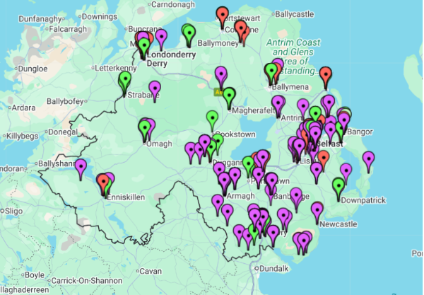
Figure 3.1. Geographical locations of Provisions across Northern Ireland.

3.7 Day Centres
As mentioned above, Day Centres are places for “assessment, rehabilitation and counselling” (Gov.uk, 2003, p.2), as well as administering general care. For this reason, these places are not considered relevant to the question of barriers and pathways for young people with SEN, as these centres, while carrying out crucial and life changing work, do not prepare or direct people into work or education. The issues of Day Centres are informative though in giving us a better picture of the overall offering available to young people with SEN in each area and across Northern Ireland and therefore will be discussed briefly.
RQIA, as the central regulating body of Day Centres, was able to provide a complete list of Day Centres across Northern Ireland (n=152). While many Day Centres were not labelled in relation to what demographics they provide care for, others state specifically what type of care they provide, whether it is specialising in dementia, substance dependencies or learning difficulties. In order to differentiate between services for young people with disabilities and other demographics, only Day Care centres labelled MP (mental disorder excluding learning disability or dementia), LD (learning disability), PH (physical disability other than sensory impairment) and SI (sensory impairment) were selected as suitable for the demographic of young people with SEN. In total there were 49 Day Centres that state they specialised in one or more of these areas, representing 32% of Day Centres overall.

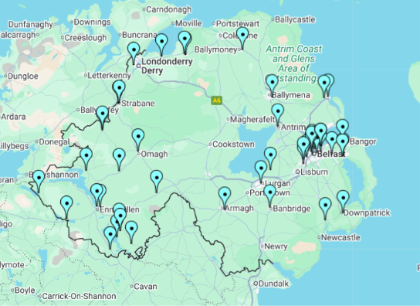
Figure 3.2. Map of Day Centres specialising in MP, LD, PH and SI.

Fig 2. shows the geographical spread of Day Centres specialising in MP, LD, PH and SI throughout Northern Ireland. While the spread of these Day Centres shows there is wide coverage across Northern Ireland, we can clearly point to areas that may have no Day Care settings appropriate for young people with disabilities such as Newry, Cookstown, Magherafelt and Ballycastle. However, it is important to keep in mind that 93 Day Centres (61%), have not included in the list which demographics they support or specialise in. It could therefore be assumed that some of these centres are providing care to young people with a disability (as only 7% of Day Centres state they do not serve this demographic), but this is not something that can be stated as a certainty. Fig. 3 below includes the Day Centres that have not stated the demographic they support or specialise in. We can see from this that there are in fact day centres in the areas noted before for an absence of centres and a much more even spread geographically across NI.

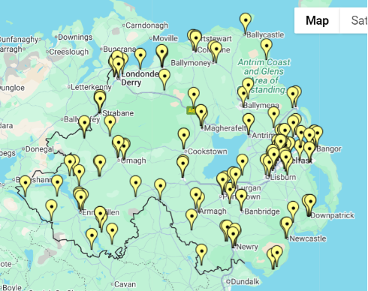
Figure 3.3. Map of Day Care Centres specialising in MP, LD, PH and SI, as well as Day Care Centres who have not declared a specialisation.

3.8 Discussion
The data collection process has highlighted a lack of centralised oversight in the area of post-19 SEN provision. Due to the lack of any centralised database, it is impossible to know the true nature and extent of provision across Northern Ireland. This in turn creates uncertainty when trying to measure provision versus population levels. In particular, it is very difficult to ascertain the number of Day Opportunities, and the diversity of offerings that Day Opportunity provides, creating difficulty in analysing the appropriateness of an area’s Day Opportunity provision in relation to the area’s SEN population. By contrast, the ease with which the RQIA was able to share a complete data set of Day Centres across Northern Ireland shows that this centralisation of provision is certainly possible. Social Enterprise NI (SENI) is another example of a centralised organisation, with around two-thirds of all Social Enterprises registered as members. ARC NI has made significant progress towards bringing different Day Opportunities together under their umbrella organisation, and this could prove a prudent starting point in any attempt to create a centralised data base of Day Opportunities across Northern Ireland.
Looking at the data collected, then, as a representation of the level of provision across Northern Ireland rather than an exact quantitative summary, it can be inferred that the level of provision for school leavers with SEN falls far short of meeting the current demand, with an average of 1 provision per 91 young people with SEN. This is especially true of Warrenpoint, Newtownabbey, Belfast, Antrim, Carrickfergus, Bangor, Ballyclare, Cookstown and Craigavon who have more than 91 people per provision. It can also be seen in the map that there are geographic areas across the north, east and southeast of Northern Ireland where the provisions are widely spaced suggesting it may be difficult for service users in these areas to find a provision that is accessible for them.
Overall, the lack of a centralised data base suggests that from policy level to the service user there is not a clear picture of what exists and where resources should be focused for greatest impact. The data that has been collected does suggest that areas with larger populations are struggling to provide enough provisions to meet demand. As well as this the east, and particularly the southeast of Northern Ireland, have large geographical gaps where there are no provisions, meaning young people with SEN may have a very long journey to avail of the nearest provision.

Chapter 4: Parents of Pupils Preparing to Transition from Special School

4.1 About You and Your Child
As conveyed in Table 4.1, there were n=39 responses to the ‘preparing to transition’ parental survey. 72% (n=28) of the respondents’ children preparing to transition were male, and 28% (n=11) were female. In addition, the mean age of the children was 17.03, with the most common age being 17 (33%, n=13). A small number of the children (13%, n=5) were aged 19, reflecting the fact that young people are entitled to remain in special education until the end of the school year following their 19th birthday (see context section above).

Table 4.1. What is your child’s gender, and what age is your child?
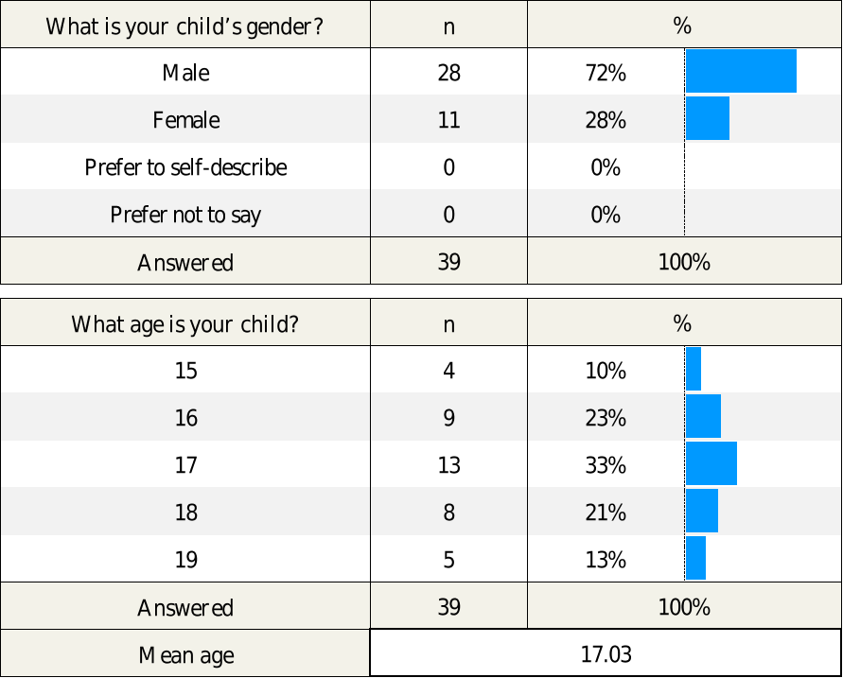

When parents in the survey sample were asked, ‘What is the nature of your child’s special educational needs or disability?’, the most common response was, ‘severe learning difficulty’ (59%, n=23), followed by, for example, ‘autism spectrum disorder’ (56%, n=22), moderate learning difficulty (38%, n=15) and speech, language or communication needs (38%, n=15). Only 13% (n=5) reported that their child had a physical disability while there were no children in the sample with a sensory impairment (see Table 4.2).

Table 4.2. What is the nature of your child’s special educational needs or disability? (Select all that apply)
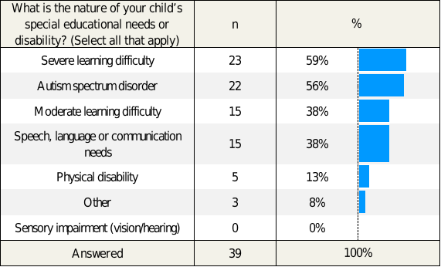

Furthermore, as shown in Table 4.3 below, the most common region where parents live was in the ‘Belfast EA Region’ (44%, n=17), and the most frequently reported Health and Social Care Trust that supported the family of the responding parents was also the ‘Belfast Trust’ (41%, n=16). There were very few respondents who lived in areas covered by the Northern and Western EA regions or the Northern and Western Health and Social Care Trusts.

Table 4.3. Which region do you live in, and which Health and Social Care Trust supports your family (if any)?
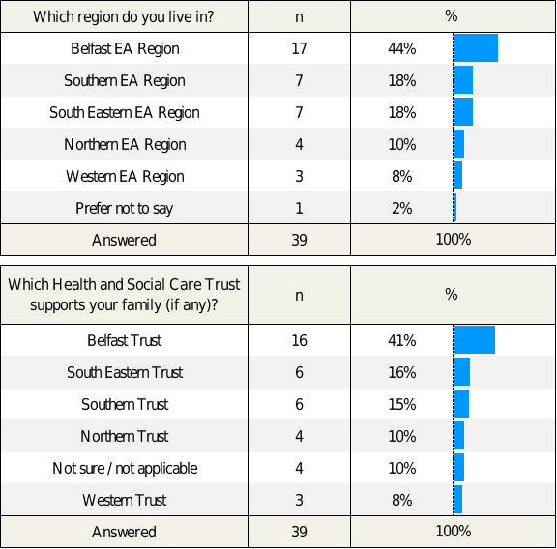

4.2 Preparing for Transition
As shown in Table 4.4, parents were asked, ‘How clear are your child’s post-school options?’, resulting in a mean score of 1.46 on a scale of 0 (not clear at all) to +3 (very clear). Most parents in fact responded that their child’s post-school options were either ‘somewhat clear’ or ‘not very clear’ (each option with 31%, n=12). Only 18% (n=7) felt that their options were ‘very clear’.
Likewise, parents were asked, ‘How supported do you feel by your child’s school in preparing for the transition?’, resulting in a mean score of 2.05 on a scale of 0 (not supported at all) to +3 (very well supported). Only a third of respondents (36%, n=14) felt that they were ‘very well supported’ by their child’s school in preparing for transition, while the most commonly reported option was that they felt ‘somewhat supported’ (41%, n=16). Just under a quarter of parents felt either ‘not very well supported’ (15%, n=6) or ‘not supported at all’ (8%, n=3).

Table 4.4. How clear are your child’s post-school options (e.g., training, employment, further study), and how supported do you feel by your child’s school in preparing for the transition?
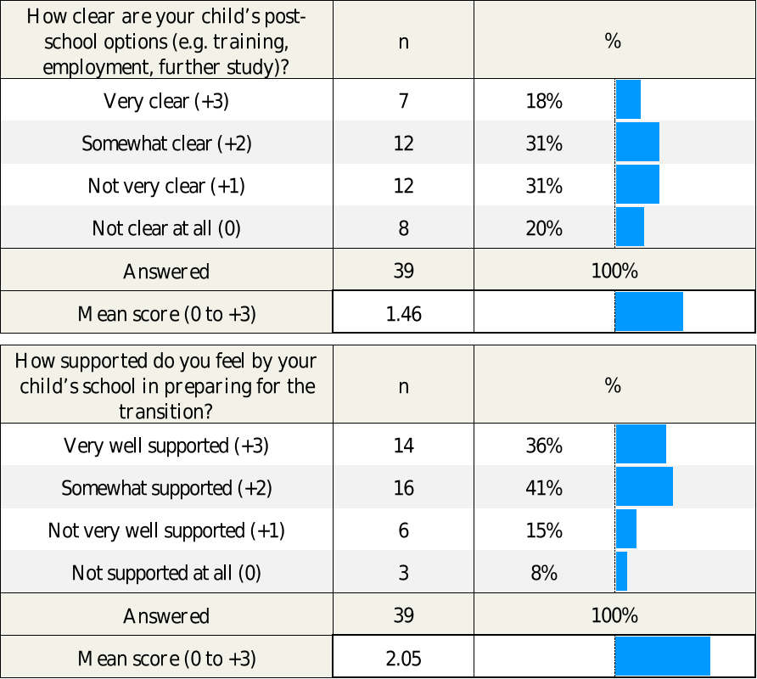

When parents were asked about what type of opportunities they believe are realistically available to their children after school (Table 4.5), there was a wide range of responses across the various options provided (parents could tick all responses that applied). Parents most commonly reported that they were ‘unsure’ (38%, n=15), potentially indicative of a lack of information, or of perceived barriers to accessing such opportunities. 36% (n=14) selected ‘day opportunity or training programme’, and 36% (n=14) also selected 'day centre’. A smaller number (15%, n=6) reported that ‘supported employment or work placement’ was a realistic option, while 4 parents (10%) suggested ‘volunteering’. Alarmingly, three of the parents (8%) reported that there were no options available to their child. Interestingly, only n=1 parent selected ‘paid employment’, highlighting that such opportunities are perceived as the least realistic immediate option across this sample of parents.

Table 4.5. What type of opportunities do you believe are realistically available to your child after school? (Tick all that apply)
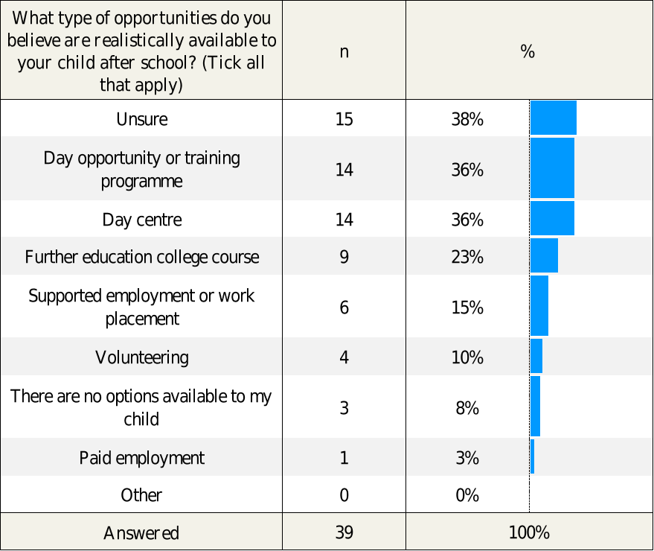

Parents were then asked, ‘How confident are you that your child’s next steps will be meaningful and suitable for their needs?’ (Table 4.6). This question resulted in a low mean score of 1.23 on a scale of 0 (not confident at all) to +3 (very confident). Just over half of respondents (51%, n=20) claimed that they were ‘not very confident’ and a further 18% (n=7) felt ‘not confident at all’ that their child’s next steps would be meaningful and suitable for their needs. By contrast, just one in five parents (21%, n=8) felt ‘somewhat confident’ and one in ten (10%, n=4) felt ‘very confident’.

Table 4.6. How confident are you that your child’s next steps will be meaningful and suitable for their needs?
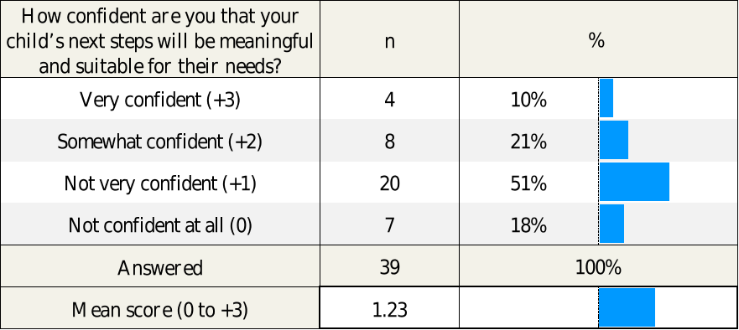

Parents were also asked, ‘How easy has it been to get information about transition options and support?’. The results, as displayed in (Table 4.7), highlight a wide spread of experiences across this sample of parents, resulting in a negligible negative mean score of -0.08 on a scale of -2 (very difficult) to +2 (very easy).
While a total of 16 parents (41%) felt that it was either ‘very easy’ (10%, n=4) or ‘quite easy’ (31%, n=12) to get information about transition options and support, the same number (41%, n=16) felt that it was either ‘quite difficult’ (23%, n=9) or ‘very difficult’ (18%, n=7). Alarmingly, 18% (n=7) had not received any information at all about transition options and support.

Table 4.7. How easy has it been to get information about transition options and support?
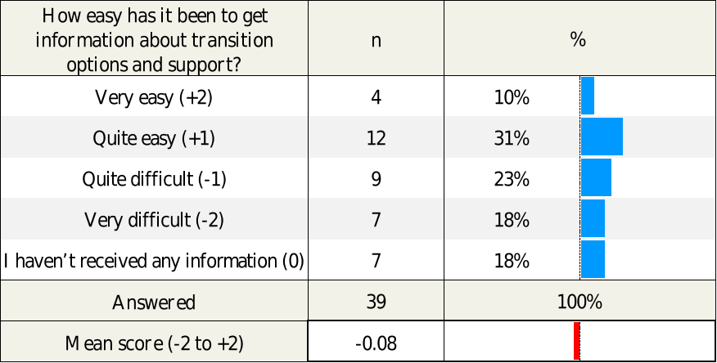

As conveyed in Table 4.8 below, parents were then asked, ‘What areas of support do you feel are most lacking?’. Again, there were a wide range of responses across the options provided, with ‘health and social care support after age 19’ (74%, n=29), ‘information and advice for parents’ (64%, n=25), and ‘transport’ (59%, n=23), reported as the top three areas of support that parents felt were most lacking. However, there were also high response rates for ‘suitable local training or education options’ (51%, n=20), ‘joined up planning between services’ (49%, n=19) and ‘work placement or employment opportunities’ (44%, n=17).

Table 4.8. What areas of support do you feel are most lacking? (Tick all that apply)
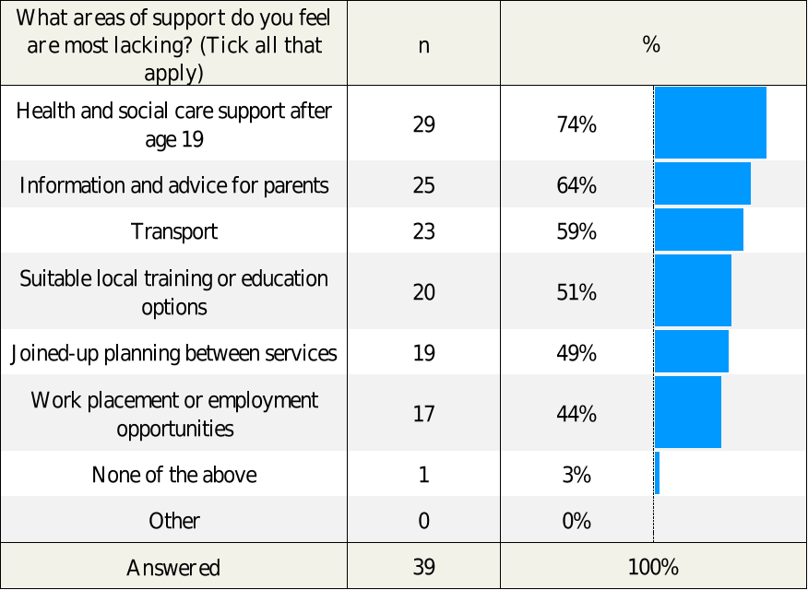

When the responses to these questions were analysed further, it can be seen that, although the number of responses was small, parents appeared least confident and found it hardest to access information when they lived in areas covered by the Southern and Western regions of the Education Authority or the Southern and Western Health and Social Care Trusts.
By contrast, parents appeared most confident and found it easiest to access information when they lived in areas covered by the Belfast and Northern regions of the Education Authority or the Belfast and Northern Health and Social Care Trusts. This would suggest that there is at least some regional variation in provision.
There were, however, no significant differences in confidence levels or in accessing information depending on the child’s type of disability.

4.3 Survey Open-Ended Responses: The Biggest Positive Difference to Transition?
Parents were given the opportunity to provide further information on what would make the biggest positive difference to transition, via a final open-ended survey question. As detailed in the following sub-sections, parents highlighted many of the prior established challenge areas (e.g., support and guidance, information and communication, transport, inequalities, early timing, tailored opportunities, and overall planning), whilst also providing further insight into how these challenges impact their children and the wider family.

4.3.1 Inadequate Transition Planning, Information and Communication
Many parents were concerned about the absence of a clear, timely and personalised transition plan from school to adult services. They also indicated a need for more centralised information and better communication.

"Current post-19 provision is wholly inadequate. There is no joined up thinking across Northern Ireland and no central information point for parents."

"Being given a clear pathway early on about what is available."

"A proper transition plan with plenty of information and good communication between school, home, and services."

"Better preparation a transition day."

"Early conversations are the key to a smooth transition being told your child’s options."

"Centralised information.”

"A co-ordinated approach across all trusts...”

"More information about prospects and options beyond next placement - ie long term plan, housing & work."

"More information on what is out there..."

4.3.2 Transport and Working Hours Barriers
Transport was consistently identified as a barrier to access for those over 19, which can have a significant impact on parents’ employment, due to challenges with working hours.

“Transport is another serious issue."

"Transport to their chosen facility."

"Transport is not available to those over 19 so parents have to change working hours..."

"Transport is another serious issue, schemes open to my son post school, do not pay a wage... there is no transport."

"Elimination of barriers e.g. transport, short and varied hours meaning parents can’t work or plan work..."

4.3.3 Support from Social Workers
Challenges with social work support were also highlighted, including mention of lengthy time periods without any social worker involvement or difficulty accessing a social worker in the first place.

"A Social Worker."

"More support from disability team."

"Support from social work."

"Haven't had a social worker for years. It's worrying and frustrating the lack of social work involvement."

“Structured support post school e.g. social worker / dedicated support worker who knows my child and their needs and the system."

4.3.4 Physical and Emotional Support and Guidance
Parents reported that they wanted their children to feel safe, valued and emotionally supported during and after the transition process.
"Support, guidance, reassurance, comfort and routine."

"My son is in a fantastic school where he feels valued, happy and supported."

"Being in the right environment for his needs."

"School provided a fun, safe space and catered for all his physical and emotional challenges."

4.3.5 Employment and Training that is Meaningful
Furthermore, parents strongly desired realistic, tailored pathways to employment or structured training to ensure purpose and routine, while they also wanted these to reflect the individual strengths and aspirations of their child.

"To have a supported training course and give him a meaningful purpose each day..."

"Clear options towards employment."

"I would like to see my child go into a training course."

"Safe meaningful opportunities that meet his needs and are realistic for his abilities..."

"Access to tailored, meaningful opportunities that reflect the young person’s strengths and aspirations..."

4.3.6. Inequality and Gaps in Provision
Parents also expressed frustration with the inequity and fragmentation in adult services.

"It’s a disgrace but nobody cares enough to do anything about it."

"Their special needs/disabilities are always going to remain, they do not vanish!"

"This must stop and must begin at transition stage and continue to remain supporting the disabled young people each step of their lives..."

"Discrimination for the less independent."

"I’m concerned about having to settle for non-optimal services..."

4.3.7. Importance of Starting Early
Many parents highlighted the need for early planning (including a person-centred approach), and gradual transition, rather than abrupt change.

"Starting early, like 1 day a month, then a week etc rather than just school stops and placement starts."

"Maybe attending college for one day a week before school finishes..."

"A strong, positive difference would come from a clearly mapped, person-centred transition plan that starts well before school ends..."

Chapter 5: Parents of Pupils Who Have Recently Transitioned from Special School

5.1 About You and Your Child
As conveyed in Table 5.1, there were n=21 responses to the ‘recently transitioned’ survey. 62% (n=13) of parents’ children were male, and 38% (n=8) were female. In addition, the mean age of the children, whose parents were completing the survey, was 20.38, with 19 the most common age (38%, n=8).

Table 5.1. What is your child’s gender, and what age is your child?
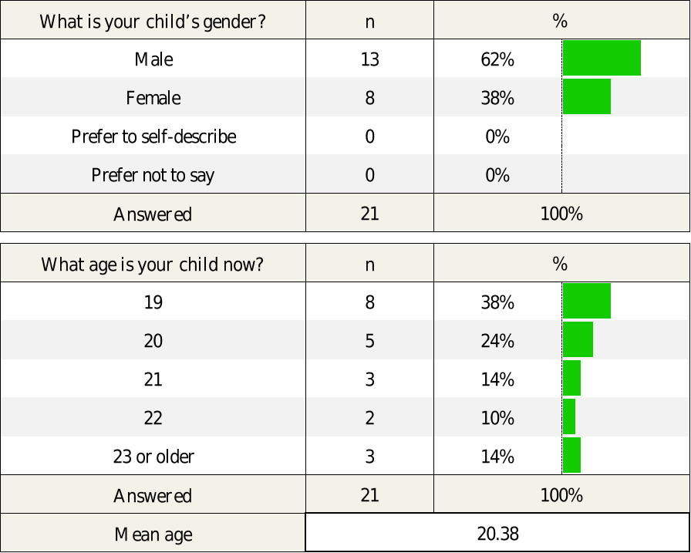

Parents in the survey sample were asked, ‘What is the nature of your child’s special educational needs or disability?’. The most common response was ‘severe learning difficulty’ (57%, n=12) followed by ‘autism spectrum disorder’ (48%, n=10) (see Table 5.2). There were also smaller percentages for other options provided, including, ‘moderate learning difficulty’ (29%, n=6), ‘speech, language or communication needs’ (29%, n=6), ‘physical disability’ (19%, n=4), and ‘sensory impairment (vision/hearing)’ (14%, n=3).

Table 5.2. What is the nature of your child’s special educational needs or disability? (Select all that apply)
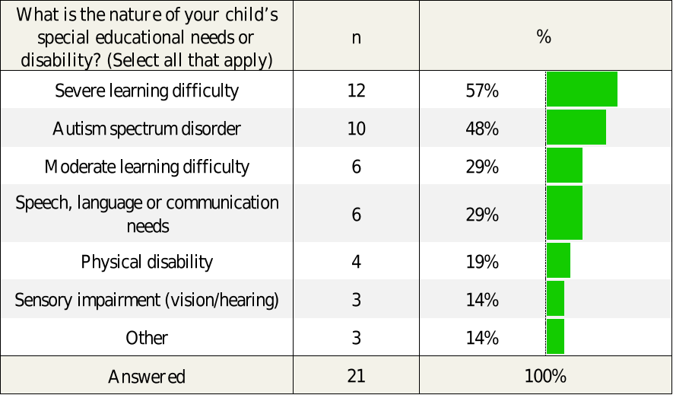
Furthermore, as shown in Table 5.3, the most common region where parents lived at the time of survey completion was the ‘Belfast EA Region’ (43%, n=9), and the most reported Health and Social Care Trust that supports the family of the responding parents was the ‘Belfast Trust’ (43%, n=9). There were very small percentages of parents living in the Western, Southern, and Northern Regions (all <14%). Similarly, there were small percentages of parents selecting the Western, Southern, and Northern Trusts as having supported their family (also, all <14%).
Table 5.3. Which region do you live in, and which Health and Social Care Trust supports your family (if any)?
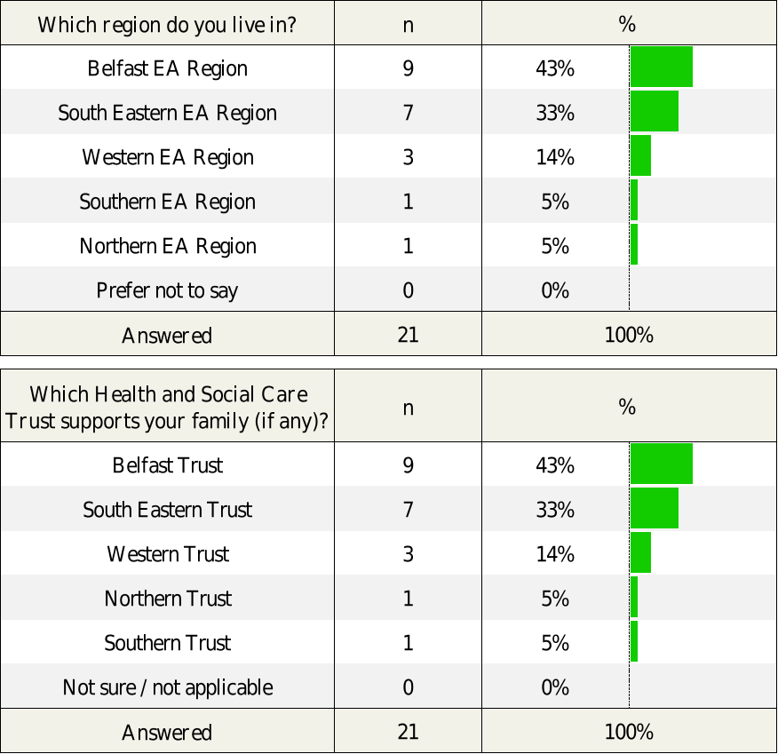

5.2 Experience After Leaving Special School
Most parents reported that their children were ‘attending a training programme or day opportunity’ (48%, n=10), ‘not currently in education, employment or training (NEET)’ (19%, n=4), or ‘in further education’ (9%, n=2), as shown in Table 5.4 below. The lowest proportion of responses from parents, was that their children were ‘in supported employment or internship’ (5%, n=1), or ‘in paid employment’ (0%, n=0). Thus, there were very few children stated as being in further education or supported employment, and none in volunteering or in paid employment.

Table 5.4. What is your child currently doing?
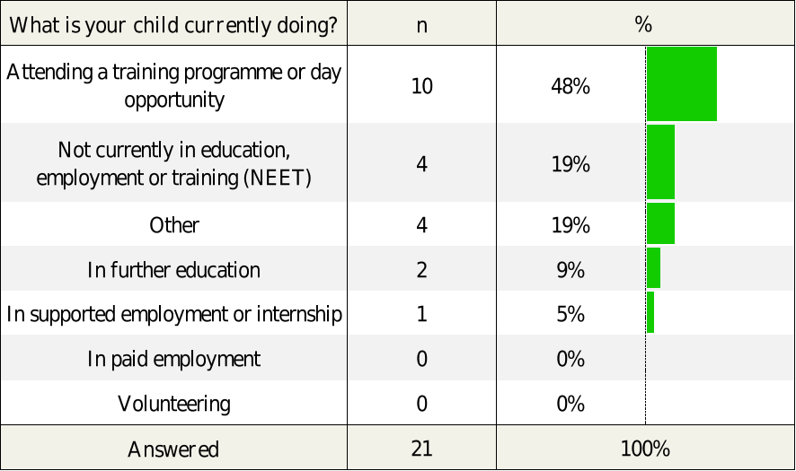

Parents were then asked, ‘How would you describe your child’s experience since leaving school?’ (Table 5.5). This question resulted in a negative mean score of -0.52 on a scale of -2 (very negative) to +2 (very positive). The most common response among the parents was ‘very negative’ (38%, n=8), with a further 14% (n=3) choosing ‘mostly negative’ (14%, n=3). Thus, when combined, it can be seen that a majority of the parents in this sample felt that their child’s experience since leaving school was either mostly or very negative (52%, n=11), while only 6 of the 23 parents (29%) reported that their child had either ‘very positive’ (10%, n=2) or ‘positive’ (19%, n=4) experiences.

Table 5.5. How would you describe your child’s experience since leaving school?
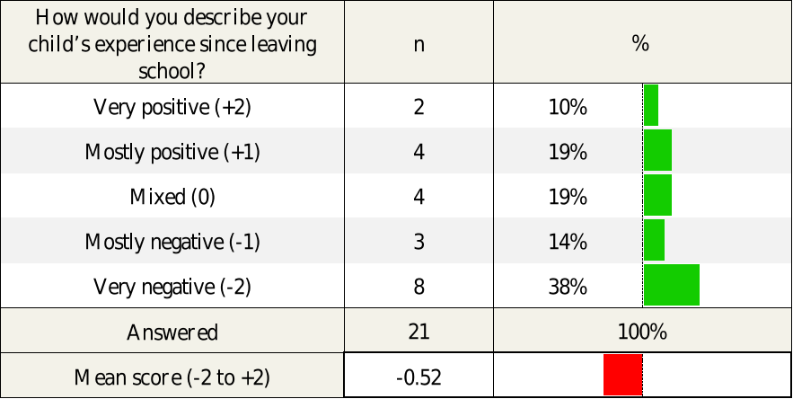

As shown in Table 5.6 below, parents were also asked, ‘How well did your child’s special school help to prepare your child for their next steps?’, resulting in a mean score of 1.14 on a scale of 0 (not at all) to +3 (very well). The most common response was in fact ‘not at all’ (43%, n=9). Once again, the parents’ responses were negatively skewed, with only 43% (n=9) reporting that their child’s school had helped to prepare their child either ‘very well’ (14%, n=3) or ‘fairly well’ (29%, n=6) for their next steps.
Likewise, parents were asked, ‘How would you rate the quality of support your child has received to date in their current setting?’, resulting in a mean score of 1.76 on a scale of 0 (none) to +4 (excellent). The most commonly reported option was ‘fair’ (33%, n=7). However, the ‘none’ and ‘poor’ response proportions combined accounted for 43% (n=9), compared with just 24% (n=5) when combining response proportions for ‘good’ and ‘excellent’

Table 5.6. How well did your child’s special school help to prepare your child for their next steps, and how would you rate the quality of support your child has received to date in their current setting?
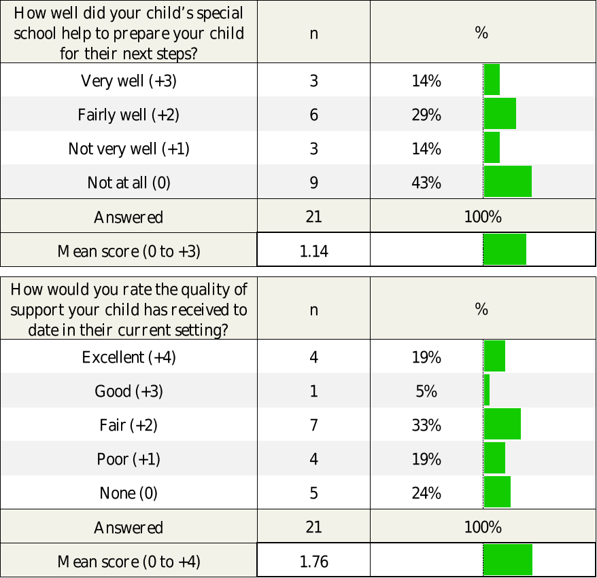

Parents were also asked, ‘What challenges has your child faced since leaving school, and what supports have made the biggest difference’. As conveyed in Table 5.7, a wide range of challenges were highlighted, with ‘poor transition planning’ (76%, n=16), ‘lack of suitable opportunities’ (71%, n=15), ‘lack of support from Health and Social Care’ (62%, n=13), and ‘limited transport’ (62%, n=13) emerging as the most commonly reported challenges. These were followed by ‘lack of support in training or work setting’ (48%, n=10), and ‘health or mental health issues’ (38%, n=8).

Table 5.7. What challenges has your child faced since leaving school, and what supports have made the biggest difference? (Tick all that apply)
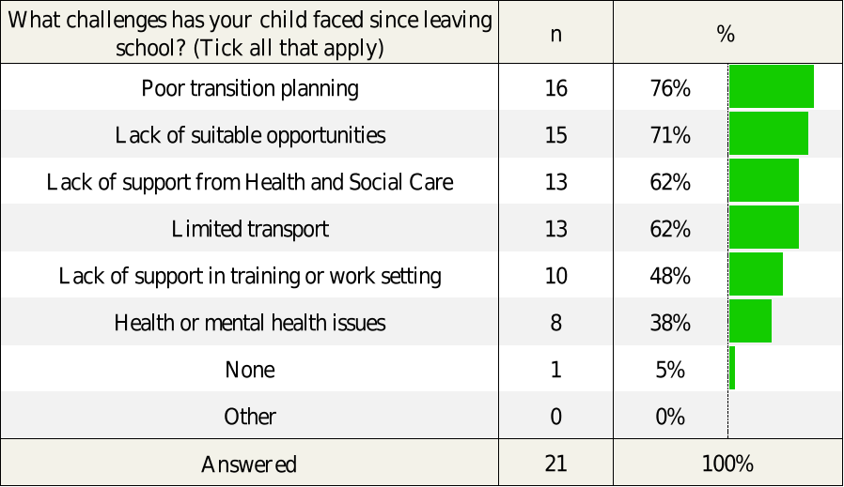
In addition, parents were asked, ‘What supports have made the biggest difference?’, with ‘strong family involvement’ (48%, n=10), the most commonly reported form of support (see Table 5.8 below). This was followed by, ‘skilled staff in training or employment setting’ (33%, n=7), ‘support from social worker’ (24%, n=5), ‘dedicated transition officer or coordinator’ (14%, n=3), ‘peer support or friendships’ (14%, n=3), and ‘good communication between services’ (10%, n=2). A third of the respondents (33%, n=7) selected the option ‘we received no support’, making this the joint second most common response among this cohort of parents.
Table 5.8. What supports have made the biggest difference? (Tick all that apply)
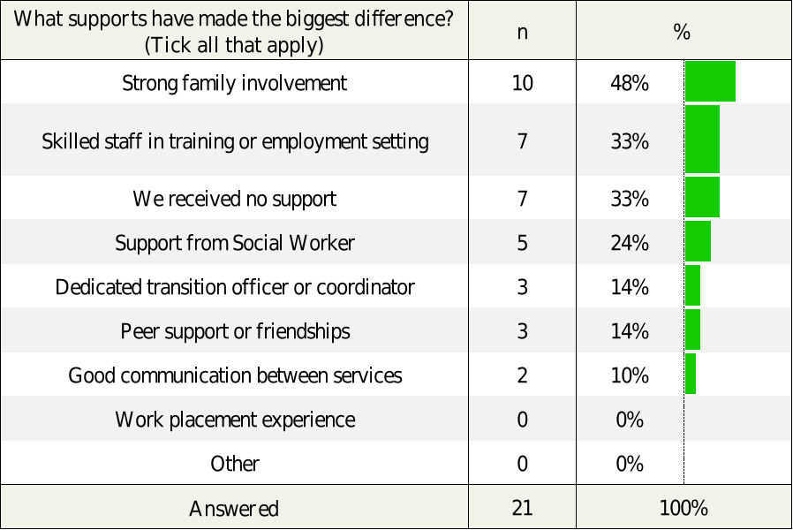
As highlighted in Table 5.9, when asked ‘Has your child experienced any delay in starting their post-19 placement?’, although a majority of the parents responded ‘no’ (57%, n=12), more than two in five (43%, n=9) said ‘yes’, indicating that there had been a delay in their child starting their post-school placement.

Table 5.9. Has your child experienced any delay in starting their post-19 placement?
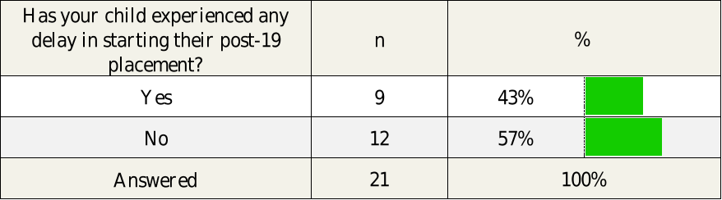
Furthermore, as shown in Table 5.10, when asked ‘Did your child start a post-19 placement that did not meet their needs?’, while the majority of the parents said ‘no’ (76%, n=16), a quarter of the parents (24%, n=6) responded ‘yes’, indicating that their child’s initial placement did not meet their needs.

Table 5.10. Did your child start a post-19 placement that did not meet their needs?
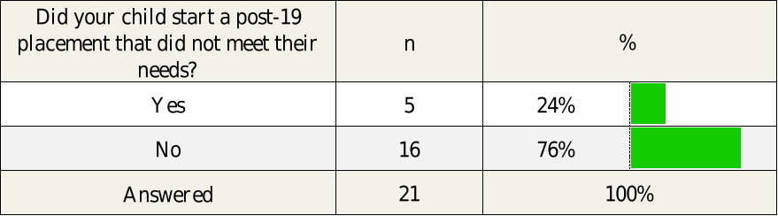

The parents who reported that their child had started a placement that did not meet their child’s needs were then asked to indicate the main reasons why the placement was unsuitable. Of those n=5 parents, the majority (60%, n=3) selected the option ‘the placement did not provide the right level of support’ for their child. This was followed by ‘the activities were not appropriate’ (40%, n=2), ‘there was a mismatch between what was promised and what was delivered’ (40%, n=2), ‘the staff lacked appropriate training or understanding of my child’s needs’ (20%, n=1), and ‘the environment was not suitable (e.g., too noisy, inaccessible) (20%, n=1). However, it must be noted that the sub-sample of 5 parents is extremely small.

Table 5.11. Since your child started a post-19 placement that did not meet their needs, what were the main reasons the placement was unsuitable? (Tick all that apply)
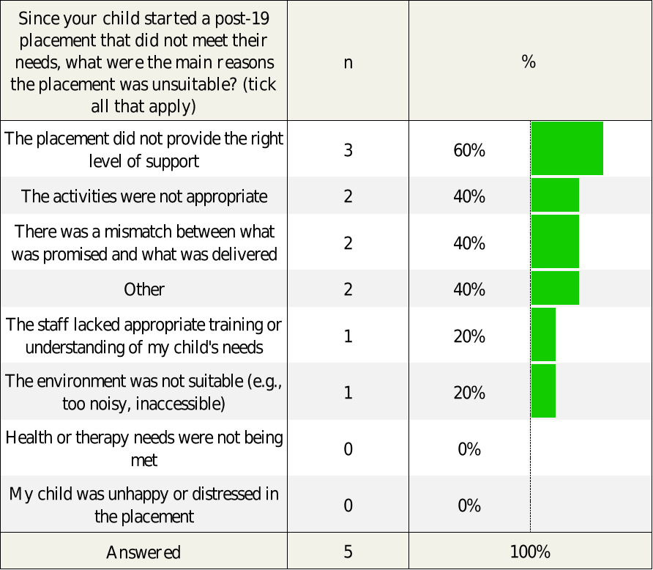

As with the survey of parents of young people preparing to transition from special schools, when the responses to these questions were analysed further, it can be seen that, although the number of responses was again very small, parental levels of satisfaction were highest in the Belfast and Northern Trust and EA regions and lowest in the Southern and Western Trust and EA regions. Despite this, almost half of the parents (44%, n=4/9) in the Belfast Trust and EA region reported significant delays in their child starting their first post-school placement.
With the small sample size, it cannot be concluded that there were any significant differences in post-school placement experience related to the young person’s type of disability.

5.3 Survey Open-Ended Responses: The Biggest Positive Difference to Transition?
Parents were given the opportunity to provide further information on what would make the biggest positive difference to transition, via a final open-ended survey question. As detailed in the following sub-sections, parents highlighted many of the previously established challenge areas (e.g., support and guidance, information and communication, transport, inequalities, early timing, tailored opportunities, and overall planning), whilst also providing further insight into how these challenges impact their children as well as the wider family.

5.3.1 Inadequate Transition Planning, Information and Communication
Parents highlighted the need for improved transition plans, ideally starting early and involving all relevant agencies. This included a need for better, timelier and coordinated communication of relevant information.
"Genuine transition planning. Assessment of their individual needs including support needs."

"A timeline from age 14 onwards defining steps that needed to be taken and completed so that there was appropriate planning."

"Proper transition planning in school. Staff within the school environment who were aware of transition planning."

"A plan that includes health, education and training and provision that is underpinned with legislation."

"A transition social worker and EA involvement! Basically left to me as a parent to research what was available..."

"Trust services are a disaster - no communication with parents, they don't reply to emails."

"If communication was delivered at a level without social worker and school repeatedly saying what about when something happens to you..."

5.3.2 Support from Social Workers
Social workers were reported to be either missing or inconsistently involved, causing parents to feel unsupported.

"Social services support. Information on local services."

"Only got a social worker in Jan and left in March then another one since March who has been fantastic."

"Having a social worker and better communication regarding transition through the school."

5.3.3 Access to Suitable, Tailored Opportunities Post-School
A further theme to emerge was the need for diverse, meaningful and tailored post-19 options rather than a one-size-fits-all approach.

"More opportunities appropriate to his abilities and which meet his support needs."

"More FE options and better support in FE."

"More challenging opportunities with appropriate support for those more able."

"Suitable places that she could go to that would prepare her for adult life."

"She is still protected. I know she’d love a chance to live in a halls type environment..."

5.3.4 Transport and Family Logistics
Several parents also added comments in relation to the need for transport provision for their child to attend placements and highlighted the impact that the lack of transport can have on families with other children and other responsibilities.

"Transport to be able to get to Belfast Met Titanic so he could do the course he wanted..."

"When they go to college, the fact there is no transport can be catastrophic."

"They don’t take in factors about family... I have a daughter with autism and can’t go in two opposite directions."

5.3.5 Emotional Support and Guidance
Some parents also stressed the importance of emotional support and guidance including with respect to pre-visits, getting to know people, and environment bridging, all of which would serve to prepare the young people emotionally for the school to placement transition.

"Pre visits."

"Knowing who they are going to be with."

"Confirmation sooner to give him time to get his head around it."

"Something to bridge the safe environment in school and the transition to the adult world."

5.3.6 Early Engagement on Needs and Supported Employment
A number of parents also referenced the importance of early engagement and discussion around supported employment and work readiness, especially for young people with specific needs.

"Engaging early to discuss Supported Employment opportunities."

"He could have been prepared for the workplace by knowing how to position himself..."

"Should he declare on application forms his visual impairment? Or should he wait until interview?"

5.3.7 Parental Burden and the Need to “Fight”
Parents reported feeling the burden of responsibility, with many reporting that they had had to fight for every opportunity for their child.

"Parent/carer having to 'fight' for placements/opportunities."

"Could have been very different if I hadn’t fought for his needs!"

"They don’t take in factors about family..."

Chapter 6: Qualitative Results

6. Qualitative Findings

6.1 Introduction
The findings presented in this chapter draw on the interviews and focus groups with 45 participants, including six parents of young people with SEN, fifteen young people, three school leaders, nine stakeholder representatives from across government, colleges, service providers, and support organisations, and a group interview with 12 members of the Association for Real Change (ARC NI) Northern Ireland, a membership organisation that supports people with learning disabilities, autism and other support needs.
Participants were asked about their lived experiences of the transition process, the perceived barriers experienced by young people, and their views on the opportunities and gaps within the current post-19 transition system. Across these diverse groups, a consistent picture emerged of a system struggling to meet expectations of continuity and support. Despite years of preparation within schools, families described a transition process in which the level of provision, planning and statutory responsibility drops sharply at age 19. Schools worked hard to prepare young people for adulthood, yet parents repeatedly reported that the support available after leaving school was fragmented, unclear and sometimes entirely absent.

“[Name of young person] did quite well in school… We started his transition process at the age of 15. So, for four years, they knew he was coming through the system. You would have thought that everything would have been in place and everything would have been organised and sorted out. But we have had a nightmare. There was no placement. There were no day opportunities. There’s nothing for him.” (Parent)
“I felt completely unsupported and alone. I felt that nobody cared.” (Parent)

Participants described the post-19 landscape as a “cliff edge,” where statutory duties end abruptly and young people are left without support for their next steps. Rather than entering adulthood with a clear plan, young people were often placed in whatever limited spaces happened to be available, regardless of their needs or aspirations.

“There’s nothing. There’s nothing out there. You're on your own, with your child forever in your house. We’re all prisoners.” (Parent)
“There’s a cliff edge, and there’s absolutely no laws to make anyone step in.” (Parent)
“No one is really properly looking at the individual. No one's looking and saying, actually, their needs are here, this is what they need. This is a detailed plan that will help get the right setting for them. No, what they're doing is, they're getting out of special school, and they're going, ‘What do we have available? We'll shove them in there.’” (Parent)

The young people interviewed articulated the emotional toll of this transition period. Some spoke of fear and reluctance as they prepared to leave a school environment that had met their needs well:
“I felt like I was at my lowest whenever I was in lower sixth, I was ready to leave, but at the same time I didn't want to leave, because it was just the perfect place for me and my physical needs.” (Young Person)

Across the interviews and focus groups, participants described the wide range of issues involved in the post-19 provisions currently available for young people in Northern Ireland with SEN. This chapter explores these findings in four linked themes: the siloed nature of the transition system; the insufficiency and instability of post-19 provision; the barriers that constrain access and aspiration; and participants’ views on what would be required to build a more robust post-19 system.

6.2 Siloed Transition System
The first key theme to emerge from the data concerns the structural organisation of the post-19 transition system. Participants consistently described a landscape characterised by fragmentation, limited coordination and the absence of clear responsibility across government departments.

6.2.1 Lack of Joined Up Working
Across almost all stakeholder groups there was a consistent perception that the responsibility for young people with special educational needs (SEN) after the age of 19 is fragmented. Departments, agencies and service providers were described as operating in ‘silos’, often resulting in young people being unable to access support. Participants called for a coordinated approach to provision, arguing that the current structure promotes bureaucratic separation rather than cooperation, thus creating inefficiency.

“The services aren't joined up.” (ARC NI Member)
“The system needs to change, and I guess that needs to come from policy. It’s Department of Education, Department for the Economy, Department for Health, and Department for Communities. They all need to work together.” (School Leader)
“If the Health Trust could have a bit more of a joined-up approach, have a bit more of an open communication for when that person transitions from childhood to adulthood … if you're looking at it from like, a health and wellbeing point of view, but also from the financial point of view, you know, it just makes sense to have that joined-up approach.” (Stakeholder)
“Some departments are reluctant to engage, despite our best efforts … I find sometimes there's a reluctance to engage with us, or even to try and get someone to work alongside, to try to see how we can work together through the process. I mean, it should be that when our jobs were set up, it was a joint venture between the departments.” (EA Official)

When describing their experiences of navigating the post-19 SEN transition with their child, parents highlighted the perceived lack of accountability across government departments.

“Not one department has taken responsibility for post-19 SEND and no one wants it. And I've met with every minister, more than once … You're ping ponging off departments. I've sat and I've been very blunt and said, “Who is responsible”? Then in my very first meeting, I got told “We don't know.” (Parent)
“None of the departments talk to each other.” (Parent)
“The Department of Economy have their own agenda. It's not our remit. Well, you know what? Whose remit is it? No one wants to figure it out.” (Parent)
“Education says, ‘It's not our remit’. If you're not on the learning disability register, Health won't take it. Economy? They don't do complex. Communities? They’re only benefits. So, who’s going to help?” (Parent)

A representative from the Department for the Economy confirmed the statutory boundaries between the different governmental departments, noting that funding routes and service eligibility are determined by the budget holders rather than by the needs of the young people.

“If I'm looking in in how government funds, special school leavers tended to be on one of two pathways; a Department for the Economy funded pathway, which was further education, skills training, that sort of direction, or a Department of Health funded pathway, which would have been through the Trust as a day care or a day opportunities provision … A lot of feedback from a lot of special schools have young people right on the cusp of that learning disability assessment who should be accessing day opportunities but can't, because somewhere somebody has assessed them as having a mild learning disability rather than a moderate … There seems to be this blurred group of young people who, all the experts around them would say, they need a learning disability and day opportunities type support, but they aren't getting it. And they're the ‘sink or swim’ category, who are not able to access FE College or training programmes.” (DfE Official)

From a policy perspective, the Equality Commission similarly recognised the limitations of the Children’s Services Cooperation Act (Northern Ireland) 2015, which ceases to apply at age 19 and has been weakly implemented.

“The Children's Services Cooperation Act places a legal duty on Departments to cooperate together in the interests of the child. And my understanding is that stops at the age of 19… We do see examples of where in education and health there is collaboration, whether it's on things like Sure Start, or early childhood interventions and stuff like that. I don't know whether there's scope to revise that legislation to extend the age that it would support young people, which would then encourage that kind of non-siloed working and more coordinated … I don't think that that there's many people within departments or ministers think that they shouldn't be collaborating together for the interest of children. But it’s, how do we actually turn that into a reality?” (Equality Commission Official)

Therefore, despite the Children’s Services Cooperation Act (Northern Ireland) 2015, many participants described a gap between legislative commitments and their lived experience of post-education transition. While officials acknowledge, in principle, the importance of cooperation, the testimonies of parents and practitioners suggest that this commitment does not translate into practice. Instead, young people continue to fall between departmental boundaries; as one parent summarised, the absence of meaningful interdepartmental collaboration creates a transition process defined more by barriers than by coordinated support.

“The government has to work in the best interests of children and young people, including when it means inter-governmental department collaboration, and that just isn't happening at the minute. It's, it's fraught with difficulty.” (Parent)

6.2.2 Confusing pathways and entry points
Participants described the transition landscape as complex and confusing. Rather than a single, coherent pathway into post-19 provision, young people and their families encounter a variety of eligibility rules, service criteria, and departmental thresholds that can make it challenging to access the support they require. Providers repeatedly emphasised that being “statemented” in school does not automatically open the door to post-school services; instead, eligibility frequently depends on an adult services learning disability assessment, the limited availability of funding streams, and the support of a social worker (once assigned).

“There are different entry points into different services and supports. So just because you're statemented in school doesn't mean that you will necessarily be able to avail of support.” (ARC NI Member)

For some families, the process of discerning which route they qualify for is a barrier in itself. Providers described young people who were excluded from a variety of opportunities due to a failure to meet rigid eligibility criteria.

“When they're actually leaving school, navigating that, ‘How do I get into your service?’ Because if I don't have a diagnosed learning disability, I don't qualify for day opportunities. If I don't fit the criteria of the employability programme that you're running at that point in time, I can't attend that programme. If I want to go to something else, like a programme funded by direct payments, I can’t access that if I don't have a social worker.” (ARC NI Member)

The process of acquiring a social worker, which was highlighted as essential for accessing health-based services, was frequently described as complex and slow. Participants emphasised that without a social worker, families were effectively unable to access a significant portion of post-19 provision, yet the process for securing one was unclear, very slow and often initiated too late.

“A lot of parents haven't realised that they need social workers in place, and that process itself is very stressful. It can take a lot of time so that can lead to that gap after leaving school.” (ARC NI Member)
“If they don't have a social worker involved, there's a whole process to try and get a social worker involved as well. So, they're navigating transition from school, they're navigating transition from children's to adult services. They're navigating their own self-transition in what they want to do, and they don't know what they want.” (ARC NI Member)
“We have parents come along to our options morning, and they speak to a lot of providers, and they think, ‘Oh yes, this is something’. And then they are coming up against this issue where they require a social worker to access some of the providers, and that has caused a lot of stress.” (School Leader)

One school leader suggested that special schools should employ a social worker to ensure young people are able to be supported through their transition.

“For special schools, if you can fund to have a social worker on site in your building, do it, because they will act as that person. They will liaise and advocate on behalf of staff, on behalf of pupils, on behalf of families. They can signpost, they understand the system, they can help you navigate it.” (School Leader)

Families also faced uncertainty about the practical implications of taking up provision. One recurring concern was how participation in day opportunities might affect household benefits, particularly in the current financial climate.

“Families are not aware about how their benefits are going to be affected if a young person will go to day opportunities. I think that also could be a little bit of a barrier, taking into account the financial climate. A lot of families are worried that, you know, they will lose some probably additional income to the household.” (ARC NI Member)

Participants highlighted the absence of a centralised, reliable information source, detailing a comprehensive overview of the options available to young people. As a result, families were reliant on informal networks to identify options available to them. Providers described using social media, school fairs, and word of mouth to advertise the services available.

“There is a massive issue around information and what their choices were, what their options were, what potential destinations looked like, what access to those … It's not straightforward, it's not, it's not easy to find, and inevitably, it's siloed.” (DfE Official)
“We would use a lot of social media. We would make sure to attend any school fairs as much as possible throughout the year… It's just getting that word out.” (Stakeholder)
“A lot of its word of mouth a lot of it is how these programmes are promoted … There's things out there, but for I suppose, people who don't work in the sector probably wouldn't know that these are available.” (Stakeholder)
“It almost feels like every family has to fight their own battle on this. There isn't really a clear pathway, a clear sort of centralised resource to give information … It really feels when you speak to parents, that navigating this is just incredibly difficult, and a lot of the information they get tends to come word of mouth from other parents who have already gone through it.” (Equality Commission Official)
“The Trust will not advertise private day opportunities because they say they’re not regulated. For now, I kind of get that to a point, but then parents have to find provision for themselves.” (Parent)
Both service providers and school leaders reported that the organisations who were responsible for supporting families to navigate this transition were unable to provide accurate information about available opportunities. As a result, service providers described being repeatedly asked to fill the information gaps.

“The Education Authority don’t know what [opportunities] are out there.” (ARC NI Member)
“We had a conversation last week with an EA advisor here in school … We were asking specifically, you know, how do we apply for funding? How do we plan ahead? And we were told, “Well, it's very, very difficult to do so”. So basically, it was put back on us, make it work, you know, you'll have to find a way.” (School Leader)
“The Education Authority don't provide advice … I was at an annual review recently, and the Transitions Officer is there, but they look at me for the answers.” (ARC NI Member)
“We're expected to provide answers about benefits, about schools, about employment, about services, about health care. That's the expectation that is set on us because there's nobody else to provide answers.” (ARC NI Member)

Several participants highlighted how the information families receive is often partial and shaped by organisational boundaries. Trusts, for example, were reported to signpost only the services they directly contract with, even when a broader set of options may be available through self-directed support.

“The other thing is the, you know, families have a right to a portfolio of choice, and so the only thing that Trusts will tell you is the services that they contract with, whereas there are other services, like, that may have contracts, but they might also be available to purchase through self-directed support. So, Trusts will never hand that information over to families.” (ARC NI Member)

Without a coordinated platform to bring providers together, schools described piecing together knowledge through chance conversations rather than through any systematic mechanism. This lack of structured information-sharing extended into statutory careers advice, with employers observing that even careers officers often lack sufficient awareness of the full range of available programmes.

“I wish there was something where you could go to, like a focal point of, of all of that information, because it's only through networking with other schools and chatting to colleagues in different places that we hear what’s out there … It's really through us just finding out ourselves.” (School Leader)
“I think careers officers should have more knowledge of programmes as well.” (Stakeholder)

The uncertainty surrounding post-19 pathways also influenced how families made decisions about their children’s futures. Departmental representatives noted that parents sometimes opted for what felt like the safest option, because other options lacked clarity or appeared too risky. In some cases, this meant steering young people toward daycare settings, because it appeared clearer or more reliable than other options.

“I talked to parents who were trying to steer their young people into daycare places because of fears that there's a lack of clarity about what the day ops would look like. I can get clarity on the daycare. I can get a bus for the daycare … Why would I push my young person into a college type placement, when the outcome two years from now is going to be the same, and two years from now, I won't have the network that I've got at the moment?” (DfE Official)

6.2.3 Regional inconsistencies
In addition to structural and informational barriers, participants highlighted significant inconsistencies across geographical regions, meaning that a young person’s access to support often depended more on their location than on their needs. Rather than a uniform system, families encounter a transition landscape shaped heavily by policies, staffing and funding decisions, resulting in markedly different experiences depending on where they live. Providers described how Trust boundaries create distinct systems, processes and referral pathways, making support inconsistent and difficult to navigate, especially for families who move between Trust areas.

“It would be helpful if there's consistency across the Trusts. If you can get your head around one Trust, as a parent or a child, say, in the Belfast Trust, and moving into the South Eastern Trust, they operate completely differently. So, you can get your head around one set of services and how the referrals are done, and then you move into a different Trust area, and it's just thrown out of the water.” (ARC NI Member)
“It's a postcode lottery. If the funding isn’t in that Trust area, we can’t offer our services. But just because the money's not there to fund these services doesn't mean that there aren't people with a learning disability, or any other form of disability, living in that area.” (Stakeholder)

These disparities also extended to social work involvement and continuity. School leaders described differences between Trusts in how long a young person retains their children’s social worker and how well transitions are managed.

“The pupils who fall within the Belfast Trust, they keep their children's social worker up until the age of 18, and then on the very day of their 18th birthday, they are discharged, and they get an adult social worker, who don't know the families, who don't know the children … The South Eastern Trust is very different, and a model that we much prefer, in that the children keep their social worker so they are constant right through until the change has happened. So, if a social worker has been involved, then they carry right through till the young person has transitioned.” (School Leader)

Parents similarly reflected on how heavily outcomes depend on where a young person lives, as well as on the individual capacity and influence of their assigned social worker. Some expressed frustration that the support available differed depending on factors beyond the families’ control:

“It all depends on where you live. It depends largely on how good your social worker is, it depends how sympathetic your social worker is, how well respected your social worker is, because the social workers can pitch for funding, and I mean, that's just an outrageous system to be part of.” (Parent)

Service providers noted that regional differences were often driven by funding pressures. Rural areas in particular faced reduced provision due to the financial impracticality of delivering specialised services across large distances.

“Regional discrepancies are down to funding and the demand. Think about rural areas, for example. It’s hard for people to have to travel into a central location, and then for us to employ maybe two or three employment support officers down there … It wouldn’t make financial sense for us.” (Stakeholder)
“There is a disparity between geographical areas, because at one point in time, some areas look like they had much more than others.” (EA Official)

6.3 Insufficient Provision
The second theme relates to the inadequate provision available for young people with SEN. Participants emphasised that even when families manage to navigate the system, the provision available is often insufficient or inappropriate to meet young people’s needs. This means that families are left with limited or non-existent options.

6.3.1 Insufficient or inappropriate provision
At a system level, respondents highlighted both a lack of places and a lack of meaningful choice. Participants observed that young people struggle not only to understand what is available, but also to secure places on the limited courses that do exist.

“We hear a lot of young people who are struggling with that transition, and both in terms of knowing what's available… and just a lack of availability. Not enough numbers of places and specific courses not being sufficient.” (Equality Commission Official)
“There’s a capacity issue, for sure. There has not been enough places on any pathway. There's insufficient spaces.” (DfE Official)

Families and providers echoed this sentiment, describing local information events that presented limited realistic options for the young people involved.

“I don't want to be overly critical of the system, but pretty much nothing at that open night was suitable.” (Parent)
“There was a very, very little choices for me.” (Young Person)
“We have, you know, many, many instances of young people leaving special schools who have no choice other than to go to [Further Education College], which isn't right for everyone.” (ARC NI Member)
“I think for anybody who's leaving school, there’s not enough post 16 providers out there … It's nowhere near sufficient, and the people are getting lost.” (Stakeholder)
“The Trust make it sound like there’s a lot of provision available, but as you start ringing, they say, sorry, we’re full up, or sorry, we don’t have your requirements, sorry we don’t have wheelchair access. And your list gets smaller and smaller.” (Parent)
“In our Trust. It’s awful. They hand you a leaflet. Here's the provision. And as I was going through them, and I knew straight away, the first place didn’t have places. The second place isn’t suitable. The third place isn’t a five-day provision. The fourth place doesn’t have spaces. The fifth place isn’t a five-day provision.” (Parent)

In addition to limited capacity and unsuitable settings, participants emphasised that young people with more complex needs faced some of the most significant barriers. Families described a pattern in which provision was more plentiful for those with mild or moderate learning disabilities, while those with higher support needs were systematically excluded from available opportunities.

“I feel that if you've got mild or moderate learning disability, that there's lots of things thrown at you, and you can do this, and let's go to this day opportunity. I think once you’re considered severe, it's ‘sorry we can't meet your needs’, and they close the door on you.” (Parent)
“If your young person has complex needs, it doesn't matter what part of Northern Ireland you're in, we're all suffering the same way. For complex needs, there's just very, very little provision.” (Parent)

Stakeholders observed that the comprehensive level of support within special schools can inadvertently increase the contrast young people face when they leave education. With full school days, reliable transport, and extensive wraparound provision, school environments offer a level of structure and support that adult services are rarely able to replicate.

“A lot of schools are too good… And then the kids are kind of wrapped in cotton wool … their stressors are exacerbated because they haven't had that ability to take ownership of stuff.” (EA Official)
“Sometimes schools are the victim of our own success… Whenever you leave that school, it is nothing like what you had.” (EA Official)

Parents expressed frustration that their expectations regarding their child’s progression after school did not align with the reality they faced post-transition. Even when parents engaged proactively with schools or providers to identify appropriate options, the outcome was often disappointing.

“We had always thought that he would go to tech, and the techs have stopped taking them. And I just think, why is that? Why have they stopped taking children with learning disabilities? It's outrageous… I’m frustrated about that, because I feel that that was just pulled away from us, without anybody ever explaining.” (Parent)
“We sat for an hour and went through every sort of job that [young person] would be quite interested in doing, and after a full hour-long session, and then about six weeks of placement, they came back and said we weren't able to find anything.” (Parent)

If families are able to secure a place, the quality and appropriateness of provision is not guaranteed. The young people interviewed described programmes that were academically undemanding and poorly matched to their level.

“I think the work level here needs upped a bit. The staff are lovely… But the work is a bit too easy for me.” (Young Person)
“I tried [day opportunity] … it just wasn't really my thing. It wasn't really the place I would have thought it was, and then, and I just didn't really settle in very well.” (Young Person)

The unsuitability of some settings offered to young people was echoed across the stakeholder groups. Many described day centres where the age mix, medical needs and behavioural profiles were profoundly mismatched, creating settings that at times felt unsafe, unstimulating or even distressing for young people just leaving school.

“My son did [day opportunity] and that didn't go well… There were people up to age 70 there… I forgot to give him his bag one day, and I drove down and had to go into one of the sessions, and he just looked completely bored. He was just sitting, you know, with his head down. And that was a wee bit upsetting for me.” (Parent)
“My friend went to visit a Day Centre. She said, 80-year-olds on Zimmer frames with her daughter. That is not going to cut it. She would knock them clean off their feet, not meaning to. My friend said she came out and she was actually she said she vomited when she came out of visiting a couple of them. Because she said, if this is the provision, it's very, very, it's very hurtful.” (Parent)
“The current day centre model is not safe for our young people. We need it for 19- 25-year-olds, and we need to make it more stimulating for them, so they're not staring into space or watching a TV. Because that’s what's happening.” (Parent)
“Something we heard a lot of by parents was concern about young people being put into adult care services but then being cared for with adults who are significantly older and might have different medical or cognitive needs and challenges, and that just not really being an appropriate setting for their young people.” (Equality Commission Official)

Others highlighted that these unsuitable placements were not chosen but forced upon families by a lack of viable alternatives. Parents described situations where, despite serious concerns, they felt they had “no option” but to try placements that were clearly misaligned to a young person’s needs, sometimes causing significant distress or trauma.

“The principal [of our special school] said to me, ‘This is the first year I've had to look at day centres. And I know that when our young post 19 leave here, I'm probably putting them in places that don't suit them, because there aren't enough spaces’.” (Parent)
“[Young person] was having a trial in a place last year. He lasted two mornings, and he phoned me and told me to bring him home and not to bring him back. And that was just two mornings, because it was older clients there as well, and just one room, and there was maybe 25 of them in one room, and it was never going to work but I felt that there was no option. I thought I had to try it and the amount of trauma and stress that that caused for us was unbelievable.” (Parent)
“My husband and I went around and looked at whatever was available, and some of the day centres just weren’t safe. She is a young, vulnerable, 19-year-old girl, and they want me to leave her alone in a room with these fully grown adult men?” (Parent)
“They want me to put [child] into a day centre. Our local day centre is absolutely full to capacity, with a three-to-four-year wait. Some adults have been in that centre, and they've been in the same room in that centre for up to 27 years. I don't think we could keep my child in that room for 27 minutes.” (Parent)

Other parents shared accounts of young people repeating the same programme multiple times because there were no progression routes available.

“My daughter has done the same course four years in a row, because there's nothing else for her to study. She has no way of accessing anything further. And we just do it because she'd be sitting at home otherwise.” (Parent)
“[Young person] was in the same placement for the last couple of years, but now it’s ended, he has nothing. It’s very frustrating.” (Parent)

One parent described how the absence of appropriate provision resulted in a young person being steered towards a highly inappropriate solution, because their family could not access suitable residential care.

“There’s a girl who is was in a special school. Her mum couldn't manage her. She wouldn't go to school, and in the end, she lashed out at her mum, and the police came and she said, ‘I need you to help me’. And they said, okay, no residential care would take her. No one stepped in, and you know what their advice was? ‘Oh, put her in Hydebank … They’re actually putting young people into prisons, instead of residential care.” (Parent)

The scarcity and inflexibility of provisions has also had profound consequences for families’ economic security and wellbeing. Several participants described how the lack of full-time opportunities forced parents to leave employment in order to provide support.

“Parents are often faced with, when their son or daughter is leaving school, whether that's at 16 or 19, ‘Who is going to maybe have to give up work to stay at home?’ Because packages are not five days.” (ARC NI Member)
“There are carers with PhDs, university degrees, meaningful careers, and they are having to leave their work go on benefits, so they can be at home for 24 hours a day to care for their young people, who cannot access any provision.” (Parent)
“Very few provisions are five-day, so you end up going to 50 different places, and there’s no transport provided, and they start at 10 and finish at 3. Now you tell me, what employer is going to say, that’s grand, you just head on at 3. So, parents leave their jobs, because they can’t do it.” (Parent)
“If you’re lucky, you might get a space with a provider that’ll take you one day per week, from 10 until 2. And they say that’s provision. Are you actually kidding me?” (Parent)
“The social worker made it feel like I was asking for a million pounds. It was so stressful, and it was like pulling teeth. ‘We might be able to get you another day, or we got you a day, or we couldn't get two days’. And you know, it just makes you feel, like you're asking for the world, that you're asking for something you're not entitled to. You're asking for something that you don't deserve.” (Parent)

Yet, despite concerns about insufficiency and mismatch, one parent reported a strong, well-matched placement for their child. After attending a school-organised information session, the parent quickly realised that none of the preferred options were available. The young person initially began attending a Day Centre, but this proved unsuitable due to a significant age gap between participants. Following further exploration, the school and parent worked together to identify another day opportunities provider able to offer a full five-day programme. The young person, interviewed separately for this research, described how much they were enjoying the placement. This isolated positive experience illustrates what is possible when provision is both appropriate and accessible.

“We have been very lucky. And I think, when you realise the system has lots of difficulties in it, then when it does go well and you do get a placement that you're happy with, you feel very grateful. And that's certainly how we feel.” (Parent)

6.3.2 Funding instability
Provision gaps were exacerbated by unstable and short-term funding arrangements across the voluntary and community sector. Participants described a system in which services rely heavily on short-term or unpredictable funding streams, creating instability for both staff and young people.

“A lot of the provision post-19, comes from the voluntary sector that relies so much on funding … And that has been really difficult. I think some people have got into these opportunities, and then funding has been pulled, and then that causes a big problem, then they're out, and then getting them back into somewhere else.” (School Leader)
“We don’t know if the funding’s going to be there next year. It's really hard for planning, and it's also a lot of stress on our employees, as in our employment support officers, because it's like, well, ‘Am I going to have a job come the first of April? What's going to happen to my clients that I support?’” (Stakeholder)

This instability not only disrupts provision but also shapes how services are publicly perceived. One participant noted that uncertainty around available placements can give the impression that services do not exist, when in reality it is more about the lack of investment needed to sustain and expand provision that is already in place.

“Everything is very negative in the media with regards to the services that are out there, and, you know, or lack of services. And as we were discussing, there is a lot of services out there that help these young people. Sometimes it can be like a slap in the face to those services who are actually out there doing the work whenever there's so much negativity around parents thinking that there is nothing for their young people. But I think one of the problems with that is it's not that there's a lack of services. I think it's the lack of funding and expansion for current services that are out there at the moment.” (EA Official)

Providers also expressed concern about the perception that voluntary or charitable organisations should operate at little to no cost, noting that this creates unrealistic expectations and further undermines financial sustainability.

“There just needs to be a bit of mutual respect. Just because we're charitable doesn't mean for free. And some of that undertone runs through many conversations that are out there, regardless of which department.” (ARC NI Member)

6.3.3 Workforce Shortages
Alongside the lack of places and unstable funding, participants stressed that even where provision does exist, workforce shortages significantly restrict young people’s access to meaningful opportunities. Workforce shortages across the education, health and community sectors significantly limit the opportunities available to young people with SEN as they approach transition from school education. In some cases, limited staffing meant that GCSE-level classes could not be offered, meaning that even learners who were academically capable of completing qualifications were denied the opportunity to do so. This had a knock-on effect on their post-school options, since some further education pathways require GCSE entry criteria.

“Special schools can only cater for as much as they can cater for because they don't have the staffing. So, when you have more complex young people in a school, unless you have a big cohort of young people who can access, who are capable of GCSEs, then what happens is they don't offer it to anyone … So, some of the young people in that school might be capable of doing GCSEs, but they aren’t given the option.” (Parent)

Staffing shortages also reduced the range of experiences schools could offer, particularly in relation to external work placements. Workforce constraints, particularly the need for classroom assistants to accompany those with medical or safety plans, meant these opportunities were difficult to facilitate.

“I guess the challenge for us is, that the profile of our children and young people, has changed so much, that seeking external work placements has become more and more challenging … We just don't have the staff to be able to send young people with epilepsy plans and requiring rescue medicine in an external work placement, along with a classroom assistant … They're the young people who would really thrive in a work placement, but just because of their medical needs, we can't send them out.” (School Leader)

Limited staffing across voluntary and community-based services also restricted the suitability of many post-school options. Several participants noted that while charities and day opportunity providers offer valuable support, they often lack the capacity to accommodate young people who require one-to-one assistance. As a result, those with higher support needs are effectively excluded from settings that might otherwise be appropriate for them.

“You've got wonderful charities out there, but there's limited options if they need a one on one, most charities can't provide that.” (Parent)
“The problem is that a lot of our young people could access the day opportunities, but they need a one on one. So, if you need a one on one, then you are out of that day opportunities. You can't have a one on one because you can't receive double funding through the Trust.” (Parent)

These shortages extended beyond education. One parent noted the scale of pressure placed on individual Education Authority transition officers, raising concerns about how effectively families could be supported in navigating complex post-19 pathways.

“The Careers Service did have a large turnover of staff and had to have a recruitment, we ourselves experienced a period of time where there were vacant posts for quite a considerable period of time.” (EA Official)
“There are currently 9000 young people transitioning out of schools, and they have one transition officer in EA for every 900 people.” (Parent)

6.3.4 Inconsistent transition planning
Participants described significant inconsistencies in how and when transition planning begins for young people with SEN. Several parents noted that, despite formal expectations, meaningful transition planning often did not begin until young people were approaching the end of their school career.

“Transition, I think they're supposed to start it when they're 15, but, you know, in terms of the Education Authority, but that was not our experience. It did not start at 15. It really started post-18.” (Parent)
“My son goes to a good Special School, and he's turning 14 soon … We have had absolutely no communication about planning for transitions. I would suspect that 14 will come and go, and that any information we find out about transitions will not come from the school.” (ARC NI Member)

One contributing factor to these delays was capacity. One departmental official reported that overstretched services were unable to begin transition planning at the recommended age, and so had to prioritise young people who were closer to leaving age.

“We don't have the capacity to get involved with somebody at 14,15,16, whenever we are so stretched. Our priority is the people in the final year, or the final 18 months.” (DfE Official)
However, stakeholders emphasised that even when transition planning begins early, the instability of post-19 provision means that the plans made might have little resemblance to the opportunities which are actually available when the young person is ready to leave school.

“The transition team come in and meet parents at year 10, just to make them aware of the process and what a transition plan looks like. But the reality on the ground, is that it's a piece of paper at 14, and that nothing really happens. I do think it would make more sense to start a little bit later … because actually what is available now will have changed dramatically by the time the child is 19.” (School Leader)
“Parents get really frustrated that nobody seems to know what direction they should be going in. And the school are saying at 15, we don't know yet, they're right in the middle of the hormone bomb. They're developing, they're maturing. And actually, at 17, their path might look quite different from what we would have opted for at 14. So, at 14 we can’t say what would be best.” (DfE Official)

6.4 Barriers to Access
Alongside the challenges of the siloed transition system and limited or inappropriate provision, participants described a range of barriers that prevented young people with SEN from fully accessing the opportunities available to them after leaving school. These barriers operated not only at the level of physical accessibility or service design, but also influenced the ambitions that young people and their families felt able to hold for the future.

6.4.1 Barriers to Accessibility
Stakeholders stressed that many young people with SEN face substantial barriers to physically, practically and structurally accessing the opportunities available to them. These barriers operated at multiple levels, including employer practices, lack of available transport and the design of buildings. For example, providers described significant physical barriers, meaning that young people were excluded from programmes due to insufficient accommodation adjustments or a lack of transport.

“There’s a young person who visited so many programmes. One couldn't fit his power wheelchair into the bathroom, the other had a lift that wouldn’t accept the weight of his wheelchair. The third one was on the other side of Belfast … In the end he had to choose online learning. We have this horrible situation where he's been excluded basically from education and training and a career because there is no physical facilities … He is trapped because the Trust can't fund, or won't fund the transport for him to get across town.” (ARC NI Member)
“I know a young lad who's got into Queen's, but he can't get there because there's no accessible taxi available for him to get. He's had to defer his place this year. And he's worked hard, got excellent grades, in his A Levels, for what? For nothing.” (ARC NI Member)

Some of the young people interviewed shared their own experiences of being unable to access certain provisions because of accessibility barriers.

“I was worried constantly about leaving school … I went and looked at three different, four different places. The other three didn't suit me, because there was no lift. It was just all stairs but the classes were upstairs, and that I cannot manage at all. Here was the only place, really.” (Young Person)
“I looked at multiple places, even stuff like accessibility, like automatic doors and stuff like that. I've looked at other places where buttons to open doors be, inaccessible. I would have often been late to class, had I went there and there wasn't very much help.” (Young Person)

Parents also raised concerns that the entry criteria for some post-19 provisions excluded the majority of special-school leavers, which effectively closed off certain progression routes.

“The Department [for the Economy] is catering very much towards the assumption that our young people coming out of special school can access all these avenues. The reality is what they've put in place and what they've offered, very, very few from special school can access any of that. So, it's pointless.” (Parent)
“Our children leaving special schools cannot access the qualifications that are on offer, because they don't have entry level qualifications. So, they're leaving special school, they don't get GCSEs, they don't do entry level requirements, so all those options are going out the window.” (Parent)
“I loved hearing about the Trinity project you did at Stranmillis, but then my heart sank when I heard what you needed to get on the programme. That’s not for our kids. Our kids won’t have the criteria to access that. So that’s them written off, because they haven't done formal qualifications … And you have to have a benchmark. I totally understand that. But it's not really understood out there in society that the benchmark is not being hit by probably 99% of the young people in special school.” (Parent)

Similarly, participants reported that some post-19 opportunities, particularly those in the workplace, were not structured to make the necessary allowances for young people with SEN.

“With some employers there is still that stigma around, like, employing people with disabilities … We would do a lot, a lot of work with employers around, like inclusion and like, removing barriers and the benefits of reasonable adjustments. But, you know, sometimes you can talk about it, you know, for ages with an employer you know, you can try your hardest, but some people just aren't ready to reduce their barriers.” (Stakeholder)
“You have to be ready and be prepared for people coming in with a disability, and you have to make allowances, a lot of places don’t.” (Parent)
“I spoke to a parent who didn’t think their son was going to sustain his placement. The parent said that the business itself wasn't set up to allow the parents to advocate on behalf of their young person, so the business wouldn't liaise with the parent. They wouldn't let the father or the mother advocate for their child.” (School Leader)
Despite these challenges, one parent described an instance where perseverance and sustained advocacy eventually led to adjustments being made, enabling their young person to secure a permanent employed position.

“He was five years voluntary in the organisation and then he applied for a job there, but he didn't get it … We got advice from Disability Action, and then we talked to [name of employer], and we talked to, we did quite a lot of background work, and then eventually they changed their interview policy … They gave him a practical interview and asked him questions as he was doing it, and because he had been doing the job, he was able to do it and he’s in a permanent job now. It’s a paid job.” (Parent)

6.4.2 Barriers to Aspiration
Another recurring theme was the way systemic barriers dampened young people’s aspirations. Providers expressed concern that raising young people’s hopes for the future could feel irresponsible when the opportunities to fulfil those ambitions were so limited.

“I'm just aware we might be building up expectations for people. Tell them, yes, we can give you the training, we can give you the job skills, and they go out of the job market, and there's nothing there … I would feel terrible to think that we're building people up and telling them, yes, we're going to make you employable, and then there's just no opportunity.” (ARC NI Member)

Parents and representative bodies similarly described how repeatedly encountering barriers at multiple stages of a young person’s educational journey eroded their confidence and hope in the future.

“There’s a lack of information, lack of availability, and I guess on a more emotive level, just like a lack of hope, optimism? Like a sense that that their young people are going to be taken care of and are going to be okay. I don't think that there's that confidence at all, because parents and young people have been let down, not just at this point of their of their journey, but often at multiple points of their educational journey.” (Equality Commission Official)
“[Young person’s] dream was to work in Marks and Spencer. That dream has now disappeared … He said to me the other day, ‘I’m worth nothing. No one wants me. I don’t have a life’. Now, this is a young person who, with the right support, could have accessed qualifications.” (Parent)
“There's no aspiration for our children, because no one sees them and no one knows they exist. They are the invisible population.” (Parent)

Yet, despite these barriers, the young people interviewed demonstrated strong personal aspirations and dreams for the future. These young people, most of whom had not yet finished school, shared vocational ambitions which reflected both their interests and the skills they had begun to develop.

“I'm hoping to go to college, after I leave here. I want to be a classroom assistant and work with kids.” (Young Person)
“I’m not sure what I want to do yet. I was thinking maybe graphic designing. I like making posters. I make posters on Adobe … I learned how to do it from other people and then I’ve just practised.” (Young Person)
“I’d like to do music producing maybe. Or a writer, or something like that.” (Young Person)
“I want to be a voice actor … I’ve been on the radio with them.” (Young Person)
“I want to be an engineer for hospital beds and everything … I've always wanted to become an engineer.” (Young Person)

Young people who had transitioned successfully into further study or employment described the pride they felt in their achievements, when given opportunities that matched their skills and interests. For one young adult working in a local supermarket 10 hours per week, this resulted in him being nominated last year by his colleagues for a regional award, which was a source of great pride for him and his parents:

“I won the colleague of the year award … It's where a colleague does very well in their job, and they get an award and sometimes they go to this ceremony where they have to get the award. It was actually in Belfast, in the Europa (Hotel).” (Young Person)

Schools emphasised the importance of listening to young people’s own preferences, noting that many are guided into stereotyped or unsuitable pathways rather than supported to pursue their interests.

“The young people's voice plays such an important part in this. You know, it would be very easy for us to say, ‘Oh, you're going to do this’… All too often, our children are shoehorned down the route of, ‘You know, you can go into hospitality, because you'll love it’, when actually they hate it!” (School Leader)

6.5 The Need for an Improved Post-19 System
This final theme brings together participants’ reflections on what would be required to create a better post-19 system for young people with SEN. Having described a landscape marked by fragmentation, insufficient provision and barriers to access, stakeholders emphasised that significant changes were required.
Two key changes emerged most strongly from the reflections of the participants. First, they called for more structured, consistent transition support, and second, they advocated for legislative reform to create a more effective post-19 system for young people with SEN.

6.5.1 Need for Transition Support
Participants highlighted that all young people require sustained, structured scaffolding as they move beyond school. For young people with SEN, this is especially true, since developmentally they might not be equipped to navigate the expectations of adult services, employment, or further study without gradual, supported transitions. This scaffolding should be intentional, consistent and systemic.

“Our young people might be chronologically at that age, but they're not functioning at that age … It’s like saying to, you know, somebody much younger, maybe 10 or 11 years old, ‘You're going to leave school, you're going to go and get a job, you're going to the supports are not there’. And when they leave school and they're handed over to adult services or wherever, they're not ready.” (ARC NI Member)
“Children and young people need to be effectively supported when moving beyond school and regardless of their age, there shouldn't be that kind of cliff edge.” (Equality Commission Official)
“Young people need to be supported when transitioning beyond school and if that is a suite of options from legislation to targeted measures, then that's something we'd obviously be supportive of in terms of access to the full range of rights that young people and young adults are entitled to.” (Equality Commission Official)

Several young people described how having opportunities to gradually familiarise themselves with new environments, such as taster days and weekly placements, made their move beyond school significantly more manageable.

“I did a taster day, a wee tour with mum and dad, and then I've been doing some placement days. And then, obviously, I loved it so much, and then that's why I've gotten into it.” (Young Person)
“The transition period did go very smooth. I think it helped that the school I attended had a partnership with [provider]. I was used to coming here one day a week, the year before I officially started so I was kind of familiar with my surroundings, which helped.” (Young Person)
“We have a lot of sampling days throughout the year, just to let them see what the providers offer and what that environment looks like.” (School Leader)

Young people who were still attending special school described how they were involved in structured work experience placements, which they enjoyed and which helped them to develop skills, confidence and independence.

“I enjoy work experience.” (Young Person)
“I do mums and tots. I help out there with the wee young ones.” (Young Person)
“I work in a registry office. I do admin work on the computer and work on spreadsheets.” (Young Person)
“In my work placement I work on a computer and I open emails.” (Young Person)
“I work with the gardening team. I do cutting grass and litter picking.” (Young Person)
“Every Saturday, at half 9 to half 10, I'll work at [shop]. I wrap soap, put them on the shelves. Sometimes I clean the shelves, stamp bags.” (Young Person)

Parents were able to point to examples of good practice, highlighting instances where schools went above and beyond to provide flexible, personalised support.

“The school could not have been any better. There was a lot of flexibility around trying to find different places to go for taster sessions. And there was, you know, there was good counselling that they offered.” (Parent)

However, stakeholders noted that this level of preparation was not consistent across all schools. While some schools had a clear understanding of post-school destinations and were able to prepare families effectively, others struggled to offer the same level of clarity or structured planning.

“Some schools seem to have a fairly clear picture of where their young people were likely to be headed, and those schools seem to be more prepared for that process, so they were better prepping parents and the young person for what might happen next … In areas where there is either far greater choice or a real lack of clarity on what's out there at all, the preparation almost seemed less concrete … So, it's not a homogenous group.” (DfE Official)

Yet, preparation and the ability to secure an initial placement are only the first steps in a young person’s transition journey. School leaders and parents emphasised that in order to sustain the placement, there must be ongoing and tailored support.

“Last year, all of our leavers actually had a placement when they when they left… But the issue, then, is some of those placements don't sustain. Usually because the provider doesn't quite have the framework in place to support a strong, next step.” (School Leader)
“For me if [Provider] hadn’t have been there, he wouldn’t have got a job. It was that support… They were just going into every shop and asking them, ‘Would you take on the young person, and allow us to come in and support them?’” (Parent)
“It's all about the staff. We had a manager who had a nephew who was autistic, so she was very supportive… If someone, if someone knows, then they tend to be more supportive than somebody who doesn't.” (Parent)

Participants argued that this essential scaffolding cannot rely solely on individual goodwill or isolated services. Instead, a broader system of supported pathways is required, including supported apprenticeships and structured, SEN-specific employment routes.

“We need to put the support systems in. Yeah, we need to massively ramp up the types of provision. We need those supported apprenticeships. We need SEN apprenticeships, we need more provision and programmes. But actually, people aren't going to be brave enough to try those things, unless they believe that there's a system of support around them.” (DfE Official)
“If a participant didn't have that support, they might not be able to thrive within their role. It’s all about giving people with disabilities the same opportunity to succeed in their role as maybe people who do not face barriers within the workplace. So, it's all about that equity.” (Stakeholder)
In the absence of clear, coordinated processes, participants felt that parents who had the capacity to advocate for their children were more likely to be able to access appropriate provision. Providers observed that those who knew how to navigate services, and had the time, confidence, or networks to do so, were far more likely to secure meaningful opportunities.

“Largely I find the parents who can advocate and go out and find the right people are the ones who can gain access. If you're relying on a really clear, consistent process of a social worker talking to school, schools talking to parents, peer support, that just isn't there.” (ARC NI Member)

Both parents and young people recognised how much background work was required by families in order to secure a chosen pathway, especially given the fundamental lack of communication about post-19 entitlements.

“It’s very frustrating as a parent that you sort of feel that really, whatever we achieve for him, will be down to us.” (Parent)
“Most families don't even know that a statement of Special Educational Needs ends at 19. They presume it's for life.” (Parent)
“When we started off, my careers adviser… was kind of putting me in the wrong direction, so I spoke to Mum and Dad, and they made sure I could [access provision], and not go where [careers advisor] was thinking of, because I didn't feel comfortable enough with what he thought.” (Young Person)

However, participants noted that not every family is able to advocate so confidently. Some parents of children with SEN face their own challenges, which can include learning difficulties or a limited support network, leaving their children particularly vulnerable.

“A lot of special needs kids have special needs parents, and there's often a learning difficulty at home, and there's often neglect and dysfunction at home. So, to sort of stand over a system that we can morally and ethically stand over, there just needs to be something put in place.” (Parent)
“In a special school, parents are not at our school gate. They don't really have that network … Sometimes they're isolated. They don't know. They're not aware. Actually, their level of understanding themselves even is a barrier for some of our parents and supporting our young people through this transition. So, it's really important that we do communicate with them and invite them in and support them.” (School Leader)
“There are those parents then who don't maybe have the capacity. This can be very overwhelming for them.” (EA Official)

Even parents who consider themselves to be capable described struggling to keep up with a system that provides limited guidance.

“I'm a pretty savvy parent, and I usually stay on top of it … But because I've never been through a transition, I didn't know what I needed to know, and I didn’t have what I needed. And I know other parents who were the same, they didn’t get anything sorted and then they’ve had their young person at home with them for four years before they even got into a day centre, which I don't think is suitable for us anyway, but I mean, so you still have that four years, and what do you do career wise for four years? There’s no system in place. It’s literally a cliff edge.” (Parent)

6.5.2 Need for Legislative Reform
Across the stakeholder groups, there was general agreement that meaningful change to post-19 provision cannot be achieved without legislative reform. Participants argued that the current system lacks accountability, transparency and statutory duties that would compel government departments and providers to deliver appropriate support for young people with SEN.

“We highlight that there is a lack of confidence or lack of visibility in what happens across our education system and a need for better systems of monitoring, inspection, ensuring compliance with statutory duties and legislation and guidance.” (Equality Commission Official)
“We often don't have the levels of regulation, accountability, transparency across different services and that obviously just leaves it open, that if there are problems or challenges that we need to address, we might not have awareness or full sight of those.” (Equality Commission Official)

Participants felt that without a statutory framework, promises of support carry little weight. They described a deep sense of frustration that while the education system offers legally mandated provision up to age 19, this protection disappears abruptly and leaves young people without enforceable rights or guaranteed services.

“I think there needs to be almost a kind of statutory requirement, for cross-departmental [planning]… But I find it so frustrating that the education for our kids is so good and it's of such a high standard, and then they all fall off a cliff when they get to 19. And I just don't think it's good enough.” (Parent)
“This needs to be underpinned by legislation, that makes it a legal document, because they can put everything on their plan, but if it's not a legal document, it's not worth the paper it's written on … It’s not worth anything.” (Parent)
“The kind of the cliff edge of the statutory duty that ends at 19 is problematic … there should be an exploration of extension of the statutory duty to support young adults with SEN and disability beyond the age of 19, and there's a very clear evidence base for that.” (Equality Commission Official)
In discussing the extension of the statutory duty, one parent suggested that provision should extend not only to age 25, but ideally should be a lifelong protection.

“I want 19 to 25 provision, but you know what, I’m angry, and what I really want is lifelong provision. Let’s go for lifelong. Because you know what, there are young people who are intelligent enough to access a course, but they aren’t getting the opportunity, and that is so wrong.” (Parent)

Another parent emphasised that legislative reform must also address the absence of reliable data on post-19 trajectories.

“There is no data. No data exists for post-19 SEND. There's no data. I've written to every department, and they've said, “Oops, no, sorry”. So, nobody knows where anyone goes. They don't know who's sitting at home. We are left with nothing … Our kids aren’t even worthy to be tracked. That’s how it feels.” (Parent)

While recent government reform agendas were welcomed, stakeholders expressed caution. They noted that progress is slow and the outcomes are currently uncertain.

“Things are starting to move in the right direction, whether it's the Department of Education SEN Reform Agenda or DfE’s work on this … I think that there's still, I think, a fair caution here, that given that how slowly government works and how long we wait for reform, that we will wait and see until, until we see what comes at the end of this. Before we get too optimistic about any of the kind of, the direction of travel, there's other areas that I would still like more information on.” (Equality Commission Official)

Parents were especially vocal regarding how the absence of post-19 statutory duties leaves their children without protection, provision or clear entitlements. Some parents argued for extending statutory education or creating new legal duties to guarantee provision.

“We need post-19 legislation. People will say, legislation doesn't always fix things. You're right, it doesn't, but you know what it does do? It gives you something to fight with … At the moment, the system ends when young people leave at 19. After that point, they don’t exist in the system. They leave school at 19, the school does their best to find the provision, and then it’s all left to the parents.” (Parent)
“Either you say, look, extend it to 25, extend the education out. I mean, it's probably pie in the sky because of the expense that would cause, and we've so many kids coming through. But then is there something? Just to say there is a statutory requirement to provide something, and I wouldn't even say 25 I would say 75 or 65!” (Parent)
“My son would make a great employee but he just needs the support … There's an onus on the government, on employers, but there has to be some statutory requirement.” (Parent)

Some parents pointed to models of practice in other jurisdictions, noting that enforceable duties elsewhere have transformed opportunities for young people with SEN.

“England and Wales have had their legislation.” (Parent)
“The American model is really terrific, because companies are obliged. It is a law. So, if you go into the supermarket, you'll find a whole row of people with a learning disability, packing your bags. You'll go into the petrol station, and somebody with a learning disability will put petrol in your car. That is government sanctioned, that has to be done.” (Parent)

Participants also emphasised that legislative change must be accompanied by stronger governance measures. Without clear lines of accountability at a departmental level, even well-intentioned reforms risk becoming ineffective.

“When you look at the core issues, almost always the predominant cause, when you look upstream, is a lack of good governance and senior managerial oversight.” (Stakeholder)

Another area identified for reform was the regulation of day opportunities. While many parents reported their children enjoying these settings, both parents and schools described the lack of statutory oversight as a serious risk for young people and a barrier to recommending provision.

“I do believe more and more day opportunities will open, because there's a need … But there’s huge concerns over them not being regulated. They’ve got to be regulated by RQIA … ETI have got to get involved. They have got to be inspected.” (School Leader)
“Parents are reporting how happy the young people are in them, but the real issue is that they're not regulated. Huge issue. Huge risk for the provider too. And as a school, we feel, that we cannot recommend these day opportunities to our parents because they're not regulated.” (School Leader)
“Effectively, there are no legislative powers to regulate day opportunities.” (Stakeholder)

Overall, participants described a post-19 system that is ill-equipped to support young people with SEN as they move into adulthood. There was agreement that meaningful improvement requires both structured, reliable transition support and a strengthened statutory framework that establishes clear duties, accountability, and oversight. Without coordinated transition pathways and legislative reform guaranteeing protections and opportunities beyond school, young people will continue to face a cliff edge at 19.

Chapter 7: Conclusion and Recommendations
This short mixed-methods study, conducted within tight time and resource constraints, has nonetheless illuminated significant issues facing young people with special educational needs (SEN) as they transition from full-time school education into further education, training, employment or day-care provision.
The policy landscape in Northern Ireland is both complex and rapidly evolving. Yet this is also a moment of unprecedented opportunity for policymakers to make meaningful progress in improving post-19 provision. The rights and needs of young people with SEN have long been underpinned by international commitments, most notably the UN Convention on the Rights of the Child (UN, 1989) and the UN Convention on the Rights of Persons with Disabilities (UN, 2006). In recent years, these have been reinforced by significant local developments, including the prioritisation of children and young people with SEN in the current Programme for Government 2024–2027 (NI Executive, 2024), the positive recommendations emerging from the DfE Review of Post-School Education, Skills and Training Provision, and the Associated Legislative Protections, for Young People with Special Educational Needs (DfE, 2025c), and the ambitious proposals outlined in the ongoing consultation on a new Disability and Work Strategy for Northern Ireland (DfC, 2025a).
The following section synthesises the evidence generated across all work packages, drawing together the key themes, conclusions and priority actions emerging from the research. Taken collectively, these findings add to a growing body of evidence highlighting substantial shortcomings in Northern Ireland’s current transition system. It is hoped that the conclusions and recommendations presented here will assist policymakers in developing more coherent, equitable and effective pathways for young people with SEN as they move into adult life.

7.1 The need for a single, live, centralised mapping system
Evidence from all strands of the study (including the parental surveys, the mapping exercise and interviews with key stakeholders) highlights a significant lack of adequate information and guidance for young people and their parents as they prepare to transition from full-time special schooling.
In the survey of parents whose children were preparing to transition, only around a third (36%, n=14) reported feeling “very well supported” by their child’s school. The most commonly selected response was “somewhat supported” (41%, n=16). Almost a quarter of parents felt either “not very well supported” (15%, n=6) or “not supported at all” (8%, n=3). Experiences among parents of young people who had already transitioned were even more concerning: over half felt their child’s school had prepared them “not at all” (43%, n=9) or “not very well” (14%, n=3). More than three-quarters (76%, n=16) reported that “poor transition planning” had presented a significant challenge since leaving school. These concerns were echoed strongly in the open-ended survey comments (e.g., "Current post-19 provision is wholly inadequate. There is no joined up thinking across Northern Ireland and no central information point for parents.") and further reinforced during interviews with parents (e.g., “Not one department has taken responsibility for post-19 SEND and no one wants it. And I've met with every minister, more than once … You're ping ponging off departments. I've sat and I've been very blunt and said, ‘Who is responsible’? Then in my very first meeting, I got told ‘We don't know.’”).
The mapping exercise (despite the considerable challenge of sourcing accurate data) has further exposed the inadequacies and inconsistencies of the current post-19 transition model. At present, no centralised, live, mapped resource (a genuine “one-stop-shop”) exists, and transition guidance provided by the EA and DfE remains insufficiently resourced to meet the needs of young people and their families.
Recommendation #1
There is an urgent need to develop and maintain a single, centralised, live mapping system (a genuine “one-stop-shop”) supported by dedicated staffing to assist young people as they navigate this critical transition. This central resource should be funded on a cross-departmental basis (DE, DfE, DfC and DoH), updated regularly, and made accessible to all young people and their parents/carers as they prepare to transition beyond school.

7.2 The need for legislative reform and a statutory duty beyond 19
The current research study is situated within a rapidly evolving policy landscape. Recently, the Department for the Economy commissioned a comparative analysis of legislative frameworks governing post-19 education and skills provision for young people with SEN and disabilities across the United Kingdom and the Republic of Ireland. This significant review (Purdy et al., 2025) concluded that Northern Ireland faces an urgent need to extend statutory protections beyond age 19. The review highlighted a “cliff edge” in Northern Ireland, where young people lose access to vital support at 19, jeopardising their progression into further education, employment and independent living. It argued that, to realise UNCRPD commitments, Northern Ireland must adopt a rights-based, lifelong approach to support, noting that extending statutory protections to at least 25 (and ideally across the lifespan) would provide “the security and protection needed for people with SEND to thrive and participate fully in society” (Purdy et al., 2025, p.4).
Momentum for reform has continued. In June 2025, the Minister for the Economy, Dr Caoimhe Archibald, announced plans to develop a statutory Assessment and Support Model for students with learning support needs in Further Education, stating that it would build on the existing SEN Statement approach in schools and would be underpinned by legislation.
Findings from the present study reinforce the urgency of legislative change. Stakeholders—including the Equality Commission—suggested extending the Children’s Services Cooperation Act (Northern Ireland) 2015, which currently ceases at age 19 and has been weakly implemented. Parents likewise emphasised the need for enforceable legal protections. One parent stressed that protections must be “underpinned by legislation … because if it's not a legal document, it's not worth the paper it's written on.” Another noted: “We need post-19 legislation … it gives you something to fight with. At the moment, the system ends when young people leave at 19 … and then it’s all left to the parents.”
While legislation alone cannot guarantee improved provision, it would place a clearer and stronger duty on government departments to ensure more consistent and equitable support. The earlier comparative review (Purdy et al., 2025) also cautioned that legislation without adequate and sustained funding will be insufficient. Furthermore, many stakeholders argued that statutory protection should extend well beyond 25 to avoid merely postponing the existing “cliff edge.”
Recommendation #2
Introduce robust, rights-based statutory protections for young people with SEN beyond age 19, accompanied by sustained multi-departmental funding. Legislative reform should ensure seamless support across education, training, employment and care, extend beyond age 25 to prevent a secondary “cliff edge,” and place clear duties on departments to deliver coordinated, enforceable provision.

7.3 The need for investment in the capacity of existing services
Findings from the current study underline both the inadequacies and the pronounced geographical inconsistencies within the services available to young people with SEN as they transition from full-time school education. Many providers reported staffing shortages, limited specialist capacity and a reliance on short-term or insecure funding arrangements, all of which undermine stability and quality of provision.
Parents of young people preparing to transition expressed limited confidence regarding their child’s next steps. Just over half (51%, n=20) reported feeling “not very confident”, with a further 18% (n=7) “not confident at all” that their child’s post-19 options would be meaningful or appropriate. The views of parents of young people who had already transitioned were similarly concerning: only a quarter (24%, n=5) were satisfied with the support their child was currently receiving, while more than three quarters (76%, n=16) expressed dissatisfaction.
The challenges reported were significant. More than two-thirds (71%, n=15) identified a “lack of suitable opportunities”, over half (62%, n=13) cited “lack of transport”, and almost half (48%, n=10) pointed to insufficient support within training or work settings. Additional concerns included delays in accessing placements, the need to change placements due to inappropriate activities or insufficient support, and difficulties securing timely engagement from social workers despite their crucial role in transition planning.
Interview evidence reinforced these survey findings. One young person reflected simply: “There was very, very little choices for me.” Parents spoke of the disparity between lists of supposed provision and the reality of what was actually available: “The Trust make it sound like there’s a lot of provision available, but as you start ringing, they say, sorry, we’re full up … sorry, we don’t have wheelchair access. And your list gets smaller and smaller.” Several highlighted that provision was particularly inadequate for young people with more complex needs: “For complex needs, there's just very, very little provision.”
Concern extended to the capacity of all Further Education Colleges to meet demand, with one parent reporting that her local FE college had been unable to offer a place to her son: “We had always thought he would go to tech … Why have they stopped taking children with learning disabilities? It’s outrageous.” Some parents also described distressing experiences of age-inappropriate day-care settings, such as a 19-year-old placed among elderly service users, an arrangement one parent described as “very, very hurtful.”
The findings highlight the need for consistent and proportionate quality assurance processes across the full range of post-19 provision, to ensure that services are fit for purpose, age-appropriate and genuinely responsive to the needs of young people with SEN. At present, variability in oversight contributes to uneven standards, limited accountability and, in some cases, placements that fail to meet even basic expectations of suitability or dignity. Any move towards strengthened quality assurance, however, must be carefully designed so that it raises standards without placing undue administrative or financial burdens on providers, particularly smaller or community-based organisations, whose role is critical within an already fragile system.
Taken together, these findings highlight the urgent need not only to expand provision but to ensure that existing services are adequately resourced, appropriately staffed, quality assured, and suitable for young people with diverse and often complex needs.
Recommendation #3
Invest substantially in strengthening the capacity, quality and consistency of existing post-19 provision across Northern Ireland, including sufficient staffing, sustainable funding, enhanced transport support and rigorous quality assurance. Provision should be age-appropriate, needs-led and equitably distributed across regions, supported by centralised planning to ensure that services meet current and future demand.

7.4 The need for joined-up planning between government departments and agencies
One of the most consistent messages emerging from this study is the lack of joined-up thinking, effective interdepartmental collaboration and meaningful interagency sharing of information. This issue sits at the heart of Programme for Government commitments, which explicitly require cross-departmental approaches to improving outcomes for children and young people with special educational needs.
Concerns about the fragmented nature of the current system have been raised repeatedly at ministerial level. The Minister of Education highlighted these challenges earlier this year in relation to SEN delivery, and the Minister for the Economy echoed similar difficulties in her Assembly statement in June 2025, particularly regarding communication and data sharing between departments. Dr Archibald also referred to the development of “collaborative and co-funded cross-departmental pilots to try to provide pathways for these young people for whom our existing systems don’t work” (DfE, 2025).
The scale of the challenge is substantial. Responsibility for meeting the needs of young adults with SEN spans multiple departments (including the Department of Health, the Department for the Economy, the Department for Communities and the Department of Education), each with differing statutory duties. Unsurprisingly, stakeholders expressed frustration at the extent to which these structures impede rather than support smooth transitions.
Interviewees highlighted these concerns clearly. One ARC NI member stated simply: “The services aren't joined up.” A special school principal emphasised the need for system-level reform: “It’s Department of Education, Department for the Economy, Department for Health, and Department for Communities. They all need to work together.” Even officials within the system acknowledged the difficulties, with one Education Authority representative noting: “Some departments are reluctant to engage, despite our best efforts … it was meant to be a joint venture between the departments.”
Parents (who experience the consequences of fragmentation most directly) were understandably critical. As one parent put it: “None of the departments talk to each other.” Another described being passed between agencies without support: “Education says, ‘It's not our remit’. If you're not on the learning disability register, Health won't take it. Economy? They don't do complex. Communities? They’re only benefits. So, who’s going to help?”
This lack of coordination can result in some young people being effectively excluded from Further Education or training because of inconsistent assessment processes (for example, when a young person who attended a special school for many years is reassessed as having a mild rather than a moderate learning disability in adulthood). As one parent concluded, interdepartmental collaboration is “just not happening … it’s fraught with difficulty.”
While there are no simple solutions (and these challenges are not unique to Northern Ireland), there is scope for creative reform. Options might include establishing a dedicated cross-departmental disability unit or adopting aspects of the model used in the Republic of Ireland (where a Junior Minister with responsibility for disability provides a single point of accountability). It is also clear that the Children’s Services Co-operation Act (Northern Ireland) 2015, though ambitious, has not delivered the improved collaboration envisaged for children up to age 18 and therefore may not offer an effective blueprint for post-19 services.
Recommendation #4
Establish a formal cross-departmental mechanism (such as a dedicated disability transition unit or jointly mandated leadership structure) to coordinate policy, planning and service delivery for young people with SEN beyond age 19. This mechanism should include shared accountability, integrated data systems and co-funded programmes to ensure that departments work cohesively rather than in silos.

7.5 The need to listen to the voices of young people
A central message emerging from this study is the vital importance of listening to, valuing and acting upon the voices of young people with special educational needs and disabilities. Both the UN Convention on the Rights of the Child (UNCRC) and the UN Convention on the Rights of Persons with Disabilities (UNCRPD) place clear obligations on governments to ensure that young people are heard in all matters affecting them, that their views are given due weight and that they are supported to participate meaningfully in decisions about their own lives. Article 12 of the UNCRC and Articles 7 and 21 of the UNCRPD emphasise participation, autonomy and expression, principles that must underpin any reformed transition system in Northern Ireland.
The young people who contributed to this study spoke with enthusiasm about their developing skills and the opportunities they valued. Many described how work experience helped them to grow in confidence and independence. One young person told us simply, “I enjoy work experience”, while another explained, “I work in a registry office. I do admin work on the computer and work on spreadsheets.” Others described hands-on roles, such as helping with younger children or supporting outdoor maintenance activities, reflecting the variety of meaningful experiences that schools had enabled.
Despite the barriers surrounding the transition system, these young people also spoke positively about their dreams for the future. One student shared, “I'm hoping to go to college … I want to be a classroom assistant and work with kids”, while another described his interest in creative digital work, explaining, “I was thinking maybe graphic designing … I make posters on Adobe.” Others aspired to careers in music, media or engineering, demonstrating both ambition and a belief in their own potential.
For those who had already transitioned into employment or further study, the sense of pride in achievement was striking. One young adult, working part time in a local supermarket, described what it meant to him to be recognised by his colleagues, saying, “I won the colleague of the year award … It was actually in Belfast, in the Europa (Hotel).” His experience illustrates the transformative impact of well-matched opportunities that recognise capability rather than impose limitation.
These voices show clearly that young people with SEN have aspirations, talents and a strong desire to contribute. Their insights must therefore be integral to the design, delivery and evaluation of services. As the UNCRC and UNCRPD emphasise, listening to young people is not optional; it is a rights-based obligation that should inform every aspect of transition policy and practice.
Recommendation #5
Embed the meaningful participation of young people with SEN at every level of transition planning and policy development. Structured mechanisms should be created to ensure that their views inform the design, implementation and evaluation of post-19 provision, in line with UNCRC and UNCRPD commitments. Young people’s aspirations and lived experiences must be central to shaping supports that enable them to thrive.

7.6 Conclusion
Taken together, the findings of this study offer a clear and compelling call for change. Young people with SEN, their families and the professionals who support them have described a transition system that is fragmented, inconsistent and too often unable to meet even the most basic expectations of clarity, continuity and appropriate opportunity. Yet the evidence presented throughout this report also points to a moment of genuine possibility. Northern Ireland now has a unique convergence of international obligations, policy ambition and political recognition of the shortcomings of the current system. If acted upon, this alignment creates real potential for transformational progress. The recommendations outlined in this chapter emphasise the need for a centralised mapping system, strengthened legislative protections, investment in sustainable and high-quality services, coordinated cross-departmental planning and, critically, the meaningful involvement of young people themselves. These reforms are mutually reinforcing and require collective ownership across government. Above all, they demand a shift towards a rights-based, needs-led and future-focused approach that recognises the talents and aspirations of young people with SEN. With purposeful leadership and long-term commitment, Northern Ireland can create a transition system that genuinely enables all young people to thrive in adult life.

8. References
Department for Communities (DfC) (2025) Oral Statement - Draft Disability and Work Strategy, communities-ni.gov.uk, Available at: Oral Statement - Draft Disability and Work Strategy | Department for Communities, (Accessed: 16/10/2025).
Department for Communities (DfC) (2025a) Disability and Work: A strategy for Northern Ireland, communities-ni.gov.uk, Available at: Disability and Work: A Strategy for Northern Ireland, (Accessed: 16/10/2025).
Department for the Economy (DfE) (2025) Minister's speech - Review of Post-School Education, Skills and Training Provision, and associated legislative protections, for Young People with Special Educational Needs, economy-ni.gov.uk, Available at: Minister's speech - Review of Post-School Education, Skills and Training Provision, and associated legislative protections, for Young People with Special Educational Needs - 16 June 2025 | Department for the Economy, (Accessed: 07/08/2025).
Department for Economy (DfE) (2025a) Apprenticeship Action Plan, economy-ni.gov.uk, Available at: Apprenticeship Action Plan, (Accessed: 11/08/2025).
Department for Economy (DfE) (2025b) Careers Action Plan 2025-2028, education-ni.gov.uk, Available at: Careers Action Plan 2025-2028 (Accessed: 07/08/2025).
Department for Economy (DfE) (2025c) Review of Post-School Education, Skills and Training Provision, and the Associated Legislative Protections, for Young People with Special Educational Needs, economy-ni.gov.uk, Available at: Review of Post-School Education Skills and Training Provision and the Associated Legislative Protections for Young People with Special Educational Needs - Summary Report.pdf, (Accessed: 12/08/2025).
Department for Economy (DfE) (2025d) Step Up, economy-ni.gov.uk, Available at: Step Up | Department for the Economy, (Accessed: 13/10/2025).
Department for Economy (DfE) (2025e) ApprenticeshipsNI Statistical Bulletin, nisra.gov.uk, Available at: ApprenticeshipsNI Statistical Bulletin, (Accessed: 20/08/2025).
Department for Economy (DfE) (2025f) 2025 Northern Ireland Social Enterprise Sector Report, economy-ni.gov.uk, Available at: SEUK-Report Design - Northern Ireland Social Enterprise-2025-Interactive-v2.pdf, (Accessed: 13/10/2025).
Department for Economy (DfE) (2023) Step Up Project FE Circular, economy-ni.gov.uk, Available at: FE Circular 05/23 - Step Up project (Accessed: 13/10/2025).
Department of Education (DE) (2005) Supplement to the Code of Practice on the Identification and Assessment of Special Educational Needs, senac.co.uk, Available at: Supplement (Accessed: 07/08/2025).
Department of Education (DE) (2015) SEND Code of Practice: 0-25 years, gov.uk, Available at: SEND_Code_of_Practice_January_2015.pdf, (Accessed: 30/11/25).
Department of Education (2025) School Enrolment – School Level Data 2024/25. Available at: https://www.education-ni.gov.uk/publications/school-enrolment-school-level-data-202425 (Accessed November 2025).
Department of Education (2025) Special Educational Needs Reform Agenda, education-ni.gov.uk, Available at: SEN Reform Agenda 2025.pdf, (Accessed: 07/08/2025).
Education and Training Inspectorate (ETI) (2025) An Evaluation of the Step Up Project, etini.gov.uk, Available at: An Evaluation of the Step Up Project in the six colleges of Further Education in Northern Ireland (Accessed: 20/08/2025).
Education and Training Inspectorate (ETI) (2025a) An Update of the Work of ETI: Sept 2025 – January 2026, etini.gov.uk, Available at: ETI update September 2025 to January 2026, (Accessed: 27/10/2025).
Education and Training Inspectorate (ETI) (2025b) Skills Insight Report, etini.gov.uk, Available at: Skills Insights Report: ApprenticeshipsNI in Children’s Care, Learning and Development, (Accessed: 27/10/2025).
Education and Training Inspectorate (ETI) (2017) A Charter for Inspection, etini.gov.uk, Available at: A Charter for Inspection (Accessed: 26/10/2025).
Gibson, K. Purdy, N. McCrudden, K. Symington, E. Shields, M. (2025) Pathways to Inclusion, Stran.ac.uk, Available at: DfE research report template, (Accessed: 20/08/2025).
Gov.uk (2025) ID 5828340 – DfE – Skills for Life and Work Programme 2025, Gov.uk, Available at: ID 5828340 - DfE - Skills for Life and Work Programme 2025 - Find a Tender, (Accessed: 21/08/2025).
Gov.uk (2025a) UK Shared Prosperity Fund 2025-2026: Northern Ireland project information, Gov.uk, Available at: UK Shared Prosperity Fund 2025-2026: Northern Ireland project information - GOV.UK, (Accessed: 21/08/2025).
Gov.uk (2025b) UKSPF 2025-26 allocations, gov.uk, Available at: UKSPF 2025-26 allocations - GOV.UK, (Accessed: 21/08/2025).
Gov.uk (2025c) Access to Work: get support if you have a disability or health condition, gov.uk, Available at: Access to Work: get support if you have a disability or health condition: What Access to Work is - GOV.UK, (Accessed: 22/08/2025).
Gov.uk (2025d) UK Shared Prosperity Fund: Prospectus, Gov.uk, Available at: UK Shared Prosperity Fund: prospectus - GOV.UK, (Accessed: 27/10/2025).
Gov.uk (2003) The Health and Personal Social Services (Quality, Improvement and Regulation) (Northern Ireland) Order 2003, Available at: The Health and Personal Social Services (Quality, Improvement and Regulation) (Northern Ireland) Order 2003, (Accessed: 12/10/2025).
HM Revenue and Customs (2020) Overview of Northern Ireland ApprenticeshipsNI Population, economy-ni.gov.uk, Available at: Overview of Northern Ireland ApprenticeshipsNI Population, (Accessed: 20/08/2025).
HSC (2014) Regional Learning Disability Day Opportunities Model, niassembly.gov.uk, Available at: Draft 1, (Accessed: 18/10/2025).
HSC (2025) Day Care Service, northerntrust.hscni.net, Available at: Day Care Service - Northern Health and Social Care Trust, (Accessed: 01/12/2025).
McCormack, J. (2025) SEN reform plans don’t go far enough, BBC News, Available at: NI education: SEN support proposals 'don't go far enough' - BBC News, (Accessed: 11/08/2025).
NI Direct (2025) Step Up the Person Centred Skills Project, nidirect.co.uk, Available at: Step Up – the person-centred skills project | nidirect, (Accessed: 13/10/2025).
NI Direct (2025a), Workable (NI), nidirect.gov.uk, Available at : Workable (NI) | nidirect, (Accessed: 22/08/2025).
NI Direct (2025b) Condition Management Programme, nidirect.co.uk, Available at: Condition Management Programme | nidirect, (Accessed : 26/08/2025).
NI Direct (2025c) Regulation and Quality Improvement Authority (RQIA), nidirect.co.uk, Available at: Regulation and Quality Improvement Authority (RQIA) | nidirect, (Accessed: 26/10/2025).
Northern Ireland Executive (2024) Our Plan: Doing What Matters Most, Programme for Government 2024-2027, Available at: Our Plan: Doing What Matters Most, (Accessed: 07/08/2025).
Northern Ireland Statistics and Research Agency (2023) Mid-year population estimates for Northern Ireland – 2023, NISRA.gov.uk, Available at: Population Estimates for Northern Ireland - Northern Ireland Statistics and Research Agency
Office for National Statistics (ONS) (2022) Population and household estimates – Wales: Census 2021, ONS.gov.uk, Available at: Population and household estimates, Wales - Office for National Statistics, (Accessed: 21/08/2025).
Open College Network Northern Ireland (OCN) (2025) About Us, ocnni.org.uk, Available at: About Us | Open College Network Northern Ireland (OCN NI), (Accessed: 27/10/2025).
Social Enterprises Northern Ireland (SENI) (2025) Social Sector Survey Findings 2025, socialenterpriseni.org, Available at: Social Enterprise Sector Survey Findings 2025 - Social Enterprise NI, (Accessed: 27/10/2025).
UK Government (1950), Employment and Training Act (Northern Ireland) 1950, Legislation.gov.uk, Available at: Employment and Training Act (Northern Ireland) 1950 (Accessed: 07/08/2025).
UK Government (1978) Chronically Sick and Disabled Persons (Northern Ireland) Act 1978, Legislation.Gov.uk, Available at: Chronically Sick and Disabled Persons (Northern Ireland) Act 1978, (Accessed: 22/08/2025).
UK Government (1996), The Education (Northern Ireland) Order 1996, Legislation.gov.uk, Available at: The Education (Northern Ireland) Order 1996 (Accessed: 07/08/2025).
UK Government (1997) The Further Education (Northern Ireland) Order 1997, Legislation.gov.uk, Available at: The Further Education (Northern Ireland) Order 1997 (Accessed: 07/08/2025).
UK Government (1998), Education (Northern Ireland) Order 1998, Legislation.gov.uk, Available at: Education (Northern Ireland) Order 1998 (Accessed: 07/08/2025).
UK Government (1998) Northern Ireland Act 1998, Legislation.gov.uk, Available at: Northern Ireland Act 1998 (Accessed: 07/08/2025).
UK Government (2005) The Special Educational Needs and Disability (Northern Ireland) Order 2005, Legislation.gov.uk, Available at: The Special Educational Needs and Disability (Northern Ireland) Order 2005, (Accessed: 07/08/2025).
UK Government (2010) Equality Act, Legislation.gov.uk, Available at: Equality Act 2010, (Accessed: 30/11/25).
UK Government (2015) Children’s Services Co-operation Act (Northern Ireland) 2015, Legislation.gov.uk, Available at: Children’s Services Co-operation Act (Northern Ireland) 2015, (Accessed: 07/08/2025).
UK Government (2016) Rural Needs Act (Northern Ireland) 2016, Legislation.gov.uk, Available at: Rural Needs Act (Northern Ireland) 2016, (Accessed: 07/08/2025).
UK Government (2016) Special Educational Needs and Disability Act (Northern Ireland) 2016, Legislation.gov.uk, Available at: Special Educational Needs and Disability Act (Northern Ireland) 2016, (Accessed: 07/08/2025).
United Nations (1989) Convention on the Rights of the Child. New York: United Nations General Assembly. Available at: https://www.ohchr.org/en/instruments-mechanisms/instruments/convention-rights-child (Accessed: 04/12/2025)
United Nations (2006) Convention on the Rights of Persons with Disabilities. New York: United Nations General Assembly. Available at: https://www.un.org/development/desa/disabilities/convention-on-the-rights-of-persons-with-disabilities.html (Accessed: 04/12/2025)

9. Author Bios

Professor Noel Purdy OBE is Director of Research and Scholarship and Director of the Centre for Research in Educational Underachievement at Stranmillis University College, Belfast. His main areas of research interest are in educational underachievement, special educational needs and pastoral care. He chaired the 2020-2021 Expert Panel on Educational Underachievement in Northern Ireland and also chaired the 2022 Steering Committee in the Republic of Ireland which led to the new Cineáltas Action Plan on Bullying in 2022. He is Editor of Pastoral Care in Education and is a governor of a special school outside Belfast.
Professor Adam Boddison OBE is CEO of the APM (Association for Project Management) having previously held leadership roles in other educational organisations, including six years as CEO of the National Association for Special Educational Needs. In addition to his role at APM, Adam has a diverse non-executive director portfolio supporting organisations and projects that benefit society. Adam is a Visiting Professor at Stranmillis University College and has published a range of books and research papers. In 2022, Adam was awarded the OBE for services to children with special educational needs.
Dr Emilia Symington is a Research Fellow at the Centre for Research in Educational Underachievement at Stranmillis University College. She has contributed to a range of projects, including research on post-19 education and skills legislation for young people with disabilities and SEN, and the feasibility of replicating the Trinity College Dublin Centre for People with Intellectual Disabilities in Northern Ireland.
Dr Mark Ballentine is a Research Fellow at Stranmillis University College. Over the past 13 years, Mark has contributed to a wide range of projects in the areas of aerospace, digital design, digital transformation, analytics, decision-support systems, technology enhanced training, STEM, and education and digital education, including with respect to educational challenges and barriers to success. Mark also has experience of teaching mathematics and digital design at higher education level, and in instructional design and multimedia.
Dr Niall Johnston specialises in the subject of special needs provision as both a researcher with Stranmillis College University and a lecturer on the supported learning courses in Belfast Metropolitan College Belfast. While SEND issues are of particular interest, educational issues in general, particularly issues of inequality within education are a wider area of interest.
Dr Katie Tate is a Research Fellow at Stranmillis University College, where she contributes to a range of research projects within the Centre for Research in Educational Underachievement (CREU). She has worked on research reports focusing on early childhood studies across the island of Ireland, sectarian bullying and how it is addressed, and effective leadership in disadvantaged school contexts. She is committed to improving educational experiences and outcomes for children and young people across Northern Ireland.

Appendix 1- Capacity Calculation
Problem Statement
Is the capacity of post-19 provisions sufficient for the population of young people with complex SEND that wish to access them? One way of addressing this question is to use a supply and demand calculation, which uses the number of post-19 provisions and the number of young people with complex SEND to determine the number of potential users per provision.
However, this study has highlighted issues with the availability and completeness of the required data. There is no centralised database of post-19 provisions and there is no publicly-available data set that states definitively the number of young people aged 19 to 24 with complex SEND. Consequently, the number of potential users per provision must be estimated based on the publicly-available data and on data collated during this study. This technical appendix sets out the estimation method and the underlying assumptions used to reach a conclusion on the number of potential users per service.
Estimation Method
The Number of Post-19 Provisions
The mapping exercise conducted for this study, identified the available provisions across Northern Ireland for young people with complex SEND. In total 333 provisions have been identified, including 134 Day Opportunity Centres, 125 Educational Opportunities and 74 Employment Opportunities. In addition to this, the RQIA provided a list of 152 regulated Day Centres, which offer a broad range of provision, often going beyond services for young people with complex SEND. Of these Day Centres, there are 49 that explicitly state they offer SEND provision.
In estimating the number of post-19 provisions, it is reasonable to conclude that there are at least 333 provisions across Northern Ireland. It is possible that there are further undiscovered provisions, which could increase this number. Given the uncertainty due to the lack of centralised data, it is difficult to quantify the possible margin of error. However, the robustness of the data collection method offers a reasonable level of assurance that the majority of post-19 provisions have been identified. Therefore, a conservative +10% MOE (margin of error) is suggested, which is typically used when there is lower precision and higher uncertainty.
Whilst the 49 regulated Day Centres are not post-19 training or employment provisions, it is arguably helpful to include them in the capacity calculation because they still form part of the overall eco-system of opportunities available to young people with complex SEND. Once again, a conservative ±10% MOE is suggested given the uncertainty in the data.
The Number of Young People Aged 19 to 24 with Complex SEND
Young people aged 19 to 25 with complex SEND are highly likely to have attended a special school up to age 19. Therefore, census data for special schools can be used to estimate the size of this population. The most recently-available data was published in February 2025 (Department of Education, 2025) and it provides a breakdown of enrolment data for special schools in Northern Ireland.
It is assumed that young people with complex SEND will continue to attend a special school until age 19. On this basis, it is possible to estimate the number of young people aged 19 with complex SEND who are leaving special schools and requiring access to post-19 provisions. The special school enrolment data lists 28 special schools that offer provision up to age 19 and the total school population is provided for each school. Assuming that the pupil population is evenly distributed by year group, the number of pupils leaving at age 19 can be approximated by dividing the pupil population by the number of year groups. Across all 28 schools, this calculation estimates that in the academic year 2024/25, 388 young people aged 19 with complex SEND left special schools. Assuming this figure is consistent year on year, the number of young people aged 19 to 24 with complex SEND is 2328 (based on 388 x 6 years).
Step Number | Assumption | Calculation / Estimate
1 | Young people with complex SEND will continue to attend a special school until age 19. Therefore, enrolment data for special schools with provision to age 19 can be used to estimate the size of this cohort. | 28 special schools with provision to age 19
2 | Assuming that the pupil population is evenly distributed by year group, the number of pupils leaving at age 19 can be approximated by dividing the pupil population by the number of year groups. | 388 young people aged 19 with complex SEND left special schools in 2024/25
3 | Assuming the number of young people aged 19 with complex SEND leaving special schools does not vary each year, the number of young people aged 19 to 24 with complex SEND can be found by multiplying the annual contribution by six years. | 388 x 6 = 2328

Once again, a conservative ±10% MOE is suggested given the uncertainty in the data.

The Estimated Capacity Calculation
$$\begin{matrix}Estimated Capacity \\ \left(potential users per service\right)\end{matrix} = \frac{\begin{matrix}Estimated Number of Young People \\ Aged 19 to 24 with Complex SEND\end{matrix}}{\begin{matrix}Estimated Number of \\ post19 SEN provisions\end{matrix} }$$

Assumption Variation | Calculation | Estimated Capacity  (potential users per service)
Maximum number of young people (with +10% MOE)  Minimum number of post-19 provisions | $$\frac{2328×1.1}{333}$$ | $$7.69$$
Minimum number of young people (with -10% MOE)  Minimum number of post-19 provisions | $$\frac{2328×0.9}{333}$$ | $$6.29$$
Maximum number of young people (with +10% MOE)  Maximum number of post-19 provisions (with +10% MOE) | $$\frac{2328×1.1}{333×1.1}$$ | $$6.99$$
Minimum number of young people (with -10% MOE)  Maximum number of post-19 provisions (with +10% MOE) | $$\frac{2328×0.9}{333×1.1}$$ | $$5.72$$
Maximum number of young people (with +10% MOE)  Maximum number of post-19 provisions inc. Day Centres (with +10% MOE) | $$\frac{2328×1.1}{\left(333+49\right)×1.1}$$ | $$6.09$$
Minimum number of young people (with -10% MOE)  Maximum number of post-9 provisions inc. Day Centres (with +10% MOE) | $$\frac{2328×0.9}{\left(333+49\right)×1.1}$$ | $$4.99$$
Maximum number of young people (with +10% MOE)  Minimum number of post-19 provisions inc. Day Centres (with -10% MOE) | $$\frac{2328×1.1}{333+49×0.9}$$ | $$6.79$$
Minimum number of young people (with -10% MOE)  Minimum number of post-19 provisions inc. Day Centres (with -10% MOE) | $$\frac{2328×0.9}{333+49×0.9}$$ | $$5.56$$

Despite the multiple assumptions and subsequent variations in the calculation, the range of the estimated capacity remains narrow, spanning 4.99 to 7.69 potential users per service. For the purposes of this study, it makes sense to consider the best-case scenario (highlighted in yellow), which is that:

- there are more post-19 provisions that have not been discovered
- there are fewer young people aged 19 to 24 with complex SEND due to variations between year groups
- Day Centre provision reduces the demand for other post-19 provisions (i.e., FE places, day opportunities etc.)

Conclusion
The current best-case scenario is that each post-19 provision should have sufficient capacity to accommodate five (4.99) young people aged 19 to 24 with complex SEND. However, this calculation may not reflect the practical reality. For example, this calculation assumes that post-19 provisions are spread equally across Northern Ireland, whereas in practice there will be geographical variation. Those living in rural areas are likely to have access to fewer appropriate post-19 provisions than those living in more densely populated areas.
Whilst the best-case scenario demands an average of five places per post-19 provision, there is no guarantee that these places will be available. For example, some provisions may be small and only cater for three or four young people. Similarly, it is feasible that a larger post-19 provision with a maximum capacity of nine places only has say two places available for the current 19 to 24 cohort.
For every post-19 provision that cannot meet the best-case scenario expectation of accommodating five young people aged 19 to 24 with complex SEND, there is further capacity pressure on the wider eco-system. This capacity pressure is amplified further when we consider that this is based on the minimum number of young people requiring access. Not only could the five potential users per service increase to eight (7.69), but there could be further demand from young people with SEND leaving mainstream schools.
Ultimately, due to a lack of monitoring, there is insufficient evidence to be confident that the best-case scenario is being realised, which is that each post-19 provision can accommodate an average of five young people aged 19 to 24 with complex SEND. Confidence levels decrease further still when the likelihood of the more likely practical realities are taken into consideration.

Assumptions
- The number of Day Opportunities for young people aged 19 to 24 with complex SEND is between 333 and 366 (based on 333 +10% MOE).
- The number of Day Centres with provision for young people aged 19 to 24 with complex SEND is between 44 and 54 (based on 49 ±10% MOE).
- Young people with complex SEND will continue to attend a special school until age 19.
- Young people leaving a special school at age 19 will require access to post-19 provision.
- The population of pupils in a special school is evenly distributed by year group.
- The number of young people aged 19 with complex SEND leaving special schools does not vary each year.



Back page

The term ‘SEN’ is generally used throughout this study for the context of Northern Ireland (with the exception of the SEND Act (Northern Ireland) 2016. The term SEND is used consistently in policy and practice in England. In Northern Ireland DfC refers to "disabled people" while DfE also refers to “school leavers with SEN”. This multiplicity and inconsistency of terminology between government departments constitutes an additional barrier to the development of a coherent and uniform approach, and is symptomatic of the broader complexity of the policy and practice landscape in Northern Ireland and beyond.
To support the analysis presented in this report, we have produced an illustrative calculation to estimate the likely capacity of post-19 provision in Northern Ireland. The full calculation, including assumptions and methodological notes, is provided in Appendix 1.
See Appendix 1 for an illustrative calculation to estimate the likely capacity of post-19 provision in Northern Ireland, including assumptions and methodological notes.

